Paper 2: Friday 8th June 2018 PM | American West | Early settlement of the West
Social and tribal structures: Plains Indians formed into Bands and lived in Tipis. They hunted and camped in bands.  Men: Responsible for hunting, looking after the horses.  Women: Responsible for cooking, looking after the tipi/children.  Old people: Valued for their wisdom and experience.  Ways of life and means of survival: Horse was essential and allowed Indians to be nomadic. Horses signified wealth and bravery.  Buffalo: Essential and hunted for Indians survival. All parts of the buffalo were eaten or used efficiently.  Beliefs about land: Indians believed in spirits and that land was sacred and not owned by anyone.  Attitudes to war and property: Indians scalped as it prevented enemies from afterlife. Counting Coup essential in showing bravery. | US Government Policy: Early relationship focussed on friendship and co-operation but moved to hostility and war.  Reservations: Settlers negotiated with Indians early on. As time progressed, Reservations were used to confine Indians.  Bureau of Indian Affairs 1824: Set up to manage relationships with Indians.  Indian Removal Act 1830: This established a Permanent Indian Frontier. Boundary between USA and Indian territory.  Indian Appropriations Act 1851: Government protected Indians + act recognised Indian reservations in protecting them. | Migration and early settlement.  Manifest Destiny: American belief that the country should occupy the continent from east to west.  Economic depression: Hit in 1837, banks collapsed, people lost jobs + wages cut. Led to high unemployment and forced people to move West.  Gold Rush of 1849: Settlers went looking for gold and known as ‘forty-niners’. They wanted wealth.
Key Words | Key Word | Key Words
Band: Small group of Plains Indians.  Nomadic: Living a life wandering the land.  Tipi: Tent made from buffalo skins and wooden poles.  Counting Coup: Winning prestige vs an enemy via acts of bravery. | Reservations: Land set aside for Plains Indians to live on. | Economic depression: Fall in living standards.  Manifest Destiny: Belief that non-native American people that it was their God-given duty to settle across the whole one of North America.
Process and problems of migration: Journey west was long and dangerous. Food supplies ran low and journeys resulted in deaths.  Dinner Party: May 1846 + took short cut rather than normal route. Four wagons, many oxen + cattle were lost. Party got caught up in the snow, stranded + people died. 87 left but 46 California made it.  Mormon migration: Escaping religious persecution and Polygamy. 16,000 crossed the Great Plains, 1846-47 + settled at Salt Lake City.  Gold Rush: Discovery of gold in California attracted over 200,000 people looking for gold in 1848. Brought violence and lawlessness.  White settlement farming: Water shortages, weather extremes, crops failing/damaged, lack of fuel + dirt/disease caused problems. | Tension between settlers and Plains Indians: As settlers came onto the Plains, tensions between settlers and Indians grew.  Fort Laramie Treaty 1851: Agreed Indians/Government. Led to reservations/hunting grounds + Indians not attacking settlers.  Problems of lawlessness: availability of alcohol/ weapons, frontier code that people had the right to defend themselves.  Examples of crimes: Highway robbery, drunken behaviour were common. Vigilantes active.  Attempts to tackle lawlessness: Towns tried to tackle this.  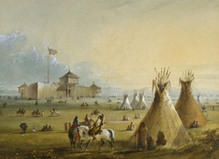  County Sheriff: Responsible for law enforcement/county jails.  Marshall: Elected official who took control within a town.  Grand Jury: Investigated crimes and handed out punishments. | Development of the Plains  American Civil War: 1861-65.  The significance of the Civil War: Created problems between settlers and the Indians. War slowed down number of settlers going to West but end of war in 1865 brought more money/settlers to the West.  Creation of the railroad: Started in 1865 and completed in 1869, creating new opportunities for people to move west.  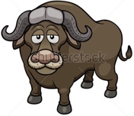  Impact of railroad: Significant numbers of buffalo were killed to feed the workforce. Impact on Indians was significant. Further acts, such as Desert Land Act 1877, passed to give settlers cheap land.
Key Words | Key Words | Key Words
Gold Rush: Rapid movement of people to seek gold  Mormon: Member of Church of Jesus Christ of Latter-day Saints founded by Joseph Smith in 1830.  Polygamy: Having more than one wife at the same time. | Country Sheriff: Elected official who enforced law and order.  Grand Jury: Jury of 23 selected to examine cases before court.  Vigilante: Member of a group who takes the law into their own hands as law enforcement was inadequate. | American Civil War: Confederate vs Union.  Desert Land Act: Promote development of arid land.  Timber Culture Act 1873: 160 acres of land if Homesteaders planted tree on ¼ of the land.
Problems faced by homesteaders: Land infertile, made worse by high winds, low rainfall, harsh winters + grasshopper/locust swarms.  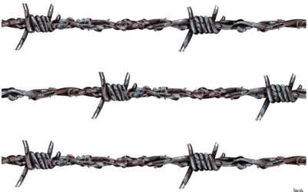  Overcoming the problems: Windmills collected water. ‘Dry farming’, new crops ‘hard winter wheat’ that could grow in harsh conditions.  Impact of technology: John Deere invented a new plough. Barbed wire invented in 1874, which allowed land to be fenced in.  Continued problems of law and order: Weapons owned without licenses. Stagecoach/train + bank robbery’s common. | Growth of the cattle industry: American Civil War helped industry grow, therefore cattle had to be taken to cowtowns.  Abilene: Cowtown, problems of saloons, gambling + brothels.  Changes in the work of the cowboy: Highly skilled in riding horses, branded cattle. Good job but not well paid.  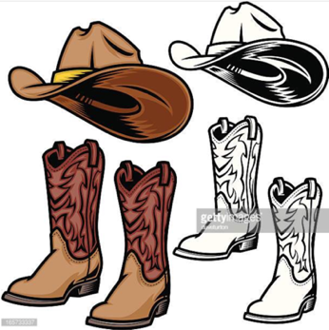  Iliff: Herd of 35,000 cattle and sold meat to railroad builders.  Goodnight: Texan Longhorn + experiment with cattle breeding.  McCoy: Cattle rancher and bought land, built stock pens.  Rivalry between ranchers and homesteaders: Cattle rachers annoyed homesteaders. Ranchers used forced to move settlers off land, charged high rents, violence or resulted to using guns. | Railroads, the cattle industry and gold prospecting:  Threatened Indians hunting grounds, buffalo also shot by hunting parties. Cattle ranching led to less space for buffalo. Gold prospecting led to tensions.  US Government policy: Sand Creek Massacre led to government intervention: reservations or be seen as hostile.  Fort Laramie Treaty: Created Great Sioux Reservation. President Grant agreed peaceful approach to the Indians.  Indian Appropriations Act: Indians viewed as a separate nation. Now treated as individuals of state.  Conflict with the Indians: Little Crows War 1861-62:  Conflict with settlers and US Army crushed Indians.  The Cheyenne Wars 1864-67: Conflict with settlers and US Army stepped in, Indians surrendered and signed Medicine Lodge Treaty.  Red Cloud’s War 1866-68: Sioux attacked miners/settler crossing Indian land. 1868 Fort Laramie Treaty protected Indian Land.
Key word | Key Words | Key Words
James-Younger gang – Notable gang including Jesse James. | Branding: Marking cattle with hot iron indicating ownership.  Cowboy: Man who tends to cattle, performed work on horse. | Medicine Lodge Treaty: Indians put on reservations.  Great Sioux Reservation: Original area of land which is now South Dakota and Nebraska.  Prospecting: Searching for potential sites of gold.  Sand Creek Massacre: 1000 volunteers attacked an Indian village despite white flag from the Indians.
Conflicts and conquest  Changes in farming: Expansion of railroads led to improvements in farming. Homesteaders now able to buy range of machinery, reapers and threshers. Increased crop yields led to more money. Challenges for Homesteaders: Could not control the weather and severe droughts in the 1870s and 80s led to bankruptcies. But, by 1890s, Great Plains had become more fertile and many prospered.  Changes in the cattle industry: Refrigerators meant cattle could be transported long distances and profits soared. Poor winter of 1886-87 meant that many cattle died and the end of the ‘Open Range’.  The Exoduster Movement: Movement of black Americans from the south looking for a new life in Kansas. Escaping persecution/racism.  The Oklahoma Land Rush, 1893: Government opened up 2 million acres of land, previously owned by the Indians. Many settlers claimed land but were disappointed as only 42,000 plots of land  were available. Land was transformed for the settlers for the better. | Extent of solutions to problems of law and order: Sheriffs, Marshall’s hired to maintain law and order, arrest + imprison.  The Earps and the OK Corral, 1881: Hired as town Marshall in Arizona. Won a gunfight at OK Corral with local outlaws.  The Range Wars: The Lincoln County War 1878: Conflict with Billy the Kid and House Cowboys for a murder. 30 killed in end.  The Johnson County War 1892: Conflict over land ownership with cattle barons and homesteaders. No charges brought.  Conflict with the Plains Indias: The Great Sioux War 187-77:  Government tried to buy Black Hills from Sioux but rejected.  The Battle of the Little Bighorn 1876: Indian victory over US Army led by General Custer who defied advice. Defeat shocked US who demanded further military actions against the Indians.  Wounded Knee Massacre 1890: Indian vision showed victory over US Army. Ghost Dance performed but US Army put Indians in camp. Some Indians resisted and were killed. | The hunting and extermination of the buffalo: Indians kept on reservations by killing buffalo endorsed by US Government. Buffalo hunters killed buffalo and sent hides back to the East.  The Plains Indians’ life on the reservation: Indians prisoners and lived on poor quality land and Indians dependent on US Governments for handouts.  Difficulties experience by Plains Indians: US agents dishonest, Indians had little status and Indian traditions banned, Indian children sent to schools.  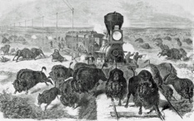  Indian Appropriations Act 1871: Meant Indians no longer treated as independent nations.  Dawes General Allotment Act 1887: Reservations to be broken up + destroyed power of Indians.

Civil War | Homestead Act 1862 | Pacific Railroad Act 1862 | Transcontinental Railroad 1869
Solutions for Homesteaders including the Timber Culture Act 1873 | Reservations and President Grant’s ‘Peace Policy’ 1868 | Law and Order | Little Crow’s War (1862), Sand Creek Massacre (1864), Red Cloud’s War (1866-68), Fort Laramie Treaty (1868)
Iliff, McCoy, Goodnight | Abilene | Impact of gold prospecting, cattle industry and railroad on Plains Indians | Cowboys and Homesteaders vs Ranchers

