The American West 1835-95
Revision notes and model answers
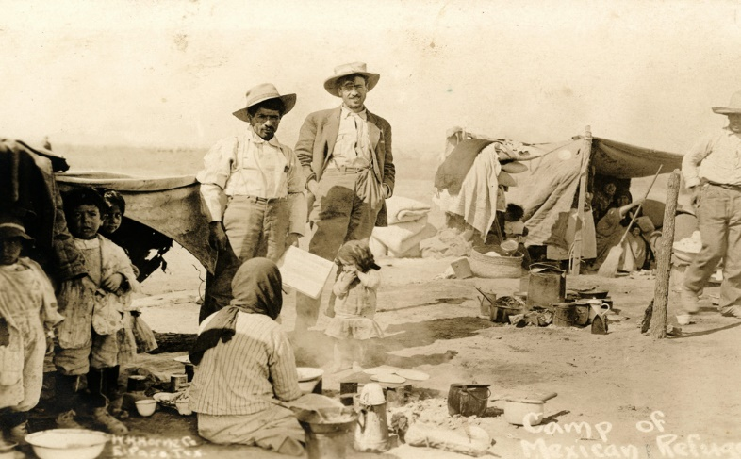
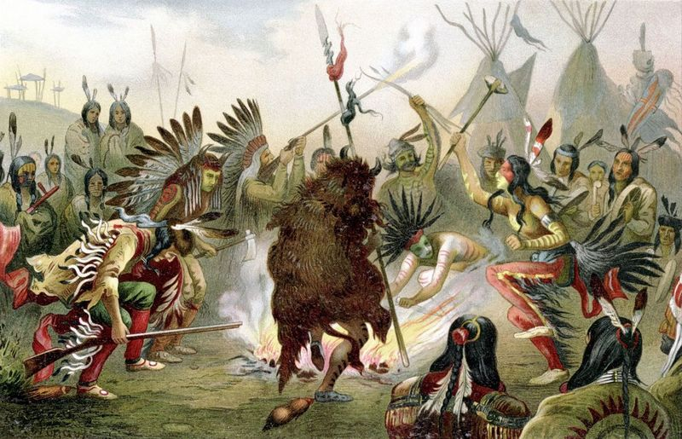

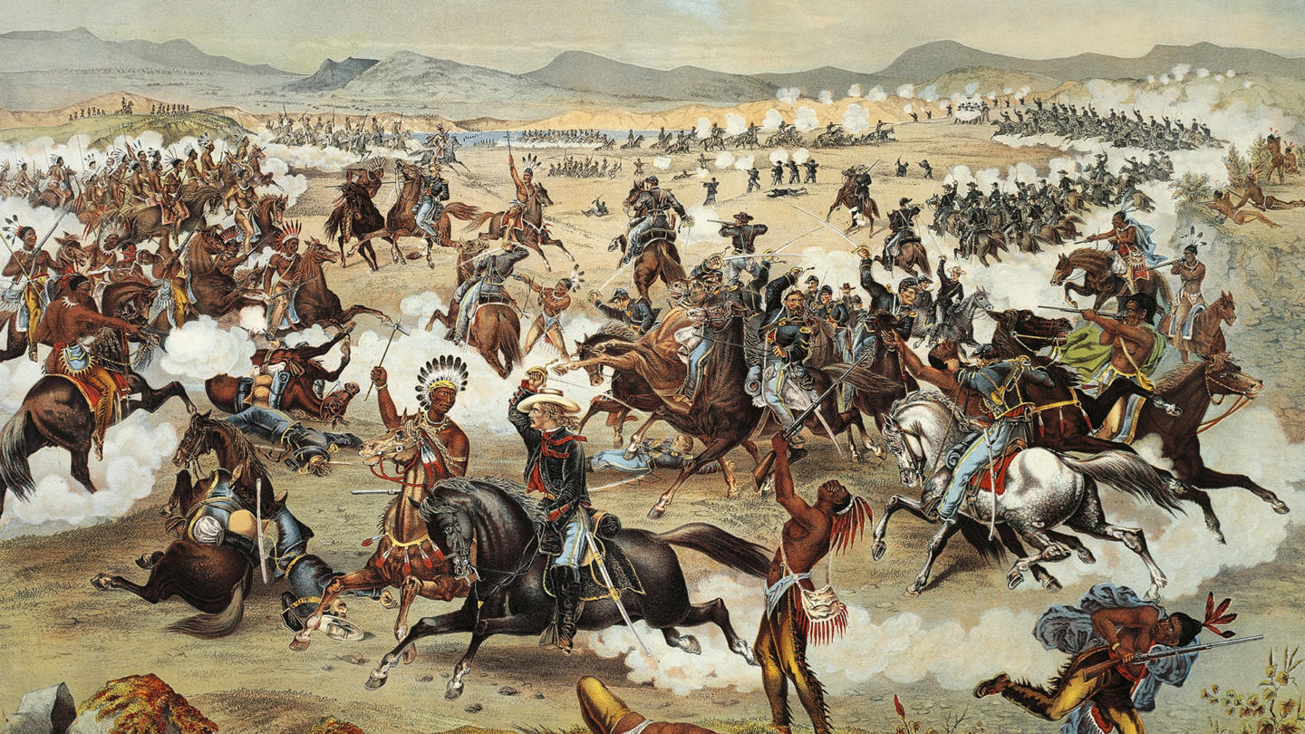

Higham Lane History Department
March 2020

Part 1 – The early settlement of the West 1835-1862
Context
In the early 19th Century, the white Americans who had colonised the eastern USA began to move westwards. This was partly due to increasing numbers of migrants arriving from Europe, but was also due to an increasing need for space for the American people to extend. The American Indians (sometimes called the Native Americans) were the native people on the great plains of the USA. These plains were west of the River Mississippi, and the Indians were reliant on the horse and the buffalo for their way of life.
By 1840, the US government had removed most of the Indians to the east of the Mississippi and had created a PERMANENT INDIAN FRONTIER. This frontier was not to remain in place for long however. The US government were under pressure to create more space for the growing white population, and the 1840s saw a belief in an idea called MANIFEST DESTINY. This suggested that it was God’s will for the American people to spread their way of life westward, and to ‘civilise’ the inhabitants of the central and western parts of the USA. There was also a growth in ‘PUSH-PULL’ factors that encouraged a large number of migrants to begin the trek over the Great Plains.
At first, the migrants travelled by foot and wagon along scouted trails such as the OREGON TRAIL. They were in search of land and reward. This growing migration created tensions between the Indians and the Whites. By 1851, the US government began to grant land and protection to the Plains Indians in return for promises that the Indians would not attack settlers. However, tensions continued to grow because of a massive difference in the belief about land ownership and a lack of white understanding about the Indians beliefs.
Mass migration continued to grow after the California Gold Rush in 1849. There was a lot of religious migration such as the Mormons; and a lot of economic migration to gain farmland and create mining communities. There was a growth of ‘lawlessness’ in the western communities, and also the increasing numbers of cattle drives had an impact on the Plains Indians. It was this period that saw the beginning of the conflicts that would explode in the 1860s and 1870s.

Chapter 1 | The Plains Indians: their beliefs and their way of life.

Who were the Plains Indians? | How was society organised?
1 – Many different tribes lived on the Plains. Some were so large that were called NATIONS. A good example would be the SIOUX NATION.  2 – Many of these tribes were competing against each other. There were many conflicts between these tribes. | 1 – Each tribe was organised into 20-30 BANDS.  2 – These groups worked together and supported each other.  3 – Most of the Plains Indians tribes were NOMADIC. They moved around.  4 – Each tribe had CHIEFS. They could have WAR CHIEFS and SPIRITUAL CHIEFS.

What was a WARRIOR BROTHERHOOD?
1 – These were important for Plains Indians tribes because they trained the young men for fighting. They also taught about the tribes values.
2 – Warrior brotherhoods were semi-independent and did not always respect peace treaties with the Whites.
3 –A famous chief of a Warrior brotherhood was CRAZY HORSE.

Women and their role in Plains Indian society.
1 – Women could NOT be chiefs in Indian society.
2 – Women were responsible for the feeding and clothing of the tribe.
3 – Women also trailed the Buffalo Hunt and skinned the dead animals.
4 – Women were highly respected by the tribe for their role.
5 – Both men and women had clearly defined roles in the tribe.

Why was the Buffalo and Horse important to Indians?
THE HORSE | THE BUFFALO
1 – The horse was used to hunt, travel and search for food.  2 – Wealth in the tribe was measured in horses.  3 – For example – the Comanche tribe had 8000 horses in the 1870s.  4 – Horse-riding skills were highly valued and seen as impressive.  5 – The horses would pull the TRAVOIS which carried the tribes TIPIS and personal possessions. | 1 – The buffalo roamed the Great Plains and was the main source of food.  2 – The Indians used every part of the buffalo. Nothing was wasted.  3 – There was also a belief that the buffalo was SACRED.  4 – The buffalo roamed freely, and the tribes had to follow the great herds.

The US government policy towards the Plains Indians 1830-1851
Government policy evolved over this 20 year period. The first plan was to separate Whites and Indians via the Permanent Indian Frontier. However, this changed as more settlers moved across the Mississippi into ‘Indian Territory’. Examine the laws and key dates from below. Then look at the NARRATIVE answer.
Key Event | US government policy
1830 – Indian Removal Act | The US government forces Indians from the eastern states to move west across the Mississippi River.
1834 – Trade and Intercourse Act | This sets out the idea of a Permanent Indian Frontier between Whites and Indians.
1836 – The Oregon Trail is opened. | This is a scouted trail to the Western USA. Government encourages migration.
1848 – The US wins the Mexican-American War. | The US gain the states of Texas and New Mexico. Encourages more migration.
1849 – Gold is discovered in California. | As a result, huge numbers of migrants travel across the Plains. This causes tension and the government has to respond to this.
1851 – The Indian Appropriations Act. | This begins the process of ‘relocating’ nomadic Indians into reservations.
1851 –The 1st Fort Laramie Treaty | This was a formal agreement between Indians and Whites. It was designed to defuse increasing conflict on the Plains.
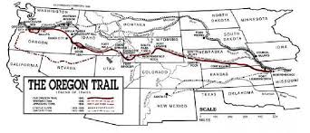

Examine the model answer about the IMPORTANCE of the Oregon Trail.

Chapter 1 | Migration and early white settlement

There were many factors that encouraged migration after 1834. These factors tend to be either PUSH or PULL factors.
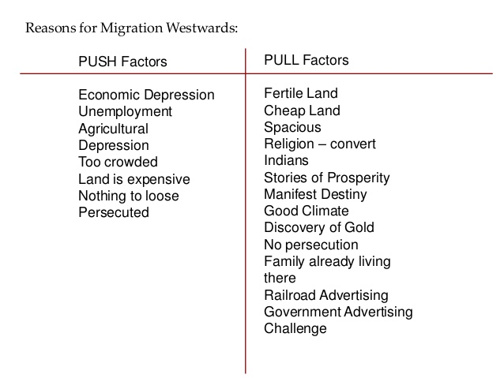

Examples – with specific details
Push Factor | Pull Factor
1 – Economic factors in the eastern USA. By the mid-1840s, unemployment was running at 25% | 1 – Farmland in Oregon was excellent and was a great incentive for many.
2 –Some religious groups were being persecuted in the east. For example, the Mormons and their belief in POLYGAMY made them leave Omaha in 1845-46. | 2 – The Gold Rush in California in 1849 attracted many thousands who were seeking to get rich.
3 – Many immigrants who arrived in the USA were fleeing persecution and poverty. Large numbers of GERMAN, IRISH and EASTERN EUROPEANS took the trek westwards in the 1840s. | 3 – The government provided financial help to attract people west. They wanted to establish a strong white American presence to make the USA a stronger nation.

Two case studies - a narrative of the Donner Party and the Mormons.
The Mormons | The Donner Party
Who?  They were a religious group led by JOSEPH SMITH. They believed in polygamy; and were unpopular with the mainstream Christian movement. | Who?  A group of 300 migrants in 40 wagons. Led by the DONNER BROTHERS, they planned to travel to California for a new life.
What happened?  In 1845, they were ordered to leave Illinois after Joseph Smith was murdered. They planned to go to Salt Lake City and set up a new settlement. Led by BRIGHAM YOUNG, they travelled on the Oregon Trail. The Mormons prepared well; and the party was well-supplied. They travelled through the Rocky Mountains and reached Salt Lake City in July 1847.  This led to a second, larger group to follow. This was also a success, and by 1869, 70 000 Mormons had settled. | What happened?  They set of in May 1846, and travelled on the Oregon Trail. In July, a group of 80 tried to take a SHORT-CUT through the mountains. This short cut was not successful, and the migrants got lost in the Sierra Nevada mountains. By then, winter was setting in, and the group were forced to eat their livestock. By December, they were starving, and they had to resort to cannibalism to survive. When rescuers arrived in February, only half the group were left alive.
Why successful?  1 – Brigham Young had planned the migration well. He used proper trail guides and was able to stay on the known routes.  2 – He organised the groups with strict discipline, and also made sure each group was well led.  3 – He set off in good time to beat the winter storms in the Rocky Mountains.  4 – The migration was planned with resting places, good supply lines and enough livestock to supply all the migrants. | Why a failure?  1 – The expedition was badly planned.  2 – The route they took had been badly scouted, and was longer than expected.  3 – The party contained a larger amount of elderly and women. There were issues with them being able to cope with the conditions.

Examine the narrative answer in the booklet. TIP – when assessing a narrative, use phrases such as ‘this led to’, ‘this was significant because’ and ‘as a result, this caused’.
KEEP THE NARRATIVE GOING.

Chapter 1 | The first conflict and tension between Whites and Indians

As the settlement increased, there was an increasing amount of conflict on the Plains. Mostly between the Whites and the Indians; but there was also an increasing problem of LAWLESSNESS in the frontier towns. The biggest problem was that white migration was affecting the movement of the buffalo. This led to the 1851 1st FORT LARAMIE TREATY.
Why was it needed? | There was a growing mistrust between settlers and the Indians. The government wanted the Indians to agree to give migrant’s access to the Great Plains.
What were the terms of the Treaty? | Indians would:  1 – End fighting amongst the tribes.  2 – Allow white migrants safe passage.  3 – Allow railway surveyors into the area.  4 – Allow the whites to build roads and forts.  5 – Pay compensation if any warrior broke these terms.  Whites would:  1 – Protect the Indians from any white aggression.  2 – Pay the tribes $50 000 a year as long as they stuck to the rules.
What were the problems with the Treaty? | - It began the process towards Indians being forced to live on reservations.  - Many of the tribes did not attend and therefore ignored the terms of the Treaty.  - Many of the white offers meant little to the nomadic Indians. For example, they had little use for money.  - The Treaty had no long-term chance for success, as the white settlers began to undermine the terms almost immediately.
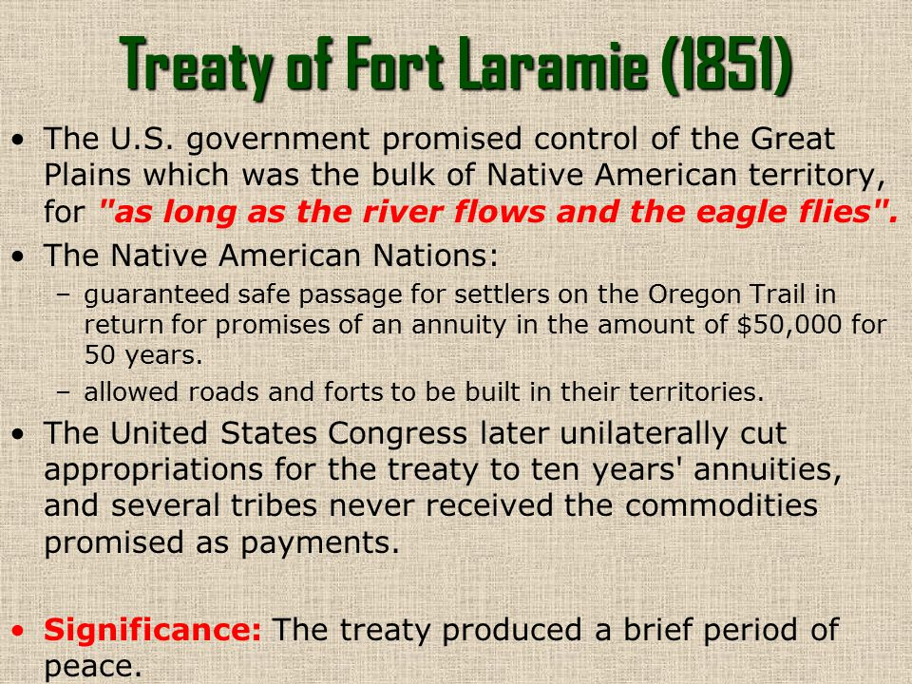

The problems of lawlessness in the early towns and settlements.
Many settlements grew quickly in the mid-West, and as a result, there was a lack of organised law enforcement. This resulted in several problems and some attempts to bring these settlements under control.
What problems existed in the towns?
1 – Many of the settlements were mining communities. ‘Claim Jumping’ was a common crime.
2 – There were large numbers of prostitutes and card-sharks in these communities. This often caused fights and tensions.
3 – During the Gold Rush, the population of San Francisco rose from 1000 to 25000. Many of these were Chinese immigrants, and this led to lots of racism.
4 – As there was not much official law and order, there was a growth of vigilante groups. Many of the cities and towns became controlled by richer men, and this meant the law was biased.

Many of these problems persisted until the Federal government was able to establish some form of law.

What did the government introduce to try and deal with lawlessness?
1 – A US MARSHAL – This police officer was in charge of a district. He was a FEDERAL (government) officer.

2 – The SHERIFF – This was an ELECTED law officer in a town or an area. They were responsible for issuing arrest warrants, making arrests and running the jails.

3 – The POSSE – A group of men who supported the Sheriff or Marshal when they were attempting to catch a criminal.

4 – VIGILANCE COMMITTEES – This was a local group who were raised by the people if there was a problem.

Summary
- The growing number of settlers moving onto the Plains led to conflict between the settlers and the Plains Indians.
- The 1st Fort Laramie Treaty involved promised being made by both the Whites and the Plains Indians.
- Law and order was difficult to enforce in the early towns and settlements. In some areas, a lack of government help meant local communities tried tackling lawlessness themselves.

Part 2 – The Development of the Plains 1862-76
Context
This period marked the real development of the West. The American Civil War (1861-65) that was fought in the eastern USA triggered a huge migration. The war between North and South cleared the way for the US Federal government to build railroads westwards. When the war ended, many refugees also poured out – especially black Americans.
The railroads brought new settlers and began to supply people with products made in the east. Meanwhile, from the southern state of Texas, cattlemen were beginning to drive cattle north towards the new railroads. There was a huge demand for meat in the east, and towns like ABILENE became ‘boom towns’ because of the meeting of the cattle routes and the railroads.
Ranching also developed with enormous numbers of cattle roaming the ‘OPEN RANGE’, guarded and rounded-up by COWBOYS.
As these developments were happening, the numbers of conflicts grew, and there were a variety of conflict. There was conflict between homesteaders and ranchers; between the large ranchers and the smaller ranchers and most importantly, conflict between Whites and the Plains Indians. The government continued to encourage Indians to move into reservations where they would be ‘protected’. However, multiple problems with the reservation policy led to a succession of ‘Indian wars’ between 1862 and 1876, culminating in the Great Sioux War of 1876. The highlight of this war was the BATTLE OF THE LITTLE BIG HORN.

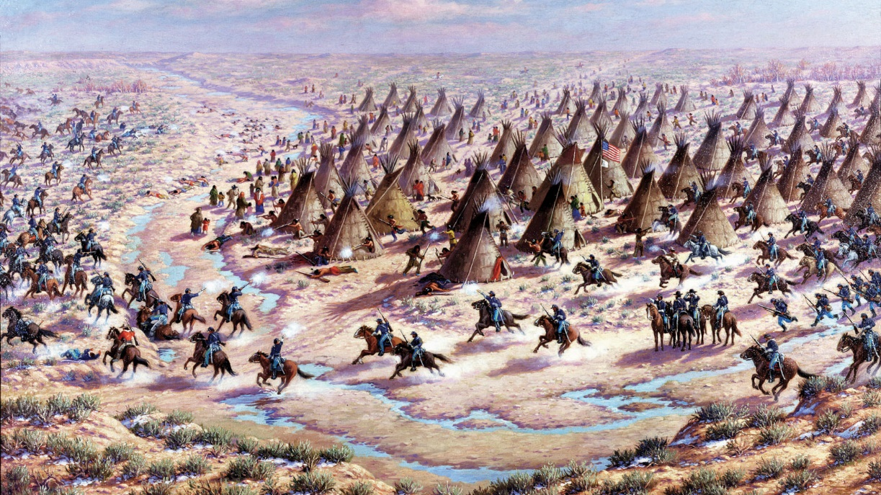

Chapter 2 | The development of settlement in the West.

The significance of the American Civil War
1 – 600 000 people died. This led to many of the states being devastated. This encouraged migration to the West.
2 – Social problems caused by racism led many freed black slaves heading west to avoid the racism that was a big factor in the war.
3 – The US government passed two very important laws. These were the HOMESTEAD ACT and the PACIFIC RAILROAD ACT.

HOMESTEAD ACT (1862) | PACIFIC RAILROAD ACT (1862)
1 – The government tried to encourage settlement of the West by offering 160 acre ‘pods’ for the cost of $10.  2 – Anyone could file a claim as long as they were the head of a family and over the age of 21.  3 – After 5 years, if you had successfully settled the claim, you could buy it outright for $30.  4 – By 1876, over 6 million acres of land had been given out.  5 – However, the government gave much of the land to the railroads.  6 – Many of the claims were re-sold on for profit. As a result, the Homestead Act did not always benefit the poorer settlers. | 1 –This Act was the incentive to build a railway across the whole USA.  2 – This split the job between the CENTRAL PACIFIC and the UNION PACIFIC companies.  3 – The US government extinguished the rights for the Plains Indians to land on the route.  3 – The government gave 45 million acres of land to the railroad companies.  4 –The two companies built a single railroad that met in 1869.  5 – Many immigrants worked on the railroad.  6 – It caused a huge rail network to develop after 1869.

The effects of the railroad on the American West
1 – The migration westwards became much safer and quicker.
2 – The Plains Indians were impacted massively. The buffalo declined rapidly due to over hunting and the tracks dividing up the herds.
3 – Railroads helped the cattle industry boom as it made it easier to transport cattle eastwards.
4 – There was a growth of towns. This created problems with lawlessness.

Examine the model answers to do with ‘Importance’ and ‘Consequence’. Both would be worth 8 marks in the exam.

Chapter 2 | New inventions for the settlement of the West.

The combination of more settlers and major farming challenges on the Great Plains led to many technological developments on the area.
Invention | Description and Importance
‘Self-governing’ windmills - 1854 | These were used to pump water out of the ground. They could pump water from up to 30 feet down.  In 1870, the blades were made out of steel to enable them to last longer.
Barbed wire - 1874 | This was used to fence off crops to protect them from livestock and other animals. It was much cheaper than wooden fences and more effective. It was not widely used until after 1880.
The sulky plow - 1875 | This was a strong plough that was effective at removing the tough grass and weeds on the Great Plains. It was easy to operate and 50 000 were sold in the first six years after 1875.
New crops ‘Turkey Red’ - 1873 | This was a grain crop which grew well in the tough soil on the plains. It was a major boost to farmers who started using it after 1874.

What was the Timber Culture Act of 1873?
The Homestead Act had given land but it did not guarantee successful farming on the Great Plains. There was not enough woodland on the Plains, so this act allowed a homesteader to claim 180 more acres of land for tree planting. There were several reasons for this:
- Trees could act as a wind-break on the Plains to protect crops and soil from erosion.
- The trees could provide timber for settlers to build houses and barns.
- The trees would provide settlers with fuel for the cold winters.
Most of the land claimed was in Dakota, Kansas and Nebraska. However, the weather was too cold, and many of the planted trees died. People also exploited loopholes in the Act to keep the land for a few years and then sell for a profit.

Remember – You may be asked to explain the IMPORTANCE of these inventions OR consider the CONSEQUENCES (Both positive and negative) for these changes.

Chapter 2 | Ranching and the cattle industry after 1865

The cattle industry had been hit by Civil War due to Texas being part of the Southern Confederacy. After 1865, things developed quickly.
Timeline of the growth of the cattle industry.
1836 | The beginning of Texan cattle drives to Missouri along the Shawnee Trail.
1855 | Quarantine Law in Missouri blocks the movement of Texas cattle.
1861 | JOHN ILIFF buys a herd of cows and fattens them on the Plains of Colorado Territory.
1861-65 | The American Civil War – longhorn cattle numbers booms on the Great Plains.
1866 | GOODNIGHT and LOVING drive cattle to Fort Sumner in New Mexico.
1866 | Kansas farmers prevent a cattle drive from Texas to Missouri. This is a first conflict between these groups.
1867 | JOSEPH McCoy established the first COWTOWN in ABILENE, Kansas.
1868 | Goodnight-Loving Trail extended to Cheyenne in Wyoming. Cattle being driven further north.
1870 | Iliff’s ranch extends to 16 000 acres of open range. This will cause problem with both homesteaders and Indians.
1867-72 | A total of three million cattle driven along the CHISHOLM TRAIL to Abilene.

There are two key developments that were significant for the growth of the cattle industry in this period.
Joseph McCoy and Abilene | The Goodnight-Loving Trail
1 –Kansas had relaxed the quarantine laws in 1867. Texas cattle could now be driven into the state.  2 – Grassland all the way to Kansas allowed cattle to be driven to Abilene,  3 – McCoy built large stockyards in Abilene. He also built hotels and saloons for the cattlemen  4 –This helped create a link between the cattle drives and the railroad.  5 – By 1872, Abilene was a boom town and McCoy was very rich. | 1 – This was established in 1866 and was designed to take cattle directly to new settlements.  2 – They moved cattle from Texas and sold them for a big profit.  3 – In 1868, Goodnight made a deal with John Iliff to drive cattle further north to Wyoming and the railroad.  4 – By 1876, Goodnight’s ranch in Texas was over 1 million acres.  5 – Other cattle ranchers followed his example, and Wyoming became a centre for the cattle industry.

Who was John Iliff?
John Iliff was a man who spotted the problems of bringing cattle on the long drive from Texas. He decided it would be better to fatten up his herd on the Great Plains and sell them without the expense of the long drive.
1 – In 1866, he brought a ranch near Denver, and by 1870 had built up a herd of 26 000 cattle.
2 – He sold beef to the Union Pacific railroad; and also won the contract to sell beef to the Sioux Indians living on a reservation.
3 – Iliff was important because he was the start of ranching on the OPEN RANGE rather than relying on a cattle drive from Texas. He became one of the first CATTLE BARONS.
The Long Drive and Cowboys -

What was the long drive? | Driving the cattle from Texas to Kansas took about three months. It took six months to get to Wyoming.  It was dangerous and usually involved about 12 cowboys herding 3000 cattle. Men were hired to deliver the cattle. The trail boss was paid $100 a month, whilst cowboys got about $25. It was a hard job, and the end of the trail saw cowboys spend their money. Normally towns like Abilene experienced lots of drinking and gambling at the end of a cattle drive.
What it like on a ranch? | Ranches covered a huge area of land. Cattle roamed freely during the winter. In the spring, the ROUND-UP began, which involved bringing all the cattle in for BRANDING and then sale. Most ranches were big, employed lots of cowboys and saw small settlements develop where they lived in BUNKHOUSES. Life was hard – but less dangerous than on a cattle drive.

Rivalry between ranches and homesteaders.
Ranchers and homesteaders frequently fell out. RANGE WARS happened.
Ranchers relied on access to the grazing land. Ranchers used legal and illegal tactics to block homesteaders from the land. | Homesteaders turned the land into PRIVATE farms. Homesteaders were accused of cattle-rustling. Ranchers also hated the use of barbed wire to fence of the land used for farms.

Examine the answer about the IMPORTANCE of Joseph McCoy.
Chapter 2 | Changes to way of life of the Plains Indians

All the developments caused by the whites had serious consequences for the life of the Plains Indians.
Impact | Description
1 – The development of the railroads after the Fort Laramie Treaty of 1851. | The railroad took away much of the land used by the Plains Indians to hunt buffalo. Many tribes such as the Pawnee tried to sign treaties with the Whites. However, the decimation of the buffalo hurt many tribes and was one of the main factors that triggered the Great Sioux War of 1876.
2 – The Cattle Industry and the growth of the long drives and ranches. | Cattle and buffalo ate the same grass on the Plains. As the buffalo were reduced in number, many Indians chose the work for the cattlemen. However many tribes such as the Comanche attacked the cattle drives and stole horses and cattle. This led to the US Army protecting them.
3 – Gold prospecting. First in California and then in the West. | The first big gold rush had been in 1849 in California but it triggered an influx to anywhere where gold might be. This brought disease and frequently devastated the Indian population. In 1862, gold was discovered in Montana. Thousands of Whites travelled along the BOZEMAN TRAIL and this went against the terms of the Fort Laramie Treaty. This influx led to RED CLOUD’S WAR.

Changing government policy towards the Plains Indians.
The US government continued to try and move Indians into reservations. Some agreed and the government promised that they would be protected. However, the reservations were often poor land, which meant that the Indians way of life was shattered. Also – the reservations destroyed the nomadic way of life of the Indians. They were frequently a long way from their original area. There was also the problem that many Whites objected to the Indians being given land instead of them.
What was President Grant’s PEACE POLICY of 1868?
1 – The US government put forward $2 million to ensure that Plains Indians living in the reservations were looked after.
2 – Any tribes who refused to go on to reservations were to be treated as HOSTILES.
3 – Indian commissioner ELY PARKER stated that Indians should be treated as ‘helpless and ignorant’. He also stated that the US government knew what was best for the Plains Indians.

Chapter 2 | Conflict with the Plains Indians

The 1860s saw a period of conflict caused by the developments on the Plains.
Conflict | What happened?
Little Crow’s War 1862 | Little Crow’s band of Dakota Sioux had lived on a reservation since 1851. However, the conditions were poor, and the Indian Agents dealing with them were corrupt and treated them badly. By 1862, the Sioux were in a desperate state. Little Crow led other Indians to attack the Agency and White settlers. Over 600 whites were killed. US troops responded, and Little Crow was defeated. Over 400 Indians were put on trial; and 38 were executed. The remainder were put back onto reservations which were poor. Little Crow was killed.
The Sand Creek Massacre 1864 | In 1858, gold had been discovered in Colorado. White settlers began to move into the area against the terms of the Fort Laramie Treaty. An attempt to defuse the situation led to the TREATY OF FORT WISE in 1861 which seemed to settle it. Many Cheyenne DOG SOLDIERS rejected the Treaty which led to three years of conflict. The Indian chief BLACK KETTLE believed he had reached an agreement, however, in 1864, the Colorado governor ordered COLONEL CHIVINGTON to attack the Indians at SAND CREEK. Over 130 Indians were massacred – mostly women and children. The remaining Indians eventually ended up on reservations.
Red Cloud’s War 1866-68 | Gold had been discovered in Montana in 1862. As a result, White settlers began moving along the BOZEMAN TRAIL which broke the Fort Laramie Treaty (again). The government began to build forts along the trail to protect the Whites. The Sioux chief RED CLOUD chose to fight the Whites. He attacked soldiers and workers building the forts. Red Cloud was a great leader, and in 1866, managed to trap and kill 80 soldiers during the FETTERMAN MASSACRE. He also laid siege to FORT PHIL KEARNY, and made it impossible for White wagon trains to move along the Bozeman Trail, The government realised they could not win this fight. In 1868, there was a SECOND FORT LARAMIE TREATY. The Whites agreed to abandon the Bozeman Trail and leave the area for a Great Sioux Reservation. This was a rare Indian victory.

Examine the narrative of the conflicts of the 1860s. Look at how the start and end of the narrative are reached. Use the linking phrases.
Part 3 – Conflict and Conquest 1876-1895
Context
1876 saw a massive defeat for the US Army by the Plains Indians at the BATTLE OF THE LITTLE BIG HORN. This radically changed attitudes towards the Plains Indians and the Whites were much harsher. By 1877, Sioux resistance was all but crushed, but army harassment continued until 1890 when the last Sioux resistance ended with the WOUNDED KNEE MASSACRE.
Farming continued to make great progress in this period. Settlement continued to grow, and this continued to push the Plains Indians into reservations. The cattle industry enjoyed a ‘beef bonanza’ during the 1870s and early 1880s. Huge profits were made. This came to an end during the appalling winter of 1886-87. And this proved open ranching was unsustainable on the Great Plains. This led to increased conflict between homesteaders and ranchers. This in turn led to more problems for law and order, as range wars broke out over land and dragged in professional gunmen such as BILLY THE KID and WYATT EARP.
For the Plains Indians, 1876 marked the end of government toleration of the American Indian nations. Reservations were reduced in size and quality, and methods were used to destroy the traditional Indian way of life. In the end, the Plains Indians would stop resisting the spread of ‘white civilisation’ and would surrender to the American way of life.

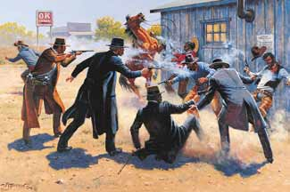

Chapter 3 | Changes in farming, the cattle industry and settlement.

Technology in this period transformed the Great Plains and the farmers using a wide-range of technology to develop the cultivation.
What new farming methods were used in the 1870s and 1880s?
Method | Description
Dry farming | This method trapped water under the surface and was developed by HENRY CAMPBELL. This promoted strong root growth; and also worked well with wheat. It grew in popularity but a series of droughts stopped it becoming widespread.
Wind pumps | These were used to pump water from underground. In 1854 DANIEL HALLADAY developed a pump that would move with the wind direction. This developed until by the 1880s, all metal pumps were being used. These were really efficient. This was a big success.
Barbed wire | This was first introduced in 1874, but becoming increasingly used in the 1880s as it became cheaper. Both farmers and cattle ranchers used it to protect their land and livestock.
Mechanisation | There was a development of machinery to help improve farming on the Great Plains. Ploughs and seed drills improved the productivity of the land which helped the US economy.

Changes in the cattle industry
Throughout this period, so much money went into cattle ranching, that the Open Range became overstocked. This had serious CONSEQUENCES in the 1880s.
What were the consequences?
1 | A fall in demand because beef had become so plentiful in the eastern USA. This caused profits for ranchers to decrease.
2 | Soil erosion caused by overstocking caused the grass to wither and die. Prairie fires reduced the grass cover even more.
3 | ‘THE GREAT DIE-UP’ in 1886-87 was caused by a harsh winter. At least 15% of all cattle died, and many ranchers went bankrupt.
4 | The huge ranches struggled and were replaced by smaller ranches. The smaller model became more successful in the long term.

What happened to settlement on the Plains in this period?
Settlement continued to grow over the 1870s and 1880s. There was a continued belief in the ideals of MANIFEST DESTINY, combined with a huge wave of black and immigrant migration after the American Civil War.
What was the EXODUSTER MOVEMENT?
Causes | 1 – Because of oppression of former black slaves in the southern US states, many black Americans decided to move westwards.  2 – BENJAMIN SINGLETON pioneered the black movement to Kansas.
Events | 1 – In 1879, 40 000 blacks headed to Kansas and also to the mid-West.  2 – These settlers were called EXODUSTERS as it was an Exodus to the dry West.  3 – The Homestead Act offered the promise of free land for black Americans.  4 – There was a Biblical element to this, as many felt this was God’s work.
Consequences | 1 – By 1880, over 50 000 black Americans had moved into the West.  2 – The unplanned nature of the migration led to many blacks not having places to live. This caused tension amongst whites.  3 – Many of the Exodusters had illness and this meant they were not welcome in many states.

The Oklahoma Land Rush of 1893.
Following the Homestead Act and the Dawes Act of 1887, much of the land on the Great Plains was put up for sale in individual blocks. Then in 1889, the US government decided to open up huge areas for white settlement all at once – in 160 acre blocks. Every piece of land was open to all –and this was called a LAND RUSH.
Between 1889 and 1895, millions of acres were opened up to whites. The biggest was in 1893 when 8 MILLION ACRES of land was opened up, and there was a land grab in Oklahoma. This marked a real end to White protection of Indian land.

Chapter 3 | Increased conflict and tension

The development of the West caused increased conflicts over the 1870s and 1880s. Some were between the whites over the development of resources. Others were between the different races now co-habiting on the Great Plains.
Timeline of the key events in this period.
1876 | Battle of the Little Big Horn. This was the biggest battle in the GREAT SIOUX WAR and saw the defeat of General Custer and the 7th Cavalry.
1877 | CRAZY HORSE surrenders to the US Army. He is later killed in captivity.
1877 | BILLY THE KID shoots Frank Cahill in self-defence. This was the first of his 21 killings.
1878 | Billy the Kid takes part in the LINCOLN COUNTY WAR. This was a range war fought between cattle barons and farmers.
1881 | Billy the Kid is shot and killed by Sheriff PAT GARRETT. Also Chief SITTING BULL surrenders to the US Army. The GUNFIGHT AT THE OK CORRAL takes place in TOMBSTONE, ARIZONA.
1882 | Marshal Morgan Earp shot and killed by the Clanton Gang.
1890 | Sitting Bull killed during attempts to arrest him on a reservation.  Chief BIG FOOT and his followers killed by US troops during the WOUNDED KNEE MASSACRE.
1892 | The JOHNSON COUNTY WAR. This was a range war between cattlemen and homesteaders.

Who were Billy the Kid and Wyatt Earp?
Billy the Kid | Wyatt Earp
1 – His real name was WILLIAM BONNEY. From his early life he was involved in crime.  2 – In 1878, he became a hired gun in the LINCOLN COUNTY WAR. He fought for cattle baron JOHN CHISUM.  3 – He killed many men after this, and was hunted by Sheriff PAT GARRETT.  4 – In 1881, Billy was captured, then escaped and was finally killed by Garrett in Fort Sumner. | 1 – Earp became a lawman in 1874 after dealing with cowboys in Kansas.  2 – In 1879, he moved to Tombstone, Arizona. There was a ‘war’ between ranchers and businessmen.  3 – Earp had to deal with ‘the Clantons’ – a gang of gunmen.  4 – In 1881, he killed 3 of them at the Gunfight at the OK Corral.  5 – However, public opinion turned and he left Tombstone in 1882.

What was the Johnson County War of 1892?
This was a range war between cattle barons and homesteaders. It is significant because it showed that even in the 1890s, the West still had places were men could take the law into their own hands.
Causes | In Wyoming, huge cattle ranches had developed in the 1870s and 1880s. After the ‘Great Die-Up’, they lost a lot of cattle and power.  These big ranchers set up the Wyoming Stock Growers Association (WGSA) to ban small ranchers. The homesteaders and small ranchers didn’t like this and blocked it. The WGSA started to take the law into their own hands.
Events | 1 – Two homesteaders ELLA WATSON and JIM AVERILL had a homestead in the middle of open-range pasture owned by ALBERT BOTHWELL. He wanted their land and they refused.  2 – In 1889, Bothwell accused the two of stealing his cows. He lynched them and hanged them both.  3 – Other killings followed, and the homesteaders set up their own association to protect themselves. The WGSA escalated the war in 1892. They hired 22 gunmen to kill any homesteader who was standing up to them.  4 – This was done with the support of the Wyoming governor. The cattlemen had bribed him.  5 – Eventually, the government stepped in. The local sheriff and towns people went after the gunmen.  6 – Finally, the US army arrived and surrounded the gunmen – forcing them to surrender.
Consequences | There was a trial where the WGSA was to be prosecuted.  However, the cattlemen had rich supporters and were able to influence the jury.  The trial eventually collapsed and all the cattlemen were found not guilty.  The war was significant because it showed that vigilante justice was still central to law and order. It also showed the power of the rich cattlemen. However, the war was the last real range-war, as cattlemen moved more toward small ranches with fenced-in pastures.

Examine the model answer about the IMPORTANCE of the Johnson County War. Look at the mixture of LONG and SHORT term factors. An importance question is very similar to a CONSEQUENCE question.

Chapter 3 | The final conflicts between Whites and Plains Indians

In 1876, the GREAT SIOUX WAR took place. It was triggered by the discovery of gold in the BLACK HILLS which were sacred to the Sioux. The government offered to buy them from the Sioux; but the Indians felt betrayed and thousands left the reservation to gather at the LITTLE BIG HORN RIVER. They were given 60 days to return to the reservation by President Grant – but deep snows made it impossible for this to be achieved. Sitting Bull said ‘THE WHITES WANT A WAR AND WE WILL GIVE IT TO THEM.’
What happened at the Little Big Horn?
1 – Three columns of soldiers converged on the Indian camp on the Little Big Horn river.
2 – General Custer led his 600 men against the Indians without waiting for support. As a result, he and over 230 men of the 7th Cavalry were massacred.
3 – It was the biggest defeat ever suffered by the Whites at the hands of the Indians.

What were the consequences of the Battle?
1 – White public opinion demanded much more harsh treatment of the Indians after this defeat.
2 – There was pressure for the Indians to be crushed.
3 – It was decided that Indians should be kept on reservations.
4 – All previous treaties were now ignored.
5 – Military control of the Great Plains was extended.

During the 1880s, the Indians were crushed and pushed into less space. However, in 1890, a new belief started. An Indian warrior called WOVOKA had a vision that all the Indian dead would come back if the Sioux rejected the Whites. This was called the GHOST DANCE and it spread rapidly. The Army was ordered into the Plains, and a band of Sioux warriors led by CHIEF BIG FOOT was cornered at WOUNDED KNEE. On 29 December 1890, the 7th Cavalry fought them and killed over 250 Indians. The Ghost Dance was over.
As a result:
- The public praised the action and saw Wounded Knee as a revenge for the Little Big Horn.
- Some people saw the Ghost Dance as the last stand of the Plains Indians.
- In late 1890, the US government declared that the Indian Frontier was officially closed – ending the Indian Wars.
Chapter 3 | The destruction of the Plains Indians way of life.

In the final years, the Indians way of life was systematically destroyed by the Whites. The buffalo was almost exterminated from the Great Plains.
Reasons for this policy:
1 | Buffalo hides were valued for making warm clothing for Whites. Buffalo hunters killed as many as they could.
2 | White guns meant that many more buffalo were killed than were needed. Many were left to rot on the Great Plains.
3 | Approx. 4.5 million buffalo a year were being killed by Whites. This compared to 500 000 a year killed by the Indians.
4 | Government policy encouraged the killing of the buffalo as it helped make the Indians less independent.
5 | The killing of the buffalo made the Plains easier to develop for cattlemen and ranchers.

What was it like for Indians on the reservations?
Shrinking Reservations | Removing power from the Chiefs
1 – The reservations were constantly reduced in size.  2 – In 1887, the Dawes Plan pressured the Indians into accepting smaller reservations.  3 – Any Indian land was then sold off to the Whites. | 1 – Chiefs were replaced by Indian councils.  2 – Special courts were set up to judge Indians.  3 – These courts were abolished and replaced by White courts. This removed all Indian power.
Government agents | Education and Religion
1 – Government agents were used to run the reservations. They used bribes to gain good behaviour from the Indians.  2 – Many Indians adopted white customs to ensure that they had a good standard of living. | 1 – Indian children were sent to learn a Christian way of life and educated as whites.  2 – By 1887, over 250 white schools had been set up for the Indians.  3 – One quote sums up the views. ‘kill the Indian in him and save the man’

The Dawes Act 1887
Break up the power of the tribe. | Encourage Indians to become farmers.
Encourage assimilation into White culture. | Free up land for white settlers.
Reduce government costs. | Reduce the size of reservations.

