GCSE History
Homework Booklet

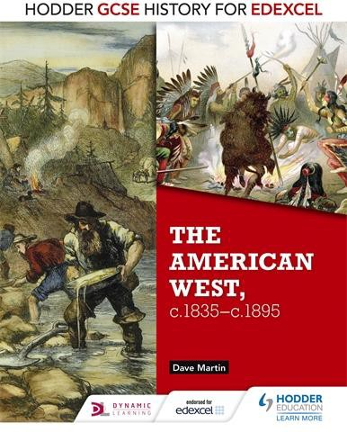
Name: Class:
The American West c.1835-c.1895

Contents

The Settlement of the West, 1835-1876 | Page
Pioneers & Territorial Expansion | 2-4
The Oregon Trail & The Donner Party | 5-6
The Mormon Migration | 7-8
The Gold Rush 1849 | 9
Living and Farming on the Great Plains | 10-11
The Mormon War 1857-58 | 12
The American Civil War and its impact on the Great Plains | 13
Homesteaders | 13 - 14
The Transcontinental Railroad | 14 - 15
Cattle Drives and the Rise of the Cattle Industry | 15 - 16
Cowboys, the Open Range to the Closed Range | 17-18
Exoduster Movement and the Oklahoma Land Rush | 18-19
Johnson County War | 19
The Plains Indians, 1835-1895 | Page
Life and Culture of the Plains Indians | 20-21
The Importance of the Buffalo and the Horse for the Plains Indians | 22
Government Policy Towards the Plains Indians | 23
The Fort Laramie Treaty 1851 | 24
Indian Wars & the Impact of US Policy | 25-26
The Great Sioux War | 27-28
End of the Plains Indians | 28-29
The Lawlessness of the West, 1862-1895 | Page
Lawlessness in Western Towns | 30-31
How Wild was the Wild West? | 32-33
Conflict due to Lawlessness in the West | 34

The Settlement of the West, 1835-1876

Introduction
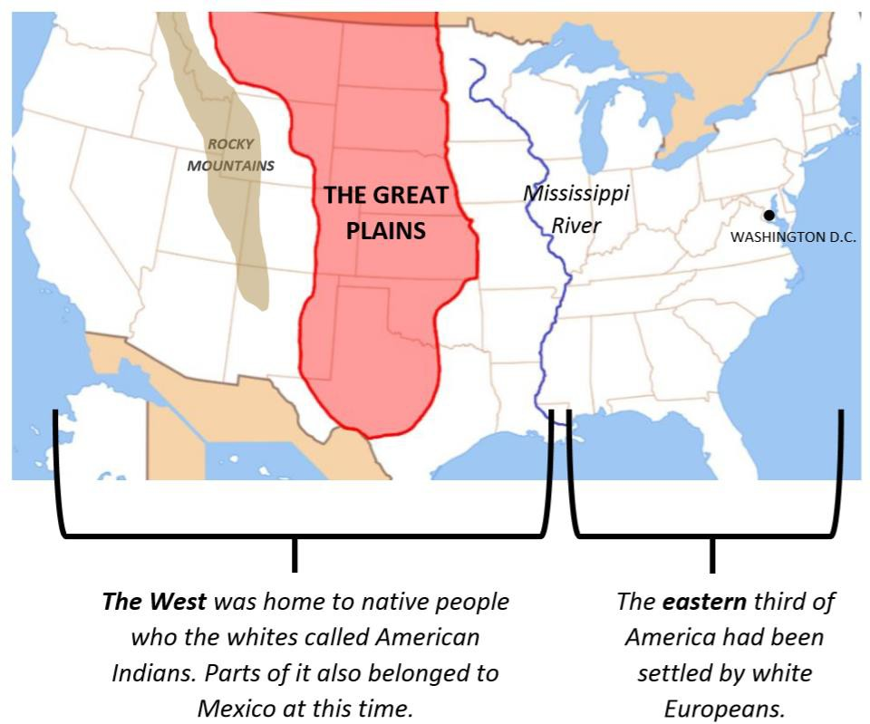
In 1834 the United States was made up of twenty- seven states but were not alone on the North American continent. As well as the Plains Indians on the Great Plains to the North there was British Canada and in the South West was Mexico. The large area in the middle was known as the Great American Desert or the Great Plains which was home to the nomadic Plains Indians; whose lifestyle was well-adapted to their environment.
The Climate of the Great Plains
The Great Plains have very hot summers and very cold winters, and are very dry with few rivers or streams. All of this made the Plains very poor land for farming, which meant white Americans had little interest in settling there to begin with.
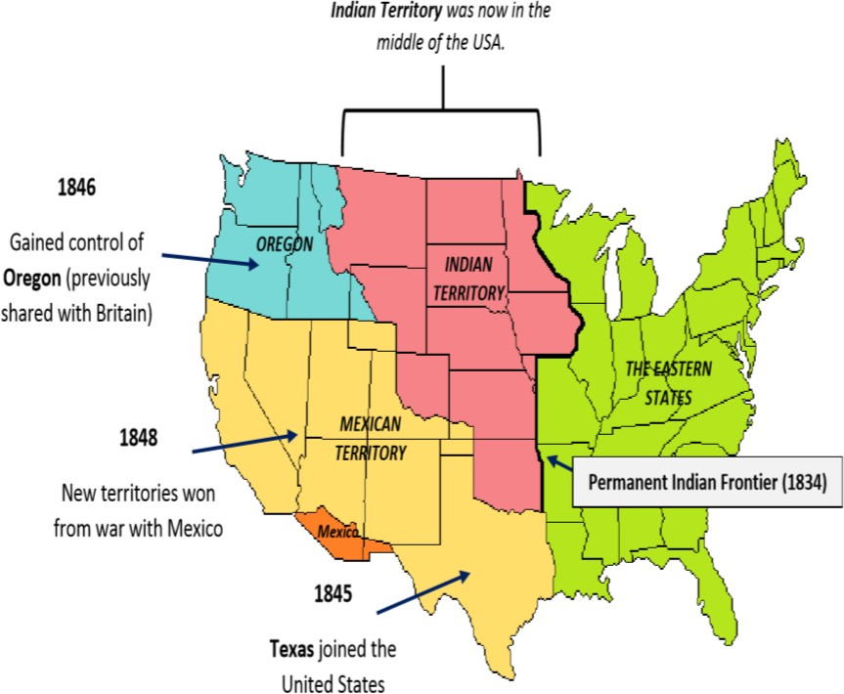
In the 1840s, things changed. America gained new territories in the West. The Mexican-American War between 1845- 48 was caused by the American annexing Texas. The resulting treaty led to them gain huge amounts of land in the South East. Negotiations with Britain allowed them to gain control of Oregon in the North West. This however created an awkward problem: it meant that Indian Territory was now right in the middle of the USA, and white Americans would have to cross it in order to reach the new areas in the West. The first people to make this journey were called pioneers

Task: Using the information above identify two consequences of the American victory in the Mexican-American war

Why did the first pioneers cross the Great Plains?

Task: Read through the reasons the early pioneers crossed the Great Plains. Using the information explain why each reason would lead to an increase migration West.
Decide if the reasons are either a Push Factor – reason to leave the East OR a Pull Factor – reason to head West
Reasons | This would increase migration because… | Push/Pull
Collapse in Cereal Crop Prices

Farmers from Mississippi were attracted west because the poor economy had caused wheat and corn prices to plummet.
Victory over Mexico

California became part of the US in 1848 which made it more attractive and accessible to settlers.
Economic Depression

In 1837 the US was hit by an economic depression. People lost their savings, their jobs and their homes. Some sought a new life out west.
Manifest Destiny

Americans believed it was
God’s will that they should expand their territory to fill the whole of the continent.
Government Encouragement

In 1842 settlers were allowed to stake a claim of 160 acres. After 14 months they could buy it for $1.25 an acre.
Unsettled farmland in Oregon & California

Mountain men told stories of the freely available fertile land and sunny climate in the west

which was perfect for farming and growing fruit trees.
Negotiation with Britain Oregon became part of the United States in 1846 which made it more accessible and attractive to settlers.
Searching for Space
As the Midwest became more populated, settlers in Mississippi wanted to move west for the challenge of resettling in Oregon and California.
Mountain Men Mountain men enabled
pioneers to travel to Oregon and California after the discovery of the South Pass through the Rockies.
Task: Which of the reasons do you think was the most important in causing westward migration? Why?
Task: Explain one way in which the government support was important in encouraging migration West?

The Oregon Trail

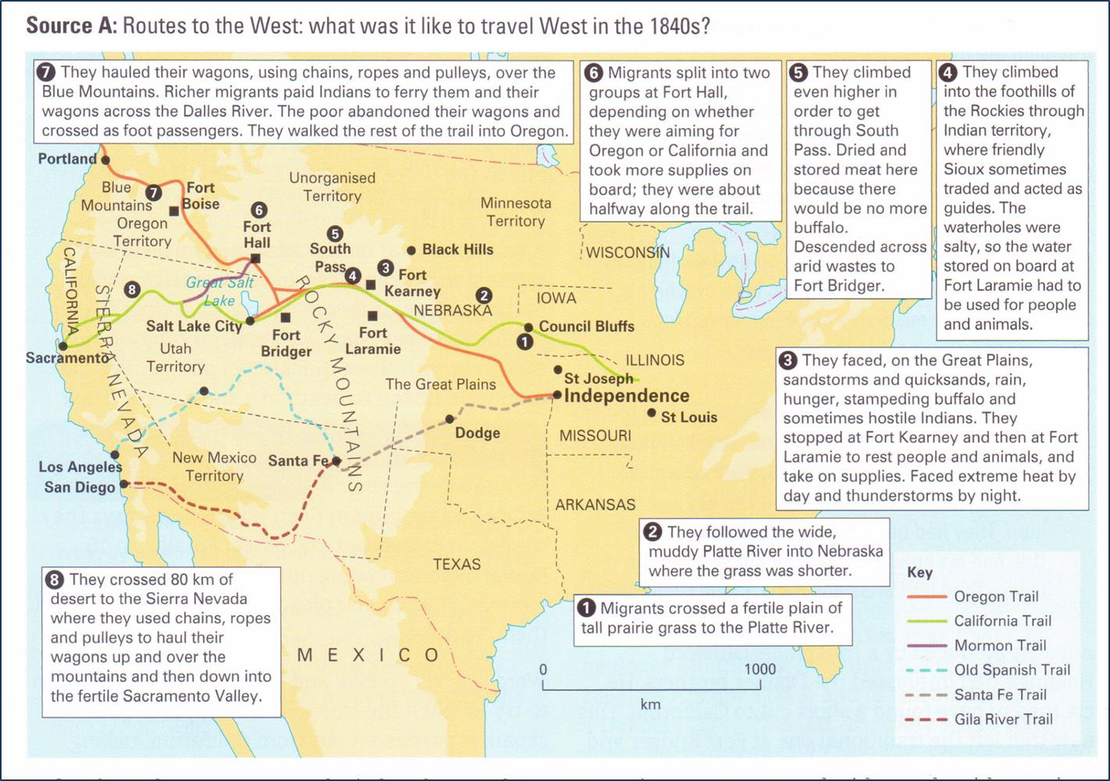
The most popular route taken by migrants was the Oregon Trail. It was 3200km long and took several months. Migrants would travel in large groups, in wagons pulled by oxen. The Oregon Trail went across the Great Plains and through the Rocky Mountains, which meant it was a challenging journey.
The journey West was 2000 miles long which would take at least 5 months. Migrants had to time their journey right – it was best not to set off until April, so there would be enough grass for the animals to feed on, and if they did not make it before winter set in, they might freeze to death. They travelled through prairie, desert and mountain. All difficult and dangerous terrain. The climate was often dry, windy and hot or wet, windy and cold. There was a lack of fire wood which was needed to light a fire at night in the cold temperatures. Migrants had to take enough food and essentials with them to survive. Most lived on salt pork but food shortages were common. The route was filled with danger and disease. Many migrants caught cholera from the water, and at least 20,000 are thought to have died along the Trail from drowning and accidents. There was also the problem of fever caused by mosquitoes. There was also the threat of the violent Indian tribes. In order to survive groups of migrants needed to have a wide range of skills. Most wagon trains had at least 20 wagons, including skilled people such as carpenters and hunters.

Task: Explain The importance of the Oregon Trail for settlers’ expansion west using the words below.
Important | Route | Plains | 2000 | Dangerous | Meant | Because | Independence | Prosperous

The Donner Party

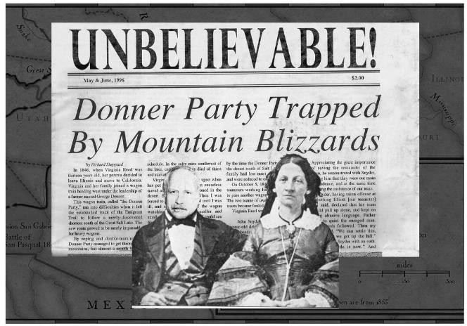
The Donner Party was a group of 300 migrants led by the Donner brothers. They set out on the Oregon Trail in May 1846. In July, around 80 of the party decided to split off and try a short cut that had been written by trail guide Lansford Hastings. Hastings had claimed the short cut was easy to travel across with plenty of water and grass which would save them 400 miles.

The route was too hard. It was difficult to cross due to dangerous rivers and uneven terrain. At times there were long stretches with no water or grass. They had to abandon all their cattle while crossing the Salt Lake Desert. They were
attacked by Paiute warriors. Fights broke out - in one, a man was killed. By mid-October the party reached the Sierra Nevada Mountains and by November their oxen were completely exhausted. Winter approached and snowstorms forced the Party to a standstill after a journey of 2,500 miles. They were just 150 miles from Sutter's Fort, now Sacramento, in California.
Rescuers reached the party in February 1847. Only about 40 of the original 80 migrants were still alive. The vast majority of these survivors had only survived by turning to cannibalism and eating those who had died. Rescue groups from Fort Sutter managed to rescue the others - the last one only in April 1847. Of 87 who set out, 46 survived, and 41 died. This case study demonstrates the dangers of migrating West and the comparative safety of the Oregon Trail.

Task: Plan a narrative account of the Donner Party migration analysing why things went so badly wrong.
Beginning
Middle
End

Who are the Mormons and why did they head West?

The Mormons were a religious group founded in the 1830s by Joseph Smith in New York. He claimed he had a religious vision where an angel (Moroni) told him about two buried gold plates. Smith dug up the plates, translated the ancient language on them and this became the Book of Mormon (1827). The plates told Smith and his followers to start building God’s Kingdom in America to prepare for the second coming of Christ. His preaching convinced many and by 1831 there were around 1000 members.
The growing Mormon religion faced hostility as people thought Smith was a fraud so they were forced to move to Kirtland, Ohio in 1831, to escape opposition. While in Kirtland they set up a bank which was used not just by Mormons but also by Gentiles however in 1837 the Mormon bank collapsed and many people lost their savings. As a result, they were forced to leave and they went to Independence, Missouri. The Mormons were not welcomed there either as they were anti-slavery in a slave owning state. They were also sympathetic towards the Indians and the locals feared they would use them as allies against them. They were again forced to leave and they went to Nauvoo, Illinois. They were able to grow their own city state and their numbers grew to 35,000 with many converts coming from Europe. In 1844 Joseph Smith announced men could have more than one wife (polygamy) which not only led to divisions amongst the Mormon community but also with non-Mormons who thought this was a sin. Violence broke out when Joseph Smith announced he would run for president and in the ensuing riot Joseph Smith was murdered.
Mormon Migration

Brigham Young (their new leader) decided that they could not live peacefully within the United States of America and so said God had called on the Mormons to migrate to Salt Lake Valley. He chose this location because:
- It was very isolated
- Reports suggested there was water and fertile farming land available
- Mormons could live together to retain their distinctive religious beliefs
- It was not in the United States but rather in Mexico and so they were not under US law
Young began to plan the journey West in detail: he spoke with explorers to get an idea of the route, and planned regular rests along the way. During the Winter of 1845-46 oxen, food and equipment had to be bought and wagons were built. Hostility in Illinois forced the Mormons to leave in February 1846 rather than the spring; the weather was very cold and they could only travel slowly. The first groups set up rest stops for the following Mormons to use along the way. As the Mormons didn’t reach Omaha until June Brigham Young decided it was too late in the year to travel to Salt Lake Valley. At the Missouri River thousands of cabins were built for the Mormons to survive the winter. The 16,000 Mormons stayed at Winter Quarters until the following spring. Despite the planning several hundred of the Mormons died from disease.
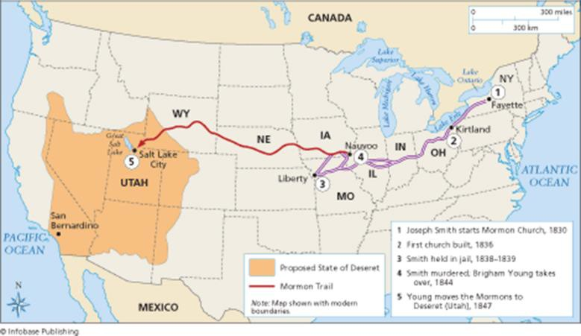
The following April 1847 an advance party of 150 people and 70 wagons set out for Salt Lake Valley. They chose a route that was away from the well-established Oregon Trail to avoid any conflict with other travellers. They constructed fords through rivers, set up ferries
across others and planted food crops along the way. They would even charge non-Mormons to use their river crossings Once over the South Pass the advance party followed the Donner Party route.
Eventually they reached the Salt Lake Valley in July 1847. As Brigham Young arrived in the Salt Lake Valley, another party of 1500 Mormons set off with a clear route to follow thanks to the advance party. Between 1847 and 1869, 70,000 Mormons followed the Mormon Trail to the Salt Lake Valley.

Task: Explain three reasons why the Mormon migration was successful
Reason 1
Reason 2
Reason 3

Meeting the challenges of Salt Lake Valley

Salt Lake Valley was a harsh landscape: the lake was salty and the land around it was too poor to grow crops on however they were able to make success of it. The Mormons were successful because they worked together to one central plan, under the strict control of Church leaders. The Mormons believed Brigham Young was God’s prophet therefore they obeyed him completely and followed a distinct plan he laid out like when it came to the migration.
Reasons they were successful
- The Mormons built irrigation systems to water the crops. This needed large numbers of people and the Young ensured this happened.
- New settlements were planned to produce particular products the Mormons needed such as food crops, minerals or timber.
- Young sent out a mix of people with the skills each settlement needed eg carpenter, blacksmith, miller etc.
- New settlements were set up in areas with more reliable water supplies
- Products (such as vegetables, flour, timber and metals) from these settlements were brought back to Salt Lake City which was founded by Brigham Young.
The Mormons had built a new life out of the United States but after the Mexican-American War they found
themselves under American control. Young wanted to found a new Mormon only State called ‘Deseret’ but he was refused. Instead a new smaller state called Utah was created and while he was made its governor some of the officials were Gentiles. They had hoped that they could live there in peace.

The Gold Rush 1849

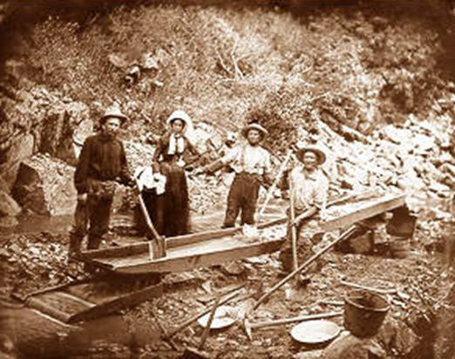
In April 1849, 100,000 people left the East to travel to California. This huge increase was because gold had been discovered in the Sierra Nevada in California the year before. Thousands travelled along the Oregon Trail, thousands more travelled from all over the world, by land and sea, in the hope of finding gold. A famine in China led to 20,000 Chinese people migrating to California in 1852. By 1855, California’s population reached 300,000.
Although a few did become very rich, most men were unsuccessful and either went back home or settled in California. Many of those who stayed became farmers and created an agricultural boom in that area. Professional miners with the equipment and expertise to mine underground took over through the 1850s.

California’s population boomed and its economy grew rapidly. The prospectors needed equipment, food, drink and entertainment, which attracted more people to the West to become shopkeepers, bartenders and traders. This was exactly what the US government had hoped for. There were now plenty of US citizens living in California, which made it much less likely that another country would try to take it from them. It also made people believe that Manifest Destiny was beginning to come true. California’s gold and successful economy was also helping the USA recover from its economic crisis. Money from the Gold Rush helped pay for the First Transcontinental Railroad in 1869. However, not all the consequences were positive. The rapid growth of mining towns led to problems of law and order including racial tension between the white miners and the Chinese immigrants. The new migrants also murdered and enslaved California Indians to get them out of their way.

Task: Explain the importance of the Gold Rush for the settlement for the West using the words below.
Important | 1849 | Boom | 300,000 | Fortune | Meant | Because | Lawless | Chinese
Task: Explain one consequence of the Gold Rush using the words below.
Consequence | 1849 | Boom | 300,000 | Fortune | Meant | Because | Lawless | Chinese

Living and Farming on the Great Plains

There was a massive growth in settlement in California and Oregon. When migrants reached their destinations in the West, many of them set up farms. They became settlers as they came to settle on their own land.
In California and Oregon – Farming land was good – California in particular had a mild climate and fertile soil and it was excellent for growing spring wheat. By 1850’s, farmers in California were making so much wheat that they sold grain to Europe. Farming meant there was a lot of money to be made. Farms could now afford steam powered farm machinery and large workforces.
Early settlement on the Plains

By the 1850’s, settlement had begun on the Great Plains. The was promoted by the US government. In 1854, the government created new territories, Kansas and Nebraska. It had not yet been decided whether the new states would be a slave state or a free state. It was left to the people of Kansas and Nebraska to decide whether their state would be slave or free and Nebraska voted overwhelmingly to be a free state.
In Kansas those who were pro-slavery and those who were against (free-soilers) encouraged likeminded people to move to Kansas so they could win the vote. By 1856 two illegal governments had formed and their supporters prepared for war. In 1856 the free-soiler town of Lawrence was sacked then in response, the pro-slavery town of Pottawatomie was attacked. Several died. In the ensuing months, violence broke out across Kansas. Property was destroyed and 200 people were killed. In 1858 the US Government stepped in and declared Kansas a free state.
As well as the political violence, settlers faced hostility from Plains Indians and rival settlers. Settlers had three months to claim a piece of land before the government surveyed the land. Many settlers were bullied and intimidated into giving up their claim, often at the point of a gun by Claim Jumpers. For those that did manage to safely claim land they still had a major problem to deal with which was that THEY WERE NOT SURE WHICH CROPS TO GROW OR HOW TO PREPAPRE THE LAND.
The main problems of farming on the Great Plains?

- Low rainfall – Half the rainfall in the West compared to the East and there was very few streams.
WHY WAS THIS A PROBLEM? Too dry for crops, not enough water for animals, frequent droughts, no way of transporting on rivers.
- Few trees – Too dry for trees away from rivers
WHY WAS THIS A PROBLEM? No timber for building homes, no timber for making fences, no wood to cook and heat.
- Climate extremes – Very hot summers, extremely cold winters, hailstorms, thunderstorms.
WHY WAS THIS A PROBLEMS? Crops shrivelled in summer, very difficult to live in the summer, destruction of crops due to weather issues. Meant that settlers built their houses out of ‘sods’ of earth. Sod houses were warm and fire-proof however they were always dirty and heavy rain would turn them into mud.
OTHER PROBLEMS FOR FARMERS:
- Life on Plains was very lonely and settlers would be miles away from other settlers.
- Soil made it very difficult to plough.
- Wells were incredibly expensive to dig; some water was 300 feet down.
- Some crops that grew well in the East did not grow in the West because of the climate.
- Prairie fires after a long, hot, dry summer.
- Grasshopper outbreaks.

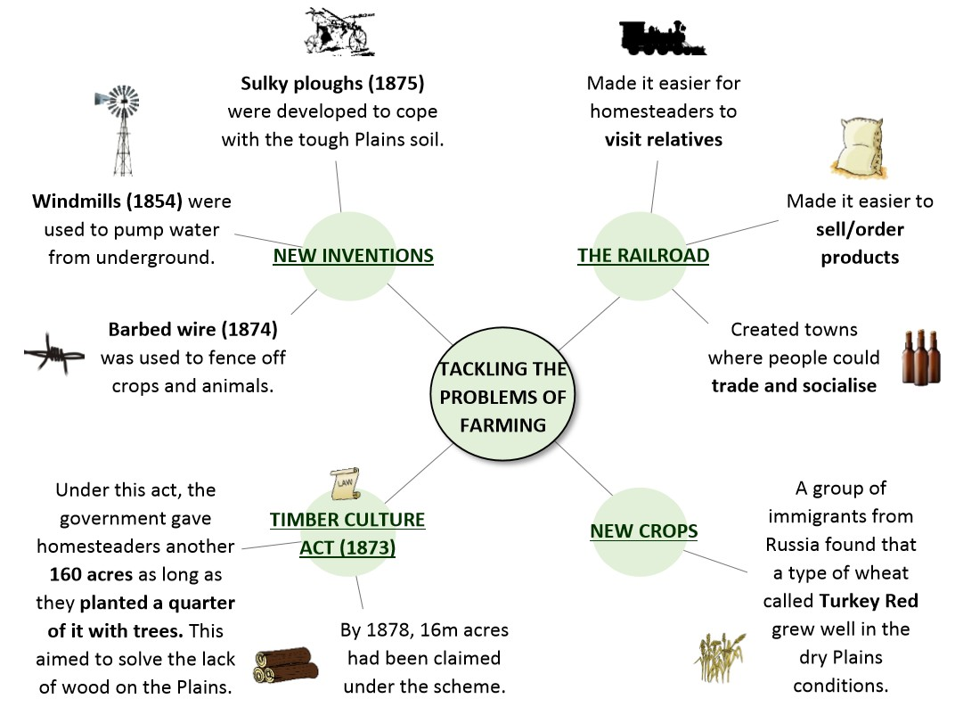

Task: Explain two problems faced by the early settlers and how they were solved.
Problem 1
Problem 2
Task: Complete the paragraph below
The first white settlers faced a number of problems when farming the Plains, but as more people moved there they began to find solutions. Settlers overcame the lack of water by using
, which pumped water from deep underground, and by growing a type of wheat called which grew well in dry conditions. To farm the tough Plains soil, they used a new invention called a plough. Another important invention was
wire in 1874, which allowed farmers to fence off their land, crops and animals. The lack of trees on the Plains was solved by the Culture Act of 1873, which encouraged farmers to plant trees on their land. Finally, farmers were able travel and trade much more easily thanks to the first , which opened in 1869.

The Mormon War 1857-58

The Mormon War, saw the outbreak of violence between the Mormons and settlers which lasted from March 1857 to July 1858. Tensions between followers of the Latter-Day Saint movement (Mormons) and Protestant Americans had simmered for two decades. By 1857 relations between Mormons and settlers soured because:
- Mormons charged high prices for supplies
- Mormons converting Indians caused fear
- Concern over the Mormon practise of polygamy
- Concern that Utah was a theocracy (area ruled by government in the name of God)
In 1857 a non-Mormon governor was sent to Utah with 2,500 troops and in response Brigham Young mobilised a Mormon militia. In September 1857 a wagon train of families bound for California was attacked by a Mormon militia. The leader of the militia decided to kill everyone so there were no witnesses in what was known as the Mountain Meadow Massacre. Everyone was killed except for 17 children under the age of 7. They were adopted into Mormon families. As part of their cover-up the Mormons blamed the Indians but this was not believed. In 1877 John Lee was convicted and executed for the Mountain Meadow Massacre.
In April 1858 a settlement was agreed:
- Mormons were pardoned
- Non-Mormon governor installed in Utah
- US army entered Utah peacefully
This began the decline in Utah’s isolation from the other US states.
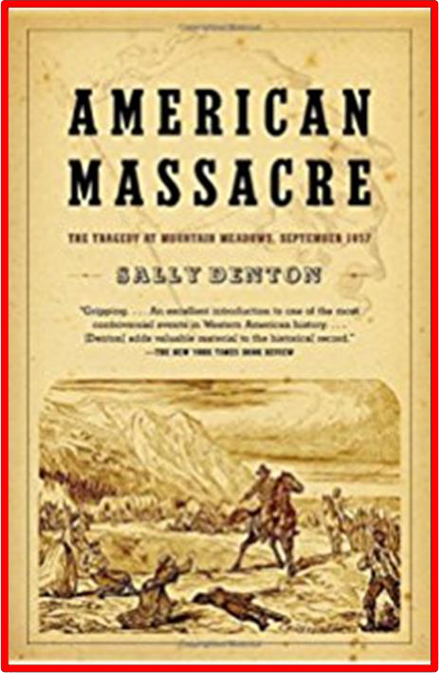
Task: Design the front page of a newspaper about the Mountain Meadow Massacre.
Could you introduce bias? How would the Mormons and the US have reported it differently?

The American Civil War 1861-65 and its impact on the Great Plains

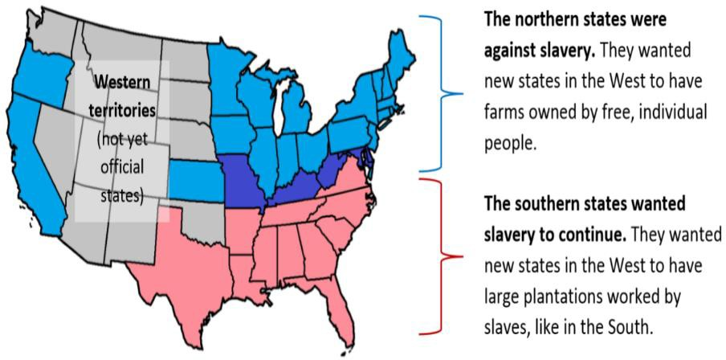
The American Civil War broke out mostly over the issue of slavery. The northern states wanted to limit the spread of slavery while the southern states saw it as an integral part of their economy. When Abraham Lincoln became the 16th President of America in 1861 the Southern states saw Lincoln as very anti-slavery.
This was the last straw in the continued hostility between the northern and the southern states. After the southern states broke away, the North could decide what
to do with the West. In 1862 they passed two important laws (the Homestead Act and Pacific Railroad Act) that the South had previously blocked. Ultimately the North won the war but the south was devastated by fighting and many people there moved to the West for a new life. The country had been divided for four years and thus it began a period known as ‘Reconstruction’. Some soldiers remained in the army following the end of the war and when war broke out with the Indians these were the men who fought. The end of the war also encouraged more people to migrate West and this was further encouraged by government acts. The End of the war also meant more money was available to spend building the railroads that had a great impact on the West.
Homestead Act 1862

One of the laws passed by the North in 1862 was the Homestead Act. This encouraged families to settle in the West by giving them cheap 160-acre plots of land (called a homestead) to farm. This was the government’s way of encouraging the settlement of the Great Plains.
It cost just $10 to register for a plot, so it was easily affordable. Homesteaders had to live on and work the land
themselves. The government didn’t want rich businessmen buying homesteads just to sell on for profit. Anyone over 21 or with a family could register for a homestead (but not American Indians). Once someone had had their homestead for 5 years, they could pay $30 to own it outright.
Results of the Homestead Act:
- By 1876, over 6 million acres of land in the West had become homesteads.
- It encouraged immigration from Europe.
- It increased the population in the West, so that some territories were able to become proper states. However,
- Many homesteaders failed to make a living as farmers on the tough Plains. 60% of homesteads were not there after 5 years.
- Some people abused the system to buy multiple homesteads, then sell them on for profit.
- Only 16% of public land in the West were homesteaded. The government gave much more land to rich railroad companies or cattle ranchers.
Southern Homestead Act July 21st 1866
- This extended the Homestead act to land in the South West
- Freed slaves and whites who had not supported the confederacy were entitled to free land in the West
- It failed because it was poorly advertised and wannabe settlers suffered prejudice, poor quality land and poverty. It was repealed in 1876

Task: Explain one way in which the American Civil War was important for the settlement for the West.

The Transcontinental Railroad

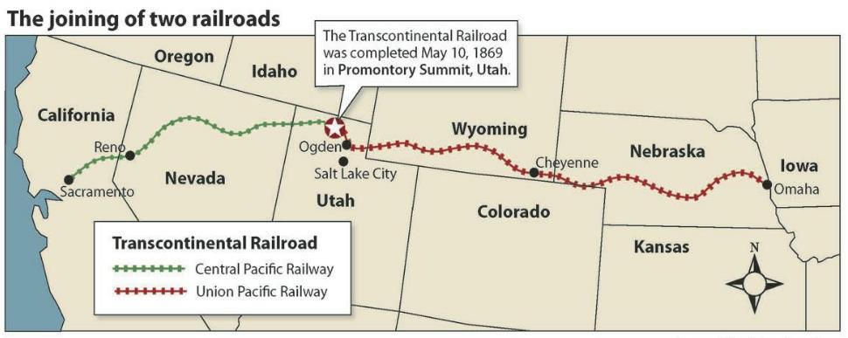
As the American Civil War took away government restraints from the southern states, they made it a priority to pass acts that would lead to the creation of a railroad that would connect the West with the northern states. In 1862 the Pacific Railroad Act was passed. This provided government support for the building of a railroad connecting the West with the northern states.

Building a 2000km railway across the West was too difficult and expensive for any company to take on itself, so the government took action to support its creation. They loaned each company $16,000 for every mile of track they built ($48,000 for mountain areas). They split the job between two companies, the Union Pacific Railway and the Central Pacific Railway and gave each company lots of land along the railway, which they could sell on for profit.
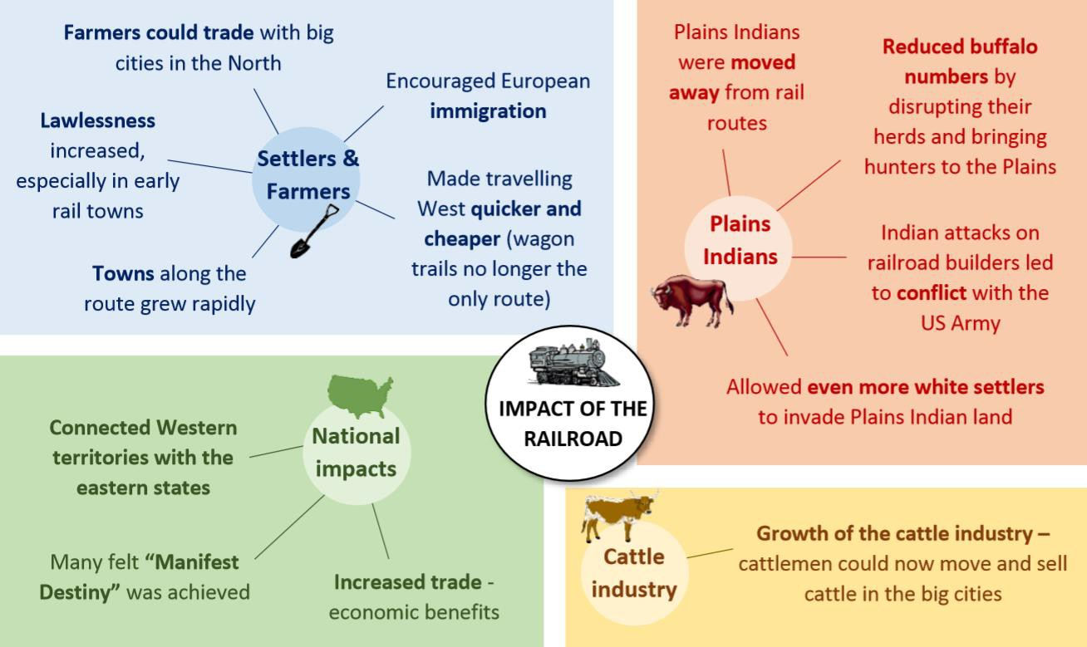
The railroad started in California in the West and went to Nebraska in the East. This connected the West to big cities in the North. The two railroad companies started from opposite ends and met in Utah in May 1869.
The impact of the Railroad on the West was huge and continued to be felt throughout the rest of the century.

Reason 1

Cattle Drives and the Rise of the Cattle Industry
Task: Explain the importance of the Transcontinental Railroad Act for the settlement of the West.
Reason 2

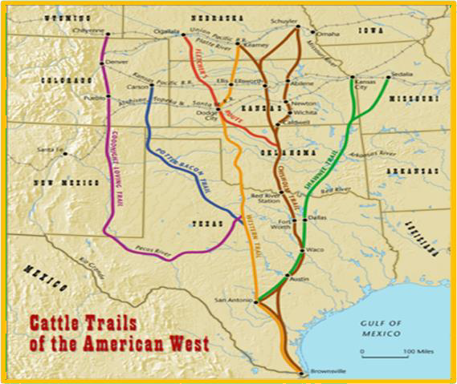
1850s: Cattle Trails
Beginning in the 1850s, a new industry developed in the West: the cattle industry.
The American cattle industry began in Texas in the 1850s. Cattle were bred in Texas then herded by cowboys to cities to be sold. This journey was known as the long drive. The long drives followed routes called cattle trails and took around 2 or 3 months.
Some farmers in Missouri blocked the cattle trails because they were afraid of Texan cattle passing a disease called Texas fever on to their own animals.
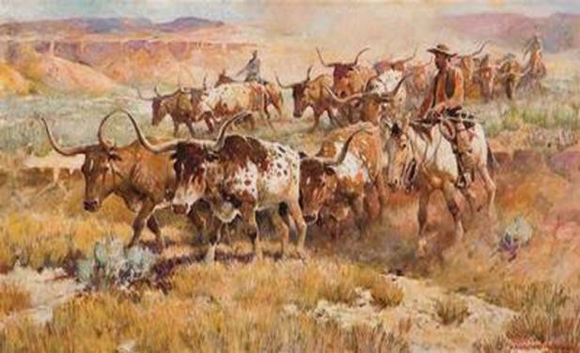
1861-65: The American Civil War

During the Civil War, the cowboys went to fight and the cattle were left unmanaged. As a result, they went half-wild and their numbers boomed and by 1865 there were approximately 5,000,000 in the southern states. Because there were so many cattle in the South, the price of beef dropped to $5 a cow.
Cowboys therefore looked to sell their cattle in the North, where they could get $40 a cow.

Task: Explain the significance of each of the following for the growth of the cattle industry
1866: The Goodnight-Loving Trail
- Charles Goodnight and Oliver Loving realised there was another market for Texan cattle: new settlements in West.
- The first trail, in 1866, was to Fort Sumner where the government had failed to get enough supplies for Navajo Indian reservations. 800 cattle sold for
$12,000 which was four times the price of cattle in Texas. In
- 1868, Goodnight’s trail extended up to Colorado (booming mining town) and Wyoming, to the Union Pacific Railroad.
- Goodnight’s success meant other cattlemen started to drive cattle to Wyoming, and Wyoming’s cattle
ranches began to grow.
1867: Joseph McCoy and Abilene
- A businessman called Joseph McCoy was the first to see the potential of a town called Abilene, Kansas and its connection to the railway line.
- He developed it into a cow town by building stockyards for cattle and hotels that cowboys stayed in when they had finished driving the cattle there.
- He built a new railroad spurs that allowed cattle to be loaded onto railroad trucks.
- He also extended the Chisholm Trail up to Abilene agreeing passage through Indian territory.
- He also spent thousands on advertising that helped bring 3 million cattle there between 1867-72.
1870: John Iliff & The Open Range
- John Illif realised that it would be cheaper to raise cattle on the Plains rather than drive them up to the railways.
- Iliff bought lots of Plains land in Colorado and raised a herd of 26,000 cattle there. This was the beginning of open range ranching, where cattle roamed freely on the Plains.
- Illif became Denver’s first millionaire by selling beef to miners, Indian reservations and railroad worker gangs. Other Cattle barons followed suit and the industry began a peak period called
the “beef bonanza”.

Cowboys, the Open Range to the Closed Range

STAGE 1: Life on the ‘Long Drive’
During the first stage of the cattle industry, the cowboy’s job was to drive (herd) cattle up from Texas. These cattle drives could take several months. They worked in groups called an outfit. Each outfit had about 12 cowboys, plus a cook and someone to look after the horses. Their lives were adventurous and exciting. On the long drive they faced dangers like stampedes, outlaw gangs and Indian attacks.

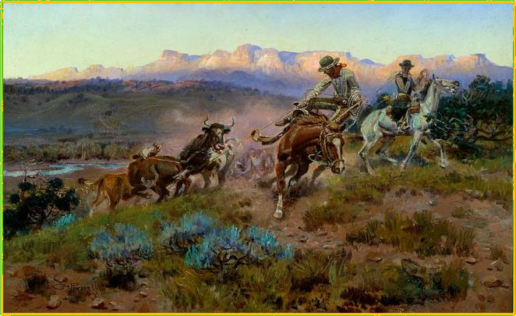

STAGE 2: Life on the Open Range

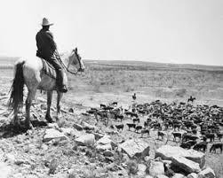
STAGE 3: The End of Open Range Cattle Ranching
Once open range ranching began, the long drives were no longer needed. The cowboys’ lives became much less exciting than before. The main job of the cowboy was now to round up the cattle each spring and then brand them ready to be sold. In the quiet winter months, they often got other jobs, such as barmen. They lived together in bunkhouses, which could be cold and lonely in the winter. Ranches often had strict rules such as no gambling.

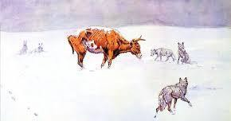
The cattle industry had been doing very well throughout the 1870s. Many cattle barons had become very rich by investing lots of money into massive open range ranches. However, two factors caused open range ranching to end in the 1880s:
- Open range ranching was a victim of its own success. Because there were so many cattle the Plains became overstocked, and the grass that the cows fed on ran out. Also, the price of beef fell because there was so much of it available.
- A bad winter killed off many of the open range cattle. During
the “Great Die-Up” of 1886-87, it got as cold as -55°. 15% of the cattle on the Plains died, and many cattle barons went bust.

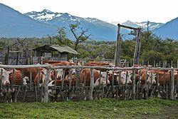
STAGE 4: The Closed Range
After 1887, ranchers kept small ranches where the cattle were fenced in, rather than massive open range ranches. This was because smaller herds of cattle were easier to look after (especially during droughts and winters). Having fewer cattle also pushed their price back up. The life of the cowboy on these small ranches was much less exciting than before. They were basically farmhands who looked after the animals, mended barbed wire fences and patrolled the boundary of the ranch (called “riding the line”).

Task: Plan a narrative account analysing the key changes in the cattle industry in the years 1875-87.
Beginning
Middle
End

Exoduster Movement and the Oklahoma Land Rush

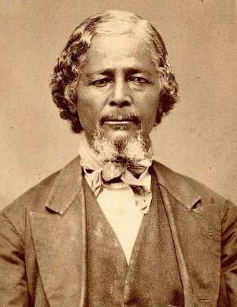
Settlement of the West continued even into the latter half of the century. The Exoduster Movement and the Oklahoma Land Rush are examples of this.
The Exoduster Movement (1879)
After the Civil War, many black people moved West to escape racism in the South. In 1879, 40,000 black people nicknamed the Exodusters migrated to Kansas. They were encouraged by a former slave called Benjamin Singleton, who had settled there himself in 1873. Kansas had a reputation as a fair, free state which would treat black people fairly.
Consequences of the Exoduster movement
  - Thousands of black people settled in Kansas and helped to create new settlements.
  - Exodusters were better off than they had been in the South, but they were still poorer than white settlers. They had the poorest bits of land.
  - The Kansas government gave some money and support to help the Exodusters get started, but this annoyed many white settlers.
  - The movement ended after people in the South heard that the reality in Kansas wasn’t as great as they had
hoped.

The Oklahoma Land Rush (1889-95)

In 1887, the Dawes Act broke up the Indian reservations and put each Indian family on a small 160-acre plot, like a homestead. Any former Indian land that was left over was then given to white people. Indian Territory in Oklahoma was opened up to white settlers in 1889. Land rushes worked like a race - thousands of hopeful settlers lined up, then when the signal was given, they all rushed over the line to claim a section of land as theirs. There were 7 land rushes in Oklahoma from 1889 to 1895. The largest was in 1893, when 8 million acres were opened up.

Task: Read the information and highlight the consequences of the Johnson County War
The Johnson County War, 1892

When ranchers and farmers clashed on the Plains, their arguments often developed into longrunning feuds called range wars. The most famous was the Johnson County War in Wyoming. Johnson County is in Wyoming, it was avoided by settlers until the 1870’s as the local Indians were very hostile. However, it had been settled by cattle ranchers in the 1870s.These cattle barons ran large-scale ranches and they became very powerful and formed together the Wyoming Stock Growers Association (WSGA). This association had 100 members. It met in Cheyenne and had among its members the governor of Wyoming and several state senators. Its purpose was to protect the interests of its members. By the 1880s these interests were being threatened in 3 ways.

- As you have previously studied cattle ranching was experiencing problems in the 1880s – low beef process, drought, harsh winter 1886-7.
- There were a growing number of homesteaders and small ranchers settling in Wyoming and this led to disputes over land ownership. The cattle barons resented these newcomers.
- There was an increasing problem of cattle rustling. The cattle barons lost cattle to rustlers and blamed it on the homesteaders and small ranchers (rustling had always been seen as a way of starting your own herd). It was hard to get juries of local men to convict men accuse of rustling and so the barons took the law into their own hands. They hired Frank Canton, a gunslinger, to hunt down rustlers.

The first killings took place in 1889 when Jim Averill, a store and saloon owner, and his partner, Ella Watson, a prostitute were lynched. They had been living on land claimed by one of the cattle barons, Averill had annoyed them by writing in a local paper that the barons were land grabbers. No one was ever prosecuted for the crime although it was known that the cattle barons were responsible. The barons claimed that the pair were rustlers. Other killings followed leaving three of the small ranchers dead.

In 1892 the barons planned an invasion of Johnson County led by Major Frank Wolcott. The acting governor of Wyoming knew about it and even supplied guns! Twenty-four gunslingers were recruited and a death list of 70 names drawn up. They were brought to Wyoming on a special train provided by the Union Pacific Railway Company. Their plan was to capture the town of Buffalo, kill the sheriff, “Red” Angus, and then kill the rest of the men on the list. The invasion force numbered 50 and there were even reporters with them.

The invaders began by cutting off the telegraph wires to Johnson County but then their plan went wrong. They stopped to attack the KC Ranch where they were heroically held back by Nate Champion and Nick Ray, by which time the alarm had been raised in Buffalo. Next day as they approached Buffalo, they heard the locals were armed and ready and so retreated to the TA Ranch, where they were besieged by 300 men until the US Cavalry had to save them.

The defeated barons were brought to trial but never convicted. However, they were widely condemned and never had the same power in Wyoming again. The homesteaders and small ranchers were able to continue their lives in peace. The Johnson County War is significant because it shows the power of vigilante justice (when people take the law into their own hands) in the West.

The Plains Indians, 1835-1895
Plains Indians Society

Plains Indians lived in groups called tribes. Large tribes were known as nations. Tribes were made up of different bands, which ranged in size from 20 to several hundred people.

Chiefs and Councils: Chiefs were the leaders in Plains Indian society. A tribe could have several leaders. They were chosen for their wisdom or skill and were replaced when these skills faded. Each band had a band chief. Band chiefs and elders made up the tribe’s council. Importance decisions made here. All people’s advice listened to in the council with respect. Normally they would talk until everyone agreed with actions. Sometimes councils made up of all men of the band, other times just important men. Some bands made their own decisions. They did not necessarily all follow the same chief. Famous chiefs include Sitting Bull and Red Cloud. They were famous as their bands followed them. A lot of bands did not follow their chiefs

Warrior Brotherhoods: Each tribe had brotherhoods made up of brave and skilled young men, who protected the tribe. The brotherhoods didn’t always follow the orders of the council, and so would sometimes ignore peace treaties that had been agreed. Guard units organised the yearly buffalo hunt and chose where the tribe made camp.
Evidence | Explain why it would be important to society
They helped organised buffalo hunts. They would ensure that old and ill tribe members
were fed and chosen where the tribe should gather to make camp.
Trained young men in fighting skills.
Trained young men in the beliefs and values of the Plains Indians.
They would be chosen due to their bravery and skills in fighting with other tribes.
They worked alongside the chief and councils, they would meet and discuss certain matters, including whether to go to
war or to discuss peace treaties.

Women: Women could not be chiefs and a man could have more than one wife- known as polygamy. Women were responsible for feeding and clothing their families; and for the family’s possessions, including the tipi which belonged to the women. Women were responsible for processing buffalo hides and meat, turning them into products that could be traded.

Children: They were highly valued by the tribe as they were the future of the band. They did not go to school so therefore could not read or write but they learned skills from family and other tribe members. They were taught to ride horses at an early age. Boys were taught how to hunt whereas girls were taught all the domestic skills needed for running a household. Children were rarely punished by their parents. Children tended to behave as it was seen as shameful to disrespect their elders. In extreme cases of misbehaviour, cold water was thrown on the children.

Elderly: The Indians had a strong tradition of respect and they respected the advice of their elders. The elderly acted as a link to the past and they preserved the history of the tribe by passing down stories and songs. They attended council meetings and also helped the women raise the children. When the elderly were ready to die they would be left behind by the Indian tribe. This was called exposure. The person was left to die in the open. The rationale behind this was the elderly person had become a burden to the tribe who had to move from place to place to hunt buffalo for survival

Nature: Everything in natures had a spirit. These spirits would sometimes help humans. Humans were a part of nature and should work with the spirits of nature rather than trying to tame nature to obey them. They could contact the spirit world through ‘vision quests’, guided by spirit animals, like hawks or foxes. They danced special ritual dances, like the sun dance, to enter the spirit world. Possible They believed it was possible to work with spirits to charge up magic items which they would then wear to bring them luck or protection.

Land: Land was sacred, the ‘mother’ of the plains. Some lands were especially such as the Black Hills of South Dakota. The Lakota believed their people had been created in a special hill in these caves by the Great Spirit. Some Plains Indian tribes farmed the land as well as living by hunting, fishing and gathering wild plant resources. In these cases, a farming plot did belong to an individual family. Over most of the Plains, the land was very difficult to farm and no one person owned the land as property. All plains Indian tribes did have hunting areas that they used together. Sometimes treaties were agreed between tribes to share these hunting areas. When food resources were scarce, conflicts occurred as tribes pushed into hunting areas that were traditionally used by others. Farming or mining were seen by some Plains Indians as disrespectful to the land. These activities in sacred places would be especially likely to disrupt the sacred link between the tribe and the spirits.

War: Survival on the Plains was so difficult that it is not surprising that Plains Indian tribes raided each other for food, horses, weapons and people (women to marry and children to bring up in their tribe). Young men were valuable to the tribe as hunters and protectors, no tribe could afford to lose many warriors in fights. A raid would only go ahead if it looked as if it would work and the raiders would escape as quickly as they could if there was too much opposition (unlike white American soldiers who were trained not to runaway). Only selected
brotherhoods would go on a raid. This reduced the tribe’s losses if the raid failed. ‘Coup’ means success. ‘Counting coup’ was a special type of fighting in which a warrior would attempt to hit or touch (rather than kill) an enemy and get away without being injured. Success gained the warrior a lot of respect from the tribe.
Task: Explain why it was important for Plains Indians to minimise the numbers of warriors killed in conflicts.
Task: Explain how the Plains Indians beliefs impacted how they survived on the Great Plains.

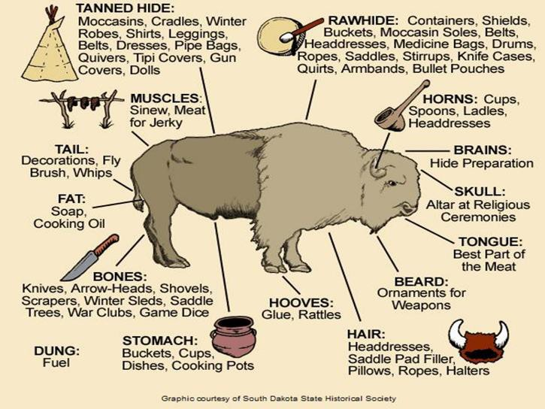
The Importance of the Buffalo and the Horse for the Plains Indians Buffalo
The tribes who lived on the plains relied on the wild buffalo
herds for survival. The Buffalo was the Indians main food source and gave them lots of resources. Two or three successful hunts a year could feed and shelter the band. This meant they had to be nomadic. Plains Indians followed the buffalo wherever they went.
Before setting off on the hunt, Plains Indians held a ceremonial Buffalo Dance that could last for several days. The point of the dance was to call on the Spirit World for help in their hunting, to bring them luck. With horses,
Plains Indians could hunt more effectively. The hunt was carefully organised, so as not to scare the buffalo before all was ready, and to ensure that not too many buffalo were killed. The warriors would surround or stampede the buffalo and shoot them with arrows. Once the buffalo was dead, it was butchered by the women and children.
Some of the body parts, such as the liver and kidneys were immediately eaten raw as delicacies. Other parts were boiled or roasted. The rest was cut into strips to be dried or smoked in the sun. The dried meat kept for a long time. Hides were pegged out to dry, scraped to remove flesh, and this was called rawhide. Some hides were tanned with the buffalo brains, and worked to make soft. They were then made into clothing or tipi covers.
Horses

Horses were not native to North America but were brought by Spanish settlers. They were very important for the Plains Indians as they enabled them to live in the plains and be nomadic. Horses were used to carry belongings from place to place but more importantly they allowed them to hunt the buffalo more efficiently. As a result of their importance they became a symbol of a tribes wealth and status. Horses were also used in war and were often the target for raids by other tribes.
Tipis
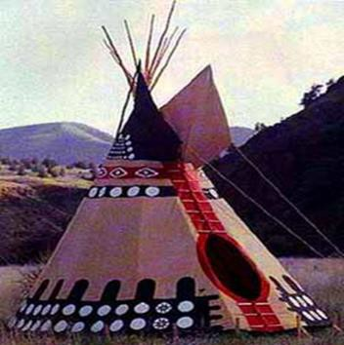
Indians lived in tipis which could be taken down and packed up for transport in 10 minutes. This was important for them to continue their nomadic lifestyle. Each tipi was made from 10-20 buffalo skins. They were a circular in design and there were 2 flaps at the top of the tipi that could be moved to direct wind so that the smoke from the fire inside could escape. In summer the bottom flaps opened to let air in and in winter the sides could be banked with earth to keep it warm. The tipi’s conical shape made it strong enough to resist the strong winds on the Plains. They were often decorated by men to show scenes of their bravery in hunts and battle.

Task: Fill in the missing words.
Spirit | White | Tipis | Nomadic | Careful | Horses | Buffalo | Indians
Around two hundred years ago, America was very different to today. The eastern third had been settled by
people, but the other two thirds - the ‘American West’ - was mostly empty desert. The only people who lived there were Native Americans, also known as the Plains .
The Plains are very large and dry, and the Indians’ survival depended heavily on one animal: the
. The Indians had a huge respect for animals and nature because they believed everything in nature had a . As a result, they were very with what they used and found a purpose for almost every part of the animals they hunted.
The Indians did not believe in owning land. Instead they lived a lifestyle, meaning they
moved from place to place. They used to travel and lived in structures called .

Government Policy Towards the Plains Indians
White Americans recognised that the Plains Indians had some rights to the land, because they had been on it for such a long time. However, they also felt that the Indians didn’t make the most of their land, and therefore white people should have it for farming and mining. The US government took two approaches. To start with, they tried to keep Indians and white people apart; later, they tried to encourage the Indians to live more like white people.

Approach 1: Keep Whites and Indians apart

  - Indian Removal Act (1830): This forced any Indians still in the east to move west of the Mississippi. President Jackson promised that this land in the West would be theirs forever.

  - Indian Trade and Intercourse Act (1830): This said that the West was officially ‘Indian Territory, and created a border called the Permanent Indian Frontier to separate it from the white eastern states. The border was guarded by US Army forts.

Why did the government change its approach?
In the 1840s, things changed. America gained new territories in the West, and this created an awkward problem: it meant that Indian Territory was now right in the middle of the USA, and white Americans would have to cross it in order to reach the new areas in the West.

The US government wanted its people to settle in the new US territories, so their attitude to the Plains Indians changed. Despite their previous promises, the government now allowed white people to cross the Frontier and travel across Indian Territory. It therefore no longer made sense to try to keep the Indians and whites apart.
Instead, the government took a new approach: to make the Indians live more like white Americans.

Approach 2: Encourage the Indians to be more like White Americans
  - Indian Appropriations Act (1851): This provided money to move Indians onto reservations. Reservations were small areas of land for each tribe to live on. By making Indians live in fixed boundaries, the government hoped to stop their nomadic lifestyle and force them to live and farm like white people.

Tension Between Settlers and Indians

Another problem for white settlers was conflict with the Plains Indians. The two groups were very different and this caused tension:

  - Indians disliked white settlers because they threatened their way of life. Migrants scared the buffalo herds and used up valuable resources (like grass) on the Plains.
  - White settlers disliked Indians because they seemed strange and threatening. Migrants sometimes got caught up in Indian tribal conflicts, and Indians would steal their animals. White people thought the Indian way of life was odd and backward.

Task: Explain a consequence of the Indian Appropriations Act of 1851 using the words below.
Consequence | Reservations | Nomadic | Hunt | Buffalo | Because | Dependence | Indians

The Fort Laramie Treaty 1851
Consequence 2

In 1851, the government tried to solve the tension between white settlers and Plains Indians by organising a treaty. Their aim was to protect white settlers by stopping fighting between Indian tribes, and to get the Indians to stay in fixed areas.

The Fort Laramie Treaty (17th September 1851)
The Indians would: | The US Government would:
End the fighting between the tribes. | Protect Indians from white Americans (including whites trying to settle on Indian land).
Allow migrants to travel through their land in safety.
Permit surveyors from railroad companies to enter their lands in
safety.
Allow the government to build roads through their lands and  construct army posts. | Pay the tribes an annuity (yearly payment) of $50,000 as long as the Treaty terms were kept to.
Pay compensation if any individuals from their tribe broke the
Treaty terms (e.g. by attacking white migrants).
PROBLEMS WITH THE TREATY
  - The government chose one chief from each tribe to sign the treaty – but Indian society didn’t work like
this. One chief did not always represent the whole tribe.
  - The treaty agreed on fixed boundaries for each tribe – but the Indians didn’t believe in owning land. Their
whole way of life was based on moving around and hunting buffalo.
  - The treaty was written in English – but it wasn’t translated for all tribes. This meant that many Indians didn’t even understand what they had signed.
WHY WAS THE TREATY IMPORTANT?
  - It threatened the Indian way of life and brought in the idea of reservations, because it forced Indians to stick to fixed boundaries.
  - It led to more white settlement on the Plains, because it gave white migrants permission to cross into Indian Territory.
  - It made the Indians dependent on the government, because the tribes now relied on government money and food supplies.
Task: Explain two consequences of the Fort Laramie Treaty, 1851.
Consequence 1

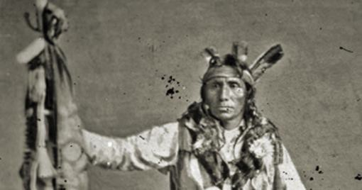
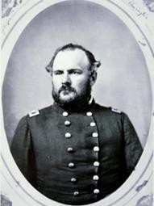
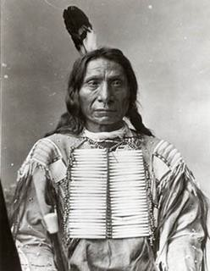
Indian Wars & the Impact of US Policy
Task: For each war identify the causes and consequences of each conflict. Use a highlighter and the key below.
Causes | Consequences
Little Crow’s War - 1862
Little Crow was the leader of around 12,000 Santee Sioux who were moved onto a reservation, promised $1.4 million and an annuity of
$80,000 for 24 million acres of land. However, until the tribe paid debts owed to traders of $200,000 the government sent them no money. In 1858 they had to give away half the reservation to pay these debts. Due to pests devastating their crops, agents charging extortionate amounts
for food and a delay in the payments, by August 1862 the tribe were starving. At first Little Crow tried to restrain his people but young warriors (called Dog Soldiers) believed they needed to take their land back to feed the people. So, they attacked government warehouses, taking food and burning the buildings, killing over 700 settlers, agency workers and the soldiers sent to deal with them. But the victory was only temporary. By October the war was over. White settlers wanted the Sioux punished – 400 were put on trial, they were sentenced to death with no evidence of their guilt. Only 38 were executed after Lincoln intervened. The 2000 Sioux left were punished by being moved to a smaller, barren reservation with no clean water. Nearly 400 died in the first winter. Chief Sitting Bull visited during this time of hardship and the situation he found there
affected his attitude to the white settlers and authorities.
The Cheyenne Wars and Sand Creek Massacre – 1864-67
War on the Southern Plains was sparked by the discovery of gold at Pikes Peak in Colorado in 1859. The thousands of miners who travelled west demanded that the government do something about the Arapaho, Cheyenne and Kiowa. Under the Fort Laramie Treaty, the area had been set up as their hunting ground, white Americans were allowed to cross but not settle. The Indians saw the mining settlement as breaking the treaty and were worried about the impact on the buffalo. The government tried to negotiate by giving the tribes a smaller reservation without a hunting ground, expecting them to farm and live off government hand-outs. A Cheyenne chief Black Kettle signed the treaty but not all of the tribes accepted the
terms and fighting broke out. On 29 November 1864 a force of 1000 men led by Colonel John M. Chivington attacked a Cheyenne village at Sand Creek. Black Kettle was flying a white flag as he thought the peace was in effect, Chivington did not. The US soldiers killed over 150 men, women and children and mutilated their bodies. Some white Americans treated Chivington as a hero, but others called it ‘the foulest and most unjustifiable crime in the annals of America’. The other Plains Indians attacked settlements across Kansas in retaliation. The Medicine Lodge Treaty 1867 – the Arapaho, Cheyenne and Kiowa were given a choice to move onto a new reservation in Indian Territory (now Oklahoma) or be treated as hostile. Most chiefs signed and many moved.
Battle of Washita 1868 – Black Kettle and a group who did not agree to the treaty were defeated by the seventh Cavalry, led by George Custer. Violence carried on, with Indians attacking people who were killing the
buffalo, but ended when the army started using rifles with telescopic lenses.
Red Cloud’s War – 1866-68
The discovery of gold in 1862 Montana led to the Bozeman trail being set up, so that miners could reach the gold fields. Unfortunately, this new trail broke the 1851 Fort Laramie Treaty, as it crossed the Lakota Sioux hunting lands. Red Cloud, chief of the Lakota Sioux, attacked the wagon trains. The government tried to solve the problem by offering gifts and opening peace talks, but Red Cloud broke off the talks when he found out that the government had already ordered forts to be built on the trail. Red Cloud and other Sioux leaders, Sitting Bull and Crazy Horse adapted the soldiers’ tactics and
fought through the winter. They stopped people using the Bozeman Trail and laid siege to the forts, trapping and killing an army detachment led by a Captain William Fetterman (this became known as Fetterman’s Massacre). The Indians could not capture the forts but no soldiers or travellers could use the Bozeman trail. So eventually the US government had to negotiate a new settlement. The new 1868 Fort Laramie Treaty agreed to close the Bozeman trail (they had found another route anyway) and the Great Sioux reservation was created.
However Chief Sitting Bull and Crazy Horse did not sign the treaty, or live on the reservation.

Task: Plan a narrative account analysing the effects of the Indian wars 1862-68 on Indian independence.
Beginning | The Indian Wars began in 1862 with _________________. The cause of this was (summarise what you have highlighted above)  This led to the Sioux being punished by….therefore effecting their independence by….
Middle | Gold was discovered in ….. this led to the Cheyenne War and Sand Creek Massacre because (summarise what caused the dispute- using these terms mining settlement, Fort Laramie Treaty, buffalo).  Fighting broke out which led to …(link what happened at Sand Creek Massacre, Chivington and the massacre)  The consequences for Indian Independence was… (what did the Indians have to agree to? How did their way of life change?)
End | Additionally, gold was also found in _______which similarly to the Cheyenne War, broke the F_______ L_______ T __________.  Red Cloud decided to (give a brief description of what he attacked and why)  As a result of Red Cloud’s War a new treaty was signed called _______________________. This altered Indian independence because…..

What was the impact of US government policy towards the Plains Indians?

Reservations
This policy was not always successful as the land was often unsuitable, the Indians struggled to adapt their way of life and the Indian agents were corrupt.

Military Force
The US Government was not willing to enforce the Fort Laramie Treaty of 1851 when miners and settlers encroached on Indian territory. Instead, when conflict broke out, their policy was to force Indians onto reservations and kill any who resisted.

President Grant’s Peace Policy
- Continue to confine Indians to reservations where they would learn to become members of American society
- Corrupt and/or incompetent Indian agents were replaced by Christian clergymen
- Army officers were placed in charge of areas in which they would protect Indians and stop war parties

Indian Appropriations Act 1871
Indian tribes no longer treated as sovereign nations. Invalidated all previous treaties.

The Great Sioux War
In 1876 The US government sent railroad inspectors and surveyors under General Custer into the Black Hills; a land sacred to the Sioux. This broke the terms of the Fort Laramie Treaty signed 6 years earlier. When they were in the Black Hills, they found gold there and as a result the word spread and miners soon flooded the area. The US government could do nothing to prevent this and as a result this led to violence between the Sioux and the miners.

What did the US Government do?
- The government offered to buy the Black Hills for £6million or $40,000 a year for the mineral rights.
- The Sioux declined
- So, the government under the leadership of Ulysses Grant gave the Indians 60 days to return to their reservation or they would be considered hostile and would be attacked.
- Bad weather prevented the Indians from obeying.
- By the spring of 1876 more than 7,000 Indians, 2,000 of whom were warriors had put up 1,000 lodges on lands between the Powder river and the Rosebud river. They were ready for war…

In 1876 the US army was ordered to attack all Sioux who had not returned to their reservation. The campaign was led by General Philip Sheridan and involved dividing his forces into three and trapping the Indians between them.
Sheridan’s plan had two major weaknesses: the separate forces were hundreds of kilometres away from each other and couldn’t effectively communicate and they had no idea how many Indian warriors there were. Two of
Sheridan’s forces were quickly on the retreat from Crazy Horse and his men. Eventually they joined together and headed for the Little Bighorn River. Custer refused the offer of extra soldiers, disobeyed orders and marched his men to the Little Bighorn, arriving a day early. The Indians were surprised but Custer and his men were exhausted. Custer refused the offer of extra soldiers, disobeyed orders and marched his men to the Little Bighorn, arriving a day early. The Indians were surprised but Custer and his men were exhausted. Reno and Benteen were soon forced into retreat, surrounded by Indians and suffered many casualties. They ignored an order to support Custer. They claimed they were under constant attack and unable to do so. Custer’s last stand occurred when his men were surrounded by the forces of Crazy Horse. Custer’s men were totally outnumbered and massacred. There were no survivors. The Indians had the advantage of vastly superior numbers (about 2,000 Indians to 600 US soldiers). The American public reacted with horror when they heard what had happened at the Little Bighorn.
2,500 reinforcements were sent to hunt the Indians down. There were too many soldiers for the Indians to fight, they struggled to protect their women and children, they were running short of ammunition and equipment and they were exhausted. Eventually they began returning to the reservations. On 4th May 1877 Sitting Bull escaped to Canada and on 5th May 1877 Crazy Horse returned to the reservation and surrendered. The armed resistance of the Sioux was over.

Results: Battle of the Little Bighorn: 25-26 June 1876
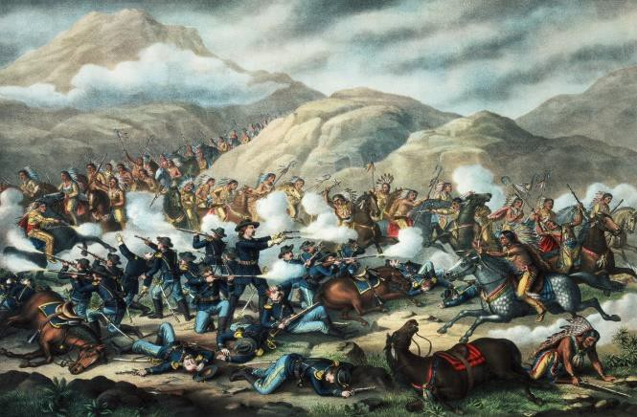
- Americans were shocked into action
  - News of the defeat reached the rest of America on 4th July, the hundredth anniversary of US independence. The public were shocked, The Indians lost much of their remaining public support and a campaign to reinvest in the army began.
  - Two new forts were built on the Yellow River and 2,500 reinforcements were sent west
- The Native Indians were defeated
  - They split up into bands after the battle and so were easier to round up and fight. They lacked supplies and couldn’t defend the women and children.
  - By May 5th 1877 Crazy Horse and his followers rode into the reservation and surrendered.
  - Sitting Bull had ridden over the border to Canada and has escaped.
  - They were moved to an even smaller reservation and placed under military rule
  - Their horses and weapons were taken away

Task: Explain The importance of the Battle of Little Bighorn for the end of Indian resistance using the words
below
Important | Crazy Horse | Custer | Reservations | Control | As a result | Resistance | Indians

End of the Plains Indians

Ever since white settlers began crossing the Plains in the 1830s, the Indian way of life had been under threat. As we have seen, the government had taken two approaches during this time. To start with, they had followed a policy of keeping Indians and whites separate. Then, as the Plains became more settled, they tried to move Indians out of the way by putting them on reservations. By the 1880s, the government was taking a third approach. Their policy was now to exterminate (get rid of) the Indian way of life and force the Indians to live like white people.

The extermination of the buffalo
The Indian way of life depended on the buffalo. The government knew that if it got rid of the buffalo, it would be impossible for the Indians to live in their traditional way. In the 1870s, hunting buffalo for its skin became very popular. Railroad companies even advertised special “hunting by rail” trips where trains took people onto the Plains to hunt buffalo. The government encouraged white people to hunt. From 1872 to 1874, 4.5 million buffalo from the southern herd were killed by hunters. By 1883, the northern herd had been exterminated completely.
With no buffalo to hunt, the Indians had no choice but to become farmers, like white people. However, they
didn’t have the skills or experience and many starved or died of disease. With the buffalo gone, it was much easier for white settlers to farm or ranch on the Plains.

Life on the reservations
In the 1880s, life on the reservations became even tougher. Social problems such as depression and alcoholism became common. The government made reservations smaller, making it harder for the Indians to hunt. The government set up special councils to rule tribes, making chiefs powerless. In 1885 they got rid of special Indian courts, meaning Indians had to live by US laws, not their own. Corrupt government agents often swayed decisions by bribing the Indian councils. Plains Indian children were sent to special military-style schools away from the reservations. They were brought up as Christians and taught to abandon their Indian way of life.

The Dawes Act – 1887
In the late 1880s, the government decided that reservations weren’t working, since they allowed Indians to still live in their traditional tribes. If they got rid of reservations, they could save money, free up more land for settlers and force the Indians to live like white Americans. As a result, in 1887 the government passed the Dawes Act:
- The reservations were broken up. Each Indian family was given a 160acre plot of land to live on and farm (like a homestead).
- Any leftover land from the former reservations was given to white settlers (the Oklahoma Land Rush).
The Dawes Act is significant because it destroyed the Indians’ way of life and brought more white settlers onto the Plains. Most Indians had no experience of farming, so their farms soon failed and they ended up selling their land to whites.

The Ghost Dance and Wounded Knee Massacre – 1890
By 1880s the Indians were desperate: they were stuck on reservations where they had very little food and were totally dependent on the government. In 1890, an Indian called Wovoka had a vision telling him that if the Indians danced a sacred dance called the Ghost Dance, the Great Spirit would bring all the dead Indians back to life and get rid of all the white settlers. The Ghost Dance quickly spread throughout the reservations. Misunderstanding it as some kind of rebellion, the government ordered the army to stop it.
At Wounded Knee Creek in South Dakota, the army opened fire on a group of Indians as they danced the Ghost Dance. Around 300 were killed, many of them women and children. The Wounded Knee Massacre is significant because the American public generally supported it. Most people saw it as revenge for the US defeat at Little Bighorn 14 years earlier.

The Closure of The Indian Frontier – 1890

In 1890, the government officially announced the end of the Permanent Indian Frontier. This meant that no part of America now belonged to the Indians – as far as the government was concerned, the entire country was now settled and civilised. “Manifest Destiny” was achieved.

Task: Plan a narrative account analysing the why the Indians way of wife was destroyed in the years 1872-90.
Beginning
Middle
End

Lawlessness in Western Towns

Lawlessness was a major problem in the west as more people travelled through, or settled there. This happened for many reasons:

The Code of the West
A basic code of honour dominated the West. In the absence of the forces of law and order it was an individual’s responsibility to settle things for himself and he had no duty to back down in a confrontation. Since most westerners carried guns, this meant that an argument could end in shooting. If you shot someone in self-defence then you had not broken the law, as long as the other person was armed too.

Geographical factors
The West was a vast area and, apart from railroads, transport was very slow. This made it difficult to enforce law and order, as it was difficult for law and order personnel to get the scene of a crime quickly.

Political factors
The new mining and cow towns which sprang up so quickly were particularly lawless in their early years. There was a shortage of reliable law enforcement officers and politicians did not think the issue was important enough to spend money on employing and training more or better officers.

Social factors
There were many potential sources of conflict between the different ethnic groups: African Americans, Chinese, Europeans, Plains Indians, Mexicans and settlers from the eastern USA. After the Civil War thousands of soldiers, Confederates and Unionists, were demobilised. There was ongoing conflict between veterans from either side who were unwilling to forgive and forget. At the end of the war, the Republican party was identified with the northern states and the Democratic Party with the southern states.

Economic factors
There were many potential sources of conflict between the different economic groups: between cowboys and townspeople; homesteaders and ranchers; miners and hunters; sheep herders and ranchers; cattle barons and small ranchers.

Weapons
Everyone was armed in the West to protect themselves against attack by Indians and outlaws. The historian
Richard Brown describes the West as a ‘uniquely armed and conflicted society’.

Case Study; Aurora, Nevada
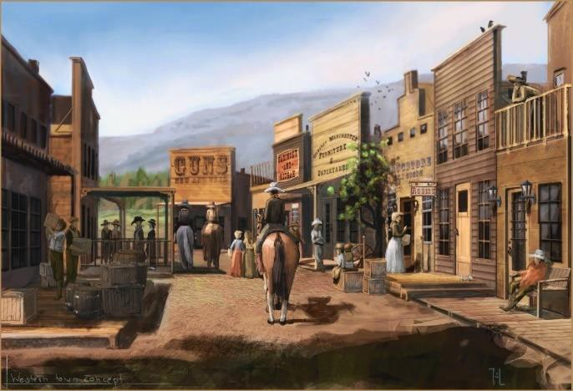
Mining towns grew rapidly as more people moved west seeking to make their fortune. Law and order were often too slow to keep up with the pace of new settlements.
  - When silver was discovered near what became known as Aurora the population grew from 800 in 1861 to 14,000 in 1864.
  - Aurora was isolated, hundreds of miles from the nearest city
  - Most of the population were white males although there were some Chinese
  - There were about 300 women, half of whom were prostitutes
  - There was one church, a brewery, 25 saloons and many gambling houses and brothels
The result was that Aurora was known for its lawlessness but t was not the only lace and so the government tried to introduce solutions to fix this problem.

Task: Read the solutions the US government introduced and decide how effective they were. 10 = completely effective – 1 = not effective at all.
You must explain your decision.
Solution | How did it solve the problem? | Effectiveness /10 and why?
Federal Government
US  Marshals | Appointed by the President to oversee a state or territory and from 1870 were under the control of the Department of Justice. Could appoint deputies to help cover vast areas and to help in manhunts. They were responsible for maintaining law and order and capturing outlaws as well as running  trials and paying expenses of witnesses and jurors.
Judges | Three federal judges were appointed in each territory or state to ride a circuit ad hear the cases brought by the US marshals. Prisoners had to be held for a long time before trial and sometimes they  were lynched before a trial could take place.
Local Government
Town Marshals | Appointed by the people of a town, often on a yearly basis
Sheriffs | Were elected by the people of a county for a two- year period of office. Often, they had to cover too wide an area to be effective. Few men made a career out of being a lawman, since it was both badly paid and dangerous. The quality of lawmen ranged from admirable to bad. Bill Tighman of Oklahoma had a distinguished career whereas Henry Plummer, a Montana Sheriff combined this  job with leading a band of outlaws.
Texas Rangers | The people of Texas came up with their own law and order solution, many years before Texas became a state, which was the Texas Rangers, formed in 1821. This was a small army of lawmen employed to enforce law and order in the state of Texas as well as provide protection from Indian  attack.
Non-government Solutions
The Pinkerton Detective Agency | This was a private company set up in 1850. It was hired by banks and railroad and stage coach companies to provide protection. Sometimes the Agency was hired to catch particular outlaws, such as the James-Younger gang. This buying of private law enforcement is a good example of the Code of  the West.
Vigilantism | This was where local communities, usually led by the local elites, took the law into their own hands. These vigilante groups used violence, including shootings and hangings. But their numbers and the sympathy of powerful people, ensured they usually  went unpunished.

How Wild was the Wild West?
When people think of the American West they picture a wild place where gunfighters and lawlessness ruled in an area rife with gambling, alcoholism and prostitution. Is this true?

Task: Read the information complete the table | Does the information tell us the West was ‘wild’ or not?  Explain your decision.
Highway & Stage Coach Robbery

- Stage coaches carried large amounts of money as well as mail and people
- They were targeted by robbers and could be held up well away from towns
- Some ex-confederate soldiers like Jesse James became outlaws
- They robbed banks and often got involved in shoot-outs in various towns
Train Robbery & Shootings

- Between 1870 and 1900 train robberies were common
- It was difficult to catch robbers because of the vast distances across the West
- Everyone was armed in the West which made violent crime much more likely
- In towns where law and order were lacking violent shootings were the norm
Law & Order in Abilene
- Cowboys arriving in Abilene from Texas wanted to have fun
- They spent their money in saloons drinking, gambling and sleeping with prostitutes
- The population of the town swelled from 500 in the winter to 7000 in the summer
- Their wild behaviour made Abilene lawless until 1869 when saloons were licensed, brothels closed down and a marshal was employed to enforce the law
John Wesley Hardin

- This son of a Methodist Minister became the most feared gunfighter in Texas
- As a Texan outlaw, he arrived in Abilene in 1871, shot a man and fled before Wild Bill Hickok caught him
- He killed between 20 and 42 men making him the deadliest gunfighter of the West

Wild Bill Hickok

- Wild Bill Hickok had a reputation as a gunfighter, drinker, gambler and womaniser
- As marshal of Abilene he controlled the Cowboys
- In 1873 he toured with Buffalo Bill in the Wild West Show
- He was shot in the back of the head in 1873 in the town of Deadwood
Dime Novels
- Most people never visited the West so got their information from fictional magazines and novels
- Men like Buffalo Bill were depicted as heroes
- The West was glamorised and sensationalised for the entertainment of the readers in the east
Buffalo Bill’s Wild West Show
- Bill Cody was a buffalo hunter and army scout
- The Wild West Show was a travelling theatrical company that re-enacted scenes from the West featuring Cowboys and Indians
- Wild Bill Hickok and Sitting Bull appeared in person
- Touring in Europe and America, this perpetuated the myth of The West
Task: Write a conclusion on how ‘wild’ the West was. Explain your judgement.

Conflict due to Lawlessness in the West
Gunfight at the OK Corral, 1881

One of the key events that people today associate with the Wild West is the gun fight at the OK Corral, Tombstone 1881. In particular the role of Wyatt Earp who was turned into a hero by a 1931 biography and a 1957 Hollywood movie starring Burt Lancaster.

Wyatt Earp was the marshal of Tombstone, Arizona. He was hired by local businessmen because he had a ‘tough guy’ reputation. Wyatt and his brothers clashed with two local ranching families, the Clantons and McClaurys, who were involved in robberies and cattle rustling. Tensions came to a head in 1881. There was a big gunfight at the OK Corral (a place where horses were kept), in which the Earp brothers killed some of the ranchers. Despite
the Earps’ victory at the gunfight, the trouble continued. When one of the Earp brothers was killed in 1882, Wyatt killed his murderers in revenge. The Earps were famous for their tough approach to law enforcement. However, their violent tactics only made things worse and after the killings they were forced to leave Tombstone.

Billy the Kid and the Lincoln County War, 1878

One of the most well-known gunfighters of the Wild West was Billy the Kid. Henry McCarty (Billy the Kid) was born in New York City on 17th September, 1859. After the death of his father, in 1863, the family moved to Wichita. His mother died in 1874. Around this time, he acquired the nickname, Billy the Kid.

In 1875 Billy was arrested but he managed to escape and fled to Arizona where he became involved in horse stealing. In August 1877 he killed Frank Cahill, an army blacksmith ad was again arrested but once again escaped and eventually found work with John Tunstall. After Tunstall was murdered on 18th February, 1878, starting the Lincoln County War, Billy the Kid was deeply affected by this murder. He joined the Regulators, a gang who claimed they had been involved in the killing of Tunstall.

On 19th July, 1878, the gang, including Billy the Kid, were besieged by the Sheriff and a group of his men. Several people were shot dead as they came out of the house, but Billy the Kid managed to escape.
In 1880 Pat Garrett was elected sheriff of Lincoln County. He immediately attempted to deal with the problems being caused by Billy the Kid. In December 1880, Garrett shot dead two of the Kid's gang. Soon afterwards Billy the Kid was captured by Garratt.

Billy the Kid was found guilty of murdering William Brady and was held in Lincoln jail while waiting to be executed on 13th May, 1881. However, Billy killed two guards and escaped. News reached Garratt that Billy the Kid was hiding out at the abandoned Fort Sumner. On 14th July, 1881, Garratt killed Billy the Kid during a shoot-out at
the home of Pete Maxwell. It was later claimed that Billy the Kid had killed 21 men in his 21 years of life. However, most experts believe he was only responsible for nine deaths.

Task: Explain what the life of Billy the Kid tells us about lawlessness in the West using the words below.
Led to | Control | Violence | Vigilantes | Billy the Kid | Dangerous | Isolated | Powerless | Justice

American West dictionary

Task: As you go through this booklet, record key words and definitions in this dictionary.
A | N
B | O
C | P
D | Q
E | R
F | S
G | T
H | U
I | V
J | W
K | X
L | Y
M | Z

Extension: Project Based Learning in History

Challenge question | The settlement of the West is the story how the American people fulfilled their destiny to settles and civilise the North American continent. How far do you agree?
Sources of evidence | How will you research this challenge question?
 | Pages to include in your Project  - Timeline of the settlement of the West 1835-1895  - Who were the Plains Indians and how did they live?  - What was manifest destiny and why is it important?  - What groups made the early journeys West and why?  - How did the movement West affect the Plains Indians?  - How did the US Civil War affect the West?  - How did the growth of the cattle industry impact both the settlement of the West and the lives of the Plains Indians?  - What happened during the Indian wars and can they be ignored as necessary to achieve settlement?  - How successful were the Homesteaders in settling on the Plains?  - Was the destruction of the Indians way of life a genocide? | What do the individuals tell us about the settlement of the West?  - Were there eyewitness accounts? What do they say?  - Were there personal testimonies about this?  - What happened to the Plains Indians? What do they tell us about settlement of the West?  What do different media tell us about the settlement of the West?  - What can we learn from sources from this time? Which were made by the White Americans and which were made by the Plains Indians?  - Are there films and TV that can give us information?  What do written sources tell us about the settlement of the West?  - What can we learn from newspapers?  - What do the published sources tell?  - What online information is there?
Writing the report | Recording your answer.  - Spread your work over several pages.  - Write in detailed paragraphs formally.  - Explain clearly what you have learned.  - Ensure you directly answer the challenge question.

