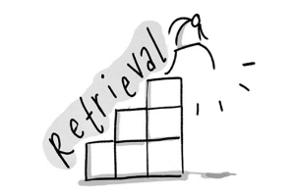Anglo Saxon and Norman England Revision Quilt : Add detail to each box
Bishop Odo | Battle of Hastings | Earl Tostig | Domesday Book | Revolt at Ely
Death of Edward the Confessor | Normanisation of the Church | Marcher Earldoms | Changes In landholding | The Witan
Colour code each box to indicate the time period
1060-1065 | 1066-1070 | 1071-1075 | 1076-1080 | 1081-1085 | 1086-1090

