Paper 3— Weimar and Nazi Germany

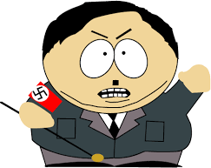
WEIMAR

& NAZI GERMANY

Q1) Give two things you can infer from source A about …………...4 marks)
Source A: Gustav Stresemann in a speech to the Reichstag, 1928

“Germany is dancing on a volcano. If America calls in their loans, a large section of our economy would collapse.”
Source A: memories of a German writer of 1923
“Two women were carrying a laundry basket filled to the top with banknotes. Seeing a crowd standing round a shop window, they put down the basket for a moment to see if there was anything they could buy. When they turned around a few moments later, they found the money was untouched, but the basket had been stolen.
Success List!
- Make the inference apply to the Q—show the connection
- Back up your idea with a relevant quote

Q1) Give two things you can infer from source A about how ordinary Germans felt about the Treaty of Versailles, 1919.
Source A: Adolf Hitler, in a speech made during the Munich Putsch

The Bavarian Ministry is removed. I propose that a Bavarian government shall be formed consisting of a Regent and a Prime Minister invested with dictatorial powers. I propose Herr von Kahr as Regent and Herr Pohner as Prime Minister. The government of the November Criminals and the Reich President are declared to be removed. I propose that, un- til accounts have been finally settled with the November criminals, the direction of policy in the National Government be taken over by me.
Source A: Front page of the German newspaper – Der Spiegel on the day after the treaty was signed.

Today in the Hall of Mirrors at Versailles a disgraceful treaty is being signed. Never forget it! On the spot where, in the glorious year of 1871, the German Empire in all its glory began, today German honour is dragged to the grave. Never forget it! There will be vengeance for the shame of 1919.

Q1) Give two things you can infer from source A about the events of the Munich Putsch

Q1) Give two things you can infer from source A about the impact of hyperinfla- tion, 1923.

Q1) Give two things you can infer from source A about the success of the eco- nomic recovery of Germany, from 1923.

Q1) Give two things you can infer from source A about living conditions after the Great Depression, 1929.
Source A: Excerpts from Hitler’s 28th February 1933 decree
“There are now restrictions on personal liberty, on the right of free expression of opinion, including the free- dom of the press, on the right of assembly and the right of association.”
Source A: Eugen Diesel, a German, describing condition in 1931

“Every fifth child of the German cities is without a bed of its own; it has to live amid poverty and sickness, immorality, dirt and coarseness. Thus millions of people exist in conditions of bitter horror, in half lit dungeons, where six to eight of even fourteen or more human beings are crowded together amid rats and filth.”
Q1) Give two things you can infer from source A about the cultural explosion in Germany, 1924-29.
Source A: F. Scott Fitzgerald writing about the 20s in Berlin
“The parties were bigger… the pace was faster, the shows were broader, the buildings were higher, the morals were looser.”

Q1) Give two things you can infer from source A about the decline of the Nazi Party, between 1923
and 1928.
Source A: comments from someone listening to Hitler speaking
“He was holding us under a hypnotic spell. I forgot everything but the man; then, glancing around, I saw that his magnetism was holding these thousands as one.”
Source A: William Shirer, The Rise and Fall of the Third Reich (1959), William Shirer was an American journalist who lived in Ger- many from 1926 to 1941

Support for the Nazi Party had grown due to the country’s problems of hyperinflation and the French invasion of the Ruhr. By 1928 Nazism ap- peared to be a dying cause. Now that Germany’s outlook was suddenly bright, the Nazi Party was rapidly withering away. One scarcely heard of Hitler or the Nazis except as a joke.

Q1) Give two things you can infer from source A about the role Hitler played in gaining support for the Nazis.

Q1) Give two things you can infer from source A about how the Nazis began to consolidate their pow- er in 1933.

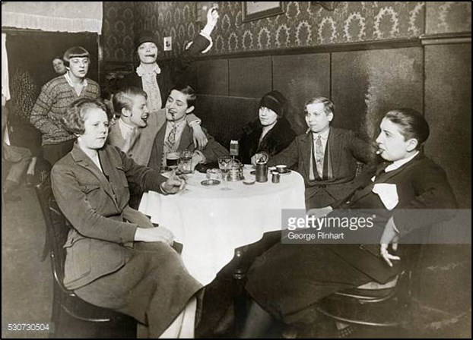Q1) Give two things you can infer from source A about women in Weimar Germany.
Source A: Women enjoying cigars in a Berlin café during Weimar Germany

Q2) Explain why the ………………...
You may use:
- …………………………….
- ………………………...
You must use one of your own (12 marks)
Success List!
- 3 points to show act as causes!
- Clear connection between the cause and the BIG event ie causing the Munich Putsch
- Lots of specific detail!
- 3 PEE paras (ideally)
- You DON’T need to use the stimulus points if you know others!

Questions below (& NEXT PAGES)—in no particular order!

Q2) Explain why Germany experienced economic crisis in 1923 You may use:
- Occupation of the Ruhr (1923)
- Weimar actions
You must use one of your own (12 marks)

Q2) Explain why the NSDAP experienced a surge in popularity from 1929- 32
You may use:
- High unemployment
- Propaganda
You must use one of your own (12 marks)

Q2) Explain why Germany experienced a ‘Golden Age’ from 1924-1929 You may use:
  - Boom of arts and culture
  - Economic stability
You must use one of your own (12 marks)

Q2) Explain why the Weimar Republic experienced instability 19120-23 You may use:
  - The Kapp Putsch
  - The Treaty of Versailles
You must use one of your own (12 marks)

Q2) Explain why hyperinflation occurred, 1923.
You may use:
    - Occupation of the Ruhr
    - The Treaty of Versailles
You must use one of your own (12 marks) Q2) Explain why the Nazis targeted the youth from 1933.
You may use:
    - Race policy
    - Nazi control
You must use one of your own (12 marks)

Q2) Explain why the position minority groups changed from 1933 onwards
You may use:
    - The Nuremberg Laws (1935)
    - Nazi Euthanasia policy
You must use one of your own (12 marks)

Q2) Explain why the conditions of workers changed in the years 1933-39 You may use:
    - KDF (Strength Through Joy)
    - DAF (The German Labour Front)
You must use one of your own (12 marks)

Q2) Explain why Hitler was able to consolidate his power, 1933-34 You may use:
  - The Enabling Act (1933)
  - The Night of Long Knives (1934)
You must use one of your own (12 marks)

Q2) Explain why the Nazis was able to prevent opposition, 1933-39
You may use:
    - The role of the SA/SS
    - Propaganda
You must use one of your own (12 marks) Q2) Explain why the Third Reich created a police state in Germany.
You may use:
    - Prevent opposition
    - Nazi control
You must use one of your own (12 marks)

Q2) Explain why the Nazis carried out the Munich Putsch, 1923
You may use:
    - Economic Crisis
    - Gustav Stresemann
You must use one of your own (12 marks)

Q2) Explain why the Weimar Republic was weak from within. You may use:
    - Proportional Representation (PR)
    - Democratic bureaucracy
You must use one of your own (12 marks)

Q2) Explain why Hitler became Chancellor in January 1933 You may use:
  - Von Papen
  - High Unemployment
You must use one of your own (12 marks)

Q2) Explain why German citizens were critical of the Treaty of Versailles.
You may use:
    - The Blame Clause
    - Reparations
You must use one of your own (12 marks) Q2) Explain why the Treaty of Versailles damaged Germany.
You may use:
    - Territorial losses
    - Economic impact
You must use one of your own (12 marks)

Q3a) Study sources B and C
How useful are Sources B and C for an enquiry into……………………...
(8 marks)
Success List!
- Look at the NOP of each source
- Evaluate the NOP—weakness and strength for source B and C!
- Explain why this means a strength or limitation
- You must have DETAILED own knowledge!
- A mini-conc at end

Q3a) Study sources B and C
How useful are Sources B and C for an enquiry into popularity of the Hitler Youth under the Third Reich (8 marks)
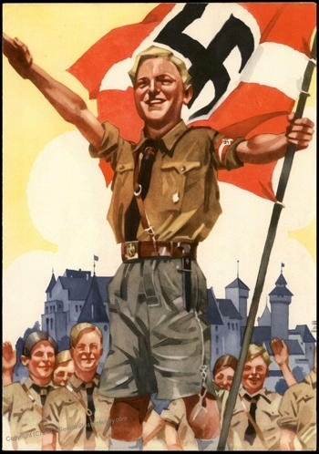
Source B: Hitler Youth illustration (c. 1936)
Source C: a Leaflet written by Hans Scholl
- a leader of the anti-Nazi youth group, the White Rose
Why do the German people behave so apatheti- cally in face of all these dreadful and inhuman crimes? It is high time we uprooted the ‘Brown Horde’. We shall only do this by cooperation be- tween many convinced and bold men who are agreed on how to achieve their aims

Q3a) Study sources B and C
How useful are Sources B and C for an enquiry into the success of the Nazi policies which targeted women (8 marks)
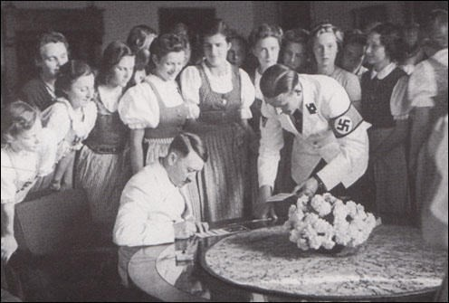
Source B: Extract from Traudl Junge’s au- tobiography, To The Last Hour: Hitler's Last Secretary (2002). Junge had been part of the Hitler’s inner circle—she was his secretary until his suicide.
“So that was why we didn't bother about join- ing the organization... It didn't touch me or my friends very much... We were interested in dancing and ballet, and I didn't care much for politics...we did not like the message that young women should not wear make-up and had to be "naturally beautiful, sporty and healthy, and giving Hitler a lot of children."
Source C: Adolf Hitler signing auto- graphs for young women (c. 1936)

Q3a) Study sources B and C
How useful are Sources B and C for an enquiry into how the Nazis viewed the role of women. (8 marks)
Source B: An extract from a speech delivered by Joseph Goebbels in 1934:
"Women has the task of being beautiful and bringing children into the world, and this is by no means as coarse and old- fashioned as one might think. The female bird preens herself for her mate and hatches her eggs for him. In exchange, the mate takes care of gathering the food and stands guard and wards off the enemy. Hope for as many children as pos- sible! Your duty is to produce at least four offspring in order to ensure the fu- ture of the national stock."
Source C: Hildegard Koch recalling a conversation she had with a leader of the BMD (the German Girl’s League).
She said that "Heinrich Himmler had been charged by the Führer with the task of coupling a small elite of German women (who had to be purely Aryan and over five foot tall) with SS men of equally good ra- cial stock in order to lay the foundation of a pure racial breed We had to sign
an undertaking renouncing all claims to the children we would have there, as they would be needed by the State and would be taken to special houses and settle- ments for inter-marriage."

Q3a) Study sources B and C
How useful are Sources B and C for an enquiry into the success of the Nazi policies which targeted women (8 marks)
Source B: Extract from Traudl Junge’s au- tobiography, To The Last Hour: Hitler's Last Secretary (2002). Junge had been part of the Hitler’s inner circle—she was his secretary until his suicide.
“So that was why we didn't bother about join- ing the organization... It didn't touch me or my friends very much... We were interested in dancing and ballet, and I didn't care much for politics...we did not like the message that young women should not wear make-up and had to be "naturally beautiful, sporty and healthy, and giving Hitler a lot of children."
Source C: Adolf Hitler signing auto- graphs for young women (c. 1936)

Q3a) Study sources B and C
How useful are Sources B and C for an enquiry into how the Nazis viewed the role of women. (8 marks)
Source B: An extract from a speech delivered by Joseph Goebbels in 1934:
"Women has the task of being beautiful and bringing children into the world, and this is by no means as coarse and old- fashioned as one might think. The female bird preens herself for her mate and hatches her eggs for him. In exchange, the mate takes care of gathering the food and stands guard and wards off the enemy. Hope for as many children as pos- sible! Your duty is to produce at least four offspring in order to ensure the fu- ture of the national stock."
Source C: Hildegard Koch recalling a conversation she had with a leader of the BMD (the German Girl’s League).
She said that "Heinrich Himmler had been charged by the Führer with the task of coupling a small elite of German women (who had to be purely Aryan and over five foot tall) with SS men of equally good ra- cial stock in order to lay the foundation of a pure racial breed We had to sign
an undertaking renouncing all claims to the children we would have there, as they would be needed by the State and would be taken to special houses and settle- ments for inter-marriage."

Q3a) Study sources B and C
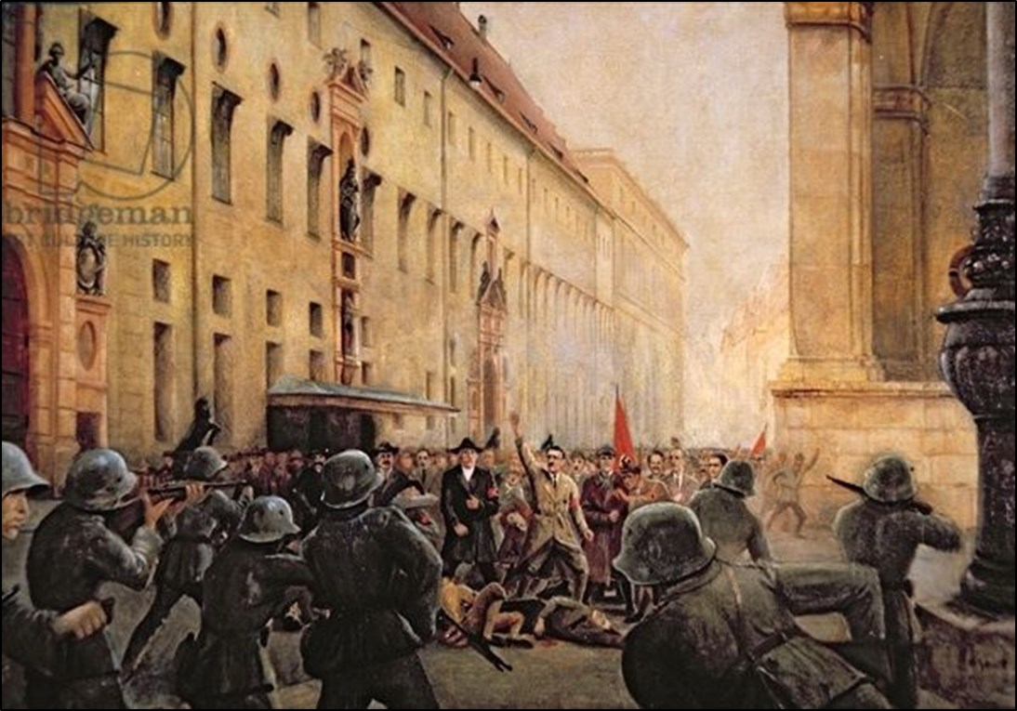How useful are Sources B and C for an enquiry into the consequences of the Munich Putsch of 1923?
Source B: A painting of the Munich Putsch of 1923 made later by one of its participants, showing the police opening fire on the Nazis.
Hitler is standing with his arm raised and Erich von Ludendorff is on his right.
Source C: From Hitler’s recollections of the Munich Putsch, given in 1933
Co-operation with General Ludendorff would have been absolutely impossible.
The sudden takeover of power in the whole of Ger- many would have led to the greatest difficul- ties in 1923 because the essential preparations had not been made by the National Socialist Party.
The events of the 9 November 1923, with their bloody sacrifice, have proven the most effective propaganda for the National Socialism.
It was the greatest good fortune for us Nazis that the Putsch collapsed because:

Q3b) Study interpretations 1 and 2. They give different views about
……………..
What is the main difference between these views? (4 marks)
Success List!
- Read the source and interpret what they tell you
- The will always be diff—so what is that diff?
- Identify this in the answer
- Back yourself up with a quote from each interp!

Q3c) Suggest one reason why interpretations 1 and 2 give different views about…………..
You may use sources B and C to help explain your answer (4 marks)
Success List!
- REMEMBER YOUR GOLDEN RULE
- EXPLAIN THIS GOLDEN RULE USING THE CONTEXT OF THE INTERPRETATIONS!

Q3d) How far do you agree with Interpretation 1 about …………………..
Explain your answer using both interpretations and your own knowledge.
(16 marks + 4 SPaG marks = 20 total!)

Success List!
- This is a two sided essay—para 1 = interp 1, then para 2 = interp 2!
- Intro at beginning, and conc at the end!
- Each para must have: ways in which interp is correct, lots of OK to support it, ways in which the interp is limited or missing info, lots of OK to support this, link the inteprs to one another to show links or connections. Quote from the interp!!!
- Fab SPaG to nail those 4 points!

Interpretation 1: Ian Kershaw, Hitler 1889-1936 , 1998
Without the changed conditions, the product of a lost war, a revolution and a pervasive sense of national humiliation, Hitler would have remained a nobody. His main ability by far, as he came to realise, was that he could inspire an audience which shared his basic politi-
cal feelings, by the way he spoke, by the force of his rhetoric, by the very power of his prejudice, by the conviction he conveyed that there was a way out of Germany's plight, and that only the way he outlined was the road to national rebirth..
Interpretation 2: Amelia Clarke, How Weimar Fell, 2008
By mid-1930, amid the economic pressures of the Great Depression, the German democratic government was beginning to unravel. In the good times before the Great Depression the Nazi Party experienced slow growth, barely reaching 100,000 members in a country of over sixty million. The crisis of the Great Depression brought disunity to the political parties in the Reichstag. The German people were tired of the political haggling in Berlin. They were tired of misery, tired of suffering, tired of weakness. These were desperate times and they were willing to listen to anyone, even Adolf Hitler.

Q3b) Study interpretations 1 and 2. They give different views about why the Nazi gained in popularity.
What is the main difference between these views? (4 marks)

Q3c) Suggest one reason why interpretations 1 and 2 give different views about why the Nazi gained in popularity.
You may use sources B and C to help explain your answer (4 marks)

Q3d) How far do you agree with Interpretation 2 that the Nazis rise to power was mainly due to the economic crisis caused by the Great Depression.
Explain your answer using both interpretations and your own knowledge.
(16 marks + 4 SPaG marks = 20 total!)

Interpretation 2: Adelheim von Saldern, Victims or Perpetrators, published in 1994
Women have often been portrayed as the victims of National Socialism. The Nazi system oppressed women and reduced them to mere objects. There were victims of discrimination in politics, society and the econo- my, forced out of offices and professions. Many young women had to work in low-paid agricultural work and as housemaids. The list of dis- criminatory measures could be enlarged considerably and the term ‘victim’ is quite appropriate.
Interpretation 1: from “German women and Nazi justice: their role in the process from denunciation to death”, by Johnson, Eric A. in 1995
The vast majority of German woman apparently »did not perceive the Third Reich as a women's hell.« Most woman conformed, kept their heads down, and had little contact with the machinery of justice and injustice. Women did not leave all political acts to the men, either for or against the regime, however, as a sizable number were involved in en- forcing social and political control in everyday life, especially by being ready to inform on non-conformists or simply on neighbours they disliked. So long as women satisfied the political, racial and social requirements, (which meant not being communist, social- ist,, Jewish, homosexual) and the vast majority did - then they had little to fear.

Q3b) Study interpretations 1 and 2. They give different views about how women were treated by the Nazi regime.
What is the main difference between these views? (4 marks)

Q3c) Suggest one reason why interpretations 1 and 2 give different views about the treatment of women in Nazi Germany.
You may use sources B and C to help explain your answer (4 marks)

Q3d) How far do you agree with Interpretation 2 that women were largely vic- tims of the Third Reich?
Explain your answer using both interpretations and your own knowledge.
(16 marks + 4 SPaG marks = 20 total!)

Interpretation 2: David Crew, Nazism and German Society 1933-1945, published in 1994.
"The most important part which held people together and kept their belief in the state was Hitler’s charismatic leadership. The ‘Hitler Myth’ secured the loyalty of millions of even those who opposed the Nazi movement it- self. Millions of ordinary Germans believed that the Fuhrer would certainly right all the wrongs in Nazi Germany. Hitler’s successes convinced ordinary Germans that the Fuhrer was a brilliant, indeed infallible leader who was leading Germany to world power.”
Interpretation 1: Eric Johnson, The Nazi Terror, published in 1999.
“the Nazi terror began to concentrate on silencing potential sources of op- position in religious circles and on removing from society what the regime deemed social outsiders, such as homosexuals, career criminals and the physically and mentally disabled. During the war the terror reached its most drastic phase. Although many German citizens belonged to one or more of the targeted groups, most Germans suffered not at all from the terror. There was no need to target them because most Germans remained loyal to the Nazi leadership and supported it voluntarily from the beginning “

Q3b) Study interpretations 1 and 2. They give different views about how the Nazis maintained control from 1933.
What is the main difference between these views? (4 marks)

Q3c) Suggest one reason why interpretations 1 and 2 give different views about how the Nazis maintained control from 1933.
You may use sources B and C to help explain your answer (4 marks)

Q3d) How far do you agree with Interpretation 1 about the most important part of maintaining Nazi rule was the support of the German people.
Explain your answer using both interpretations and your own knowledge.
(16 marks + 4 SPaG marks = 20 total!)

Interpretation 2: GCSE Modern World History, Ben Walsh in 2009
In November 1938 a young Jew killed a German diplomat in Paris. The Na- zis used this as an excuse to launch a violent revenge on Jews….They ran riot, smashing up Jewish shops and workplaces. Ninety-one Jews were mur- dered. Hundreds of synagogues were burned. Twenty thousand Jews were taken to concentration camps. This event became known as Kristallnacht.
Many Germans watched the events of Kristallnacht with alarm and concern.
Interpretation 1: Daniel Jonah Goldhagen, Hitler’s Willing Executioners, published in 1996
“It was not economic hardship, not the coercive means of the Nazi state, but it was ideas about Jews that were deeply set in Germany and had been for decades that caused Germans to kill defenseless, unarmed Jewish men, women and children without pity. The perpetrators were not just SS men, not even Nazi Party members, but were run of the mill, normally decent family men and women."

Q3b) Study interpretations 1 and 2. They give different views about who participated in anti-Semitic acts.
What is the main difference between these views? (4 marks)

Q3c) Suggest one reason why interpretations 1 and 2 give different views about who participated in anti-Semitic acts.
You may use sources B and C to help explain your answer (4 marks)

Q3d) How far do you agree with Interpretation 1 that the discrimination of the Jews, 1933-39, was actively allowed and helped by ordinary Germans.
Explain your answer using both interpretations and your own knowledge.
(16 marks + 4 SPaG marks = 20 total!)

Interpretation 2: From Encyclopedia of the Third Reich by Louis L. Snyder, published in 1998.

On the surface the Beer-Hall Putsch seemed to be a failure, but actually it was a brilliant achievement for a political nobody. In a few hours Hitler catapulted his scarcely known, unimportant movement into headlines throughout Germany and the world. Moreover, he learned an important lesson: direct action was not the way to political power. It was nec- essary that he seek political victory by winning the masses to his side and also by at- tracting the support of wealthy industrialists. Then he could ease his way to political su- premacy by legal means.
Interpretation 1: From Germany 1858-1990: Hope, Terror and Revival by A. Kitson, published in 2001.

Kahr was forced to promise Hitler his support, but this support was short-lived. The next day it became clear to Hitler that neither Kahr nor the army were going to support his march. The Bavarian police were sent to stop the few thousand supporters that had gath- ered and opened fire, killing 16 Nazis. Hitler was driven away. Two days later he and other Nazi leaders were arrested and accused of high treason. The Nazi Party was banned and Hitler was given the minimum sentence of five years’ imprisonment.

Q3b) Study Interpretations 1 and 2. They give different views on the con- sequences of the Munich Putsch of 1923.
What is the main difference between the views?
Explain your answer using details from both interpretations (4 marks)

Q3c) Suggest one reason why Interpretations 1 and 2 give different views about the consequences of the Munich Putsch of 1923.
You may use Sources B and C to help explain your answer.
(4 marks)

Q3d) How far do you agree with Interpretation 2 about the consequences of the Munich Putsch of 1923.
Explain your answer using both interpretations and your own knowledge.
(16 marks + 4 SPaG marks = 20 total!)

