Key topic 1: The Weimar Republic, 1918-1929
  - The origins of the Republic, 1918-1919

The First World War ended in 1918 and left Germany scarred and crumbling, having been defeated by the combined forces of Britain, France, Russia, Italy and the USA. It had been a long and expensive war:
- 11 million Germans had fought in the war. 2 million German troops had died, over 4 million were wounded = .55% of German troops became casualties
- Germany’s debts trebled between 1914 and 1918 from 50 billion marks to 150 billion marks
- 750,000 Germans died because of food shortages during the First World War
The German leader (emperor), Kaiser Wilhelm and his ministers had lost control of Germany and so he abdicated in November 1918. In many German towns, workers and soldiers had set up their own, unofficial councils to replace the Kaiser’s officials.
On the 10th November 1918, Frederich Ebert set up a new German Republic. The next day (11th November) Ebert signed the armistice – the war was over.
In January 1919, a new democratic constitution for Germany was drawn up. It became known at the Weimar Constitution, and this period of German History became known as ‘The Weimar Republic.’ The Weimar Constitution outlined some key points:
- A Bill of Rights guaranteed every German citizen freedom of speech and religion, and equality under the law.
- All men and women over the age of 20 were given the vote. This was even better than Britain where only women over 30 could vote.
- There was an elected president and an elected Reichstag (parliament).
- The Reichstag made the laws and appointed the government, which had to do what the Reichstag wanted.
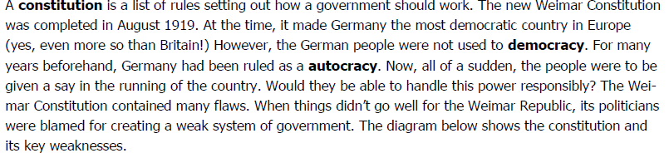

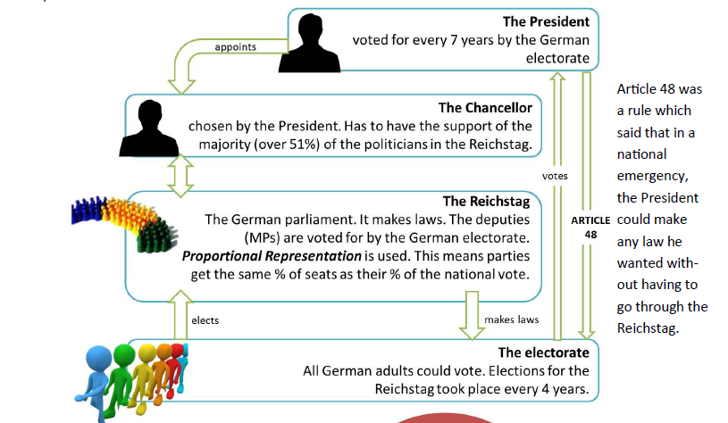

Strengths of the Weimar Constitution | Weaknesses of the Weimar Constitution
- Established the most advanced democracy in Europe – men and women had the vote at the age of 20 at a time when in Britain the age was 21 for men and 30 for women  - The President was elected every 7 years and had the power to appoint the Chancellor (head of the government)  - The Reichstag (parliament) had the power to pass or reject changes in the law. Members of the Reichstag were elected by proportional representation every four years (a good correlation between votes cast and seats won)  - Established the right of free speech and freedom of religious belief  - Clear system of checks and balances – not one person or one group could have too much power. The President had the power to choose the chancellor and the president could also dismiss the Reichstag. The electorate (people) could change the president | - Article 48 said that in an emergency the President could make laws without going to the Reichstag. This gave the President too much power. By 1930, the chancellor regularly relied upon the president to pass laws  - Proportional representation often led to many small parties gaining seats, including extremist groups like the Nazis. No one party was big enough to form a majority and therefore there were lots of coalition governments that were often weak and short lived  - The army generals and judges were the same men who had served the Kaiser, and many of them did not like the Weimar Republic.  - The Weimar Republic was not really the choice of the people – the Republic was created out of violence without real public enthusiasm.
1.2 Early challenges to the Republic, 1919-1923
The Treaty of Versailles
The politicians who set up and ran the Weimar Republic were the same ones who surrendered at the end of the First World War and accepted an unpopular peace treaty. The Weimar Republic was therefore always linked to surrender and harsh peace treaty terms.
On 11th November 1918, Matthias Erzberger, representing the government of the new republic, signed the armistice – an agreement to stop fighting. Once the armistice was signed, the Allied leaders decided the terms of the peace. The peace treaty was eventually signed on 28th June 1919 – the hated Treaty of Versailles. The Treaty of Versailles was extremely unpopular.
The terms of the Treaty
Reparations | Germany had to pay 6.6 billion pounds (136,000 million marks) in compensation
Colonies | 11 German colonies in Africa and the Far East were given to victorious countries
Military | Army limited to 100,000 men  Navy limited to 6 battleships, 6 cruisers, 12 destroyers and 12 torpedo boats  0 submarines were allowed  No air force was allowed  Rhineland (German land which bordered with France) was demilitarised
Land | Alsace and Lorraine were lost to France  Eupen and Malmedy were lost to Belgium  Posen and West Prussia were lost to Poland  Lost 10% of its population, 13% of its European territory, all overseas property and investments and 50% of its iron and 15% of its coal reserves
War Guilt | Article 231 meant that Germany had to accept the blame for the outbreak of the war

Many Germany saw the Treaty of Versailles as a diktat – enforced peace. The Germans were not invited to the peace negotiations and therefore they felt they had been treated unfairly.
They also saw it as a dolchstoss – the stab in the back. Many German people did not believe their army had been defeated in the war. The army felt they could have carried on fighting.
The Treaty of Versailles damaged Germany’s economy and imposed heavy reparations, so that it could not start another war. This made the economy weak from the outset. The Weimar Republic was also politically weak – the treaty was so harsh that people resented the leaders of the new German republic. They became known as the November criminals because they surrendered in November 1918. From the outset, the Weimar Republic was linked to defeat, humiliation and weakness.
Challenges to the Weimar Republic from the Left and Right (inside)
The new Weimar Republic government faced opposition from groups inside and outside the Reichstag, from both the left and right wings.

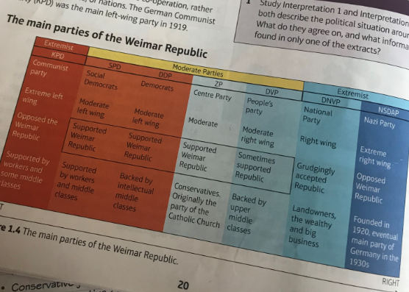
Extreme right-wing groups wanted a return of a strong government with a strong army, headed by a powerful leader like the Kaiser. They supported capitalism – private ownership of land and business – and championed families, law and order and traditional values. They tended to place the interests of the nation over the individual. The National Party (DNVP) was the main right-wing party in 1919.
Extreme left-wing groups wanted Germany to be controlled by the people. They opposed capitalism and wanted to abolish private ownership of land and businesses, and put them into the hands of the workers. The German Communist Party (KPD) was the main left-wing party in 1919.
For most of the 1920s, the moderate centre parties struggled to form majority coalitions, whilst being constantly attacked in the Reichstag by extremist politicians from the left and right wings.

The challenges from outside the Reichstag

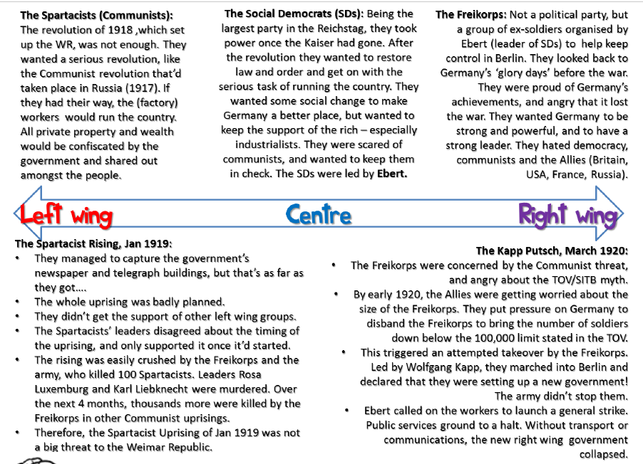

Even after the defeat of the Spartacist and Kapp uprising, political challenges to the Weimar Republic continued from the left and right wings. One of the other challenges involved a series of political assassinations.
- Hugo Hasse: one of Ebert’s Council of People’s Representatives, murdered in 1919

- Matthias Erzberger: politician who signed the surrender to the Allies in 1918, was shot and killed in August 1921

- Walther Rathenau: Weimar foreign minister was machine-gunned to death in Berlin in June 1922
Between 1919-1922 there were 376 political murders, mostly of left-wing or moderate politicians. Not a single right-wing murderer was convicted and executed, whilst ten left-wing assassins were. Judges were sympathetic to the right wing even undermined the Weimar Republic in the courts.
The crisis year - 1923
1923 turned out to be a crisis year for the Weimar Republic. A number of key events took place that rocked the stability of the Weimar Republic.
- Reparations: Germany to pay reparations to the Allies. The reparations bill was announced in April 1921. It was set at £6600 million, to be paid in annual instalments. This was 2% of Germany’s output. The Germans protested that this was an intolerable strain on the economy which they were struggling to rebuild after the war, but their protests were ignored.

- Invasion of the Ruhr: The first instalment of £50 million was paid in 1921, but in 1922 nothing was made. Ebert did his best to play for time and to negotiate concessions from the Allies, but the French in particular ran out of patience. They too had war debts to pay to the USA; In January 1923 French and Belgian troops entered the Ruhr (legally) and began to take what was owed to them in the form of raw materials and goods. Results of the occupation were disastrous for Germany. The government ordered the workers to carry out passive resistance (go on strike). That way, there would be nothing for the French to take away. French reacted harshly, killing over 100 workers, and expelling over 100,000 protesters from the region. It led to a halt in industrial production in Germany’s most important region causing the collapse of the German currency. France and Belgium invaded Germany, because they could not pay the reparations, despite owing a lot. Due to Germany being unable to pay, France and Belgium entered the Ruhr Industrial area (legally) and took what was owed to them in the form of raw materials. Germany were completely outnumbered by the French as the Germans only had 100,000 men whilst the French had 750,000. The occupation of the Ruhr crippled Germany, as it contained many factories and around 80% of German coal, iron and steel reserves. The disruption increased Germany’s debts, increased unemployment and worsened the shortage of good.

- Hyper-inflation: because it had no goods to trade, the government simply printed more money. For the government this seemed an attractive solution. It paid off its debts in worthless marks, including war loans of over £2200 million. The great industrialists were able to pay off all of their debts as well. This set off a chain-reaction. With so much money in circulation, prices and wages rocketed, but people soon realised that this money was worthless. It was a viscous circle – the more prices rose, the more money was printed, the more the prices rose. Workers needed wheelbarrows to carry home their wages. Poor people suffered, but the greatest casualties were the richer Germans with savings. This great economic instability created political instability.
Positive effects of hyperinflation | Negative effects of hyperinflation
- Farmers benefitted as they were paid more for food  - Some people and businesses could pay off loans and mortgages  - Fixed rents for rooms or shops became very cheap  - Foreign visitors could buy more for their money | - Some people could not afford essentials like bread  - Wages rose, but not as quickly as prices  - Some businesses went bankrupt  - People with fixed or monthly incomes such as pensioners suffered the most  - Savings became worthless – middle class most affected  - People blamed the Weimar government = unpopular

After August 1923, a new chancellor, Gustav Stresemann found solutions to some of the problems of 1923. By this point, however, the political and economic turmoil from 1918 to 1923 had done its damage.
- The Weimar Republic was shown to be weak. It had to be rescued by the Freikorps in 1919 and workers’ strikes in 1920. Government forces had killed thousands of Germans in order to stay in power
- All Germans had suffered. Most blamed the Weimar Republic for their suffering. The middle classes, which would normally be the bedrock of the republic, suffered the most
- Extremist parties, with private armies hostile to the republic, had gained in strength

1.3The recovery of the Republic, 1924-1929
In August 1923, President Ebert appointed Gustav Stresemann as his new chancellor and foreign secretary. Stresemann resigned the chancellorship in November 1923, but remained as foreign secretary until 1929.
Economic recovery
Reform/description | Strengths | Weaknesses
Rentenmark: Stresemann set up a new state-owned bank and introduced a new currency. The supply of the new notes was strictly limited and their value was tied to the price of gold = the currency had real value | Back by Germany’s gold reserves  German money trusted at home and abroad  Hyperinflation ended  Stronger basis for the recovery of German businesses and improvements to employment | People still had lost a lot of money during the era of hyperinflation = confidence in the Republic knocked
The Dawes Plan, 1924: Reparations were temporarily reduced to £50 million per year and US banks agreed to give loans to German industry. Between 1924 and 1930 the US loaned Germany $25 billion. | Reassured Allies they would get their reparation payments  French left the Ruhr because Stresemann had called off passive resistance  Industrial output doubled between 1923-1928 passing pre-war levels  Employment, trade and income from taxation increased | Extreme political parties furious that Germany had agreed to pay reparations  Fragile German economy relied on American loans – could be recalled at any point
The Young Plan, 1929: reduced the total reparations debt from £6.6 billion to £2 billion. It also gave Germany an extra 59 years to pay | Lower reparation payments allowed the government to lower taxes on ordinary German people  Lower taxes released public spending power – boosted German industry and created more jobs  French agreed to leave the Rhineland in 1930  Increased the confidence of Germans in the Weimar Republic | Extremist parties resented the additional length of time given  Annual payments were still £50 million per year  Stretched out payments until 1988

Recovery in foreign relations
Reform/description | Strengths | Weaknesses
The Locarno Pact, 1925: a treaty between Germany, Britain, France, Italy and Belgium. It was agreed on equal terms with other main powers – it was not imposed upon Germany. Germany accepted its new 1919 border with France, and France promised peace with Germany. Germany and the Allies agreed that the Rhineland would be permanently demilitarised. The five powers agreed to open talks about German membership to the League of Nations | Made war in Europe less likely.  Stresemann was given the Nobel Peace Prize in 1926  Germany was treated as an equal – a boost to the prestige of the Weimar Republic. | Some extremist parties resented the hated Versailles borders had been confirmed.
The League of Nations, 1926: the LON had been set up at the end of WW1, and Germany were not allowed to join in this. Stresemann persuaded a number of the great powers in September 1926 to give Germany membership. | Germany given a place on the League of Nations Council – took the most important decisions of the League  Boost to the moderate parties who supported Stresemann  Boosted the confidence of most Germans in the Weimar Republic | The League was a symbol of the hated Treaty of Versailles and they wanted nothing to do with it
The Kellogg-Briand Pact, 1928: Germany and 61 other countries signed this pact. It promised that states would not use war to achieve foreign policy aims. | Germany was included amongst the main powers, not dictated to by them  Another sign that the Weimar Republic was now aa respected, stable state  Another boost to the prestige of the Weimar Republic in the eyes of the German public. It increased confidence that the moderate political parties could be trusted to make Germany strong | Did nothing to remove the hated terms of the Treaty of Versailles, which still restricted German strength with reparations, lost land and military restrictions

By 1929, the Weimar Republic was a more secure and stable state. In May 1924, moderate parties received 50% of the public support, whereas by 1928 they received 58%. Germany’s growing confidence in the Weimar Republic was strengthened in 1925 when Ebert, president of the republic, died. He was replaced by Paul von Hindenburg, a former field marshal of the Kaiser’s army. Hindenburg reassured the middle class and gave the Weimar Republic a strong figurehead.
BUT… on 3rd October 1929, after six years as foreign minister, Stresemann had a heart attack and died. The loss of his moderate policies was a severe blow to the Weimar Republic. Worse still, a world economic crisis followed soon after. This unleashed a new wave of extreme economic and political pressures on the Weimar Republic.
1.4 Changes in society, 1924-1929
Living standards suffered as a result of the economic problems between 1918 and 1923. BUT… there were gradual social improvements after 1924. Many of these were funded by the Weimar government.
Unemployment and unemployment insurance | In 1924, over 4% of the total possible workforce was unemployed. Gradual improvements – 1926 = 2 million u/e and by 1928 = 1.3 million u/e  The Unemployment Insurance Act (1927) charged 16.4 million workers 3% of their wages, and in return provided around 60 marks per week in unemployment and sickness benefits if they fell out of work
Work and wages | Length of the working week shortened from 50 hours in 1925 to 46 hours in 1927, real wages (the value of goods that wages brought) rose by 25% from 1925 to 1928
Housing | In 1925 there was a 15% rent tax introduced to fund building associations. Between 1925-1929, private building companies built 37,000 new homes whilst the building associations built 64,000 new homes. There was still a shortage of houses, but it had eased by 1928.
Other improvements | 1920 Reich Pension Law helped war veterans – pensions paid throughout the 1920 to 750,000 war veterans, 400,000 war widows and 200,000 parents of dead servicemen.  Education improved and by 1928, there were 110,000 people in higher education, compared to 70,000 in 1914.

Women
Work | Politics | Leisure
- Most women gave up work after they got married. There was a drop in women working from 75% in 1918 to 36% in 1925  - Few women secured high status jobs  - Increase in part-time work  - Teaching and medicine offered new opportunities for women  - Women encouraged to go to university | - Women earned the vote in 1918 and could stand for elections  - 90% turned out in elections  - Article 109 of the constitution stated that women had equal rights with men and could enter professions on an equal basis  - Marriage was an equal partnership | - Greater earning power led to more independence for younger, single women  - Women were less interested in family and more interested in having a good time  - Behaviour of new women was not liked by some men and women who felt traditional values were eroding

These limited improvements for women were a source of worry to many people in Weimar Germany- though some people welcomed them.
- Some women felt liberated by new opportunities and freedoms; BUT… other women found the expectation that they should change a scary or daunting challenge
- Some men accepted changing roles for women, while others thought that the changes were inappropriate; there were some men who even thought that these ‘new women’ threatened the role of men in society
- Conservatives and traditionalists in society complained loudly that women should concentrate on being mothers and wives, and not challenge the male-dominated society
- Some people blamed the economic instability in Germany in the 1920s on women upsetting the labour market

Cultural changes in the Weimar Republic
In the 1920s, several factors caused a surge of artistic and cultural energy

The restrictions of the old imperial regime of the Kaiser had been thrown off | The new Weimar constitution enshrined freedoms – such as the freedom of speech – in law | Economic recovery after 1924 created wealth to finance the Arts

This energy caused the growth of a number of new ways of looking at the Arts

New objectivism  The idea that the Arts should not show a romantic view of the world, but should show life as it really is, including poverty and squalor | Modernism  The idea that the Arts should not always hark back to the past, but should, instead, embrace the future and see beauty in cities, industry and technology | Expressionism  The idea that the Arts should reflect the thoughts and feelings of the artists rather than being limited to showing things exactly as they really look

There were two factors helping to spread these ideas

The Bauhaus movement  Walter Gropius was the head of The Bauhaus, a design college in Berlin. Under Gropius, the college developed a style of design which influenced all areas of the Arts. The Bauhaus style stressed the beauty in technology, simple lines and careful craftsmanship. | Government support  The Weimar government gave grants to support art galleries, theatres, orchestras, museums and libraries

All these factors combined to cause a blossoming of culture in Weimar Germany

Art: painters like Otto Dix often painted expressionist versions of scenes from German life which were critical of German society, for example, the harsh life of war veterans and falling standards of behaviour in Germany’s night life during the Weimar Republic.
Architecture: Erich Mendelsohn was influenced by the Bauhaus school of design. When Mendelsohn was asked to design the Einsteen Tower, an observatory in Potsdam, he designed a futuristic towers which looked like a rocket
Cinema: Films became popular all over the world in the 1920s. Expressionism flourished in film-making, particularly in Weimar Germany due to fewer restrictions. Some German films were very new and exciting in how they challenged traditional cinema.

Check your understanding: Answer these quick fire questions
- What happened to the Kaiser after WW1?
- Who was the first president of the Weimar Republic?
- Which political party did he belong to?
- Who replaced him as President in 1925?
- How much in reparations did Germany owe after the Treaty of Versailles?
- What were the people who signed the Treaty of Versailles nicknamed?
- Who was the minister who dominated Weimar economic and foreign policy from 1923?
- In what year did he die?
- What was the minimum age for voting under the Weimar Constitution?
- What was Article 48 of the Weimar Constitution?
- What was proportional representation?
- Why was proportional representation a problem?
- Why did the French invade the Ruhr?
- What does hyperinflation mean?
- Money becomes more valuable.
- B. Prices rise to an extent where money is worthless.
- C. Wages and interest rates rise.
- Who was the leader of the Sparticist Uprising?
- In what year did it take place?
- Who was the leader of the Kapp Putsch?
- In what year did it take place?
- Why was 1923 known as a crisis year?
- What was the Dawes Plan?
- What was the Locarno Pact?
- What was the Young Plan?
- How did the standard of living improve in Germany after 1924?
- How did women’s role change?

