Key topic 3: Nazi control and dictatorship, 1933-1939
3.1 The creation of a dictatorship, 1933-1934
- January 30th 1933: Hitler was in a precarious position and few believed that he would be able to maintain control.

- 17TH February 1933: Police forces ordered to cooperate with the SS and the SA.

- 27th February 1933: Reichstag Fire- a fire sparking much controversy as to who actually started it. Hitler blamed the Communists, although he could have started the fire himself so that he could blame them. 4000 Communists and other Nazi opponents were arrested on this night.

- 28th February 1933: Emergency Decree issued by Hindenburg at Hitler’s request. It allowed the police to arrest suspects and hold them without trial and Hitler to take other regional governments.

- 5th March 1933: Reichstag elections- the government used control of radio and police to intimidate opponents. Slogan attracting voters ‘the battle against Marxism’. The Nazis won 52% of the vote.

- 13th March 1933: Entire media control

- 24th March 1933: Enabling Act which allowed Hitler to pass decrees without the President’s involvement. Made Hitler a legal dictator.

- 7th April 1933: Civil Service and education purged: all alien elements are removed i.e. Jewish and Nazi opponents

- 2nd May 1933: trade unions banned

- 14th July 1933: Law against the formation of new parties which meant Germany became a one party state

- January 1934: All state governments taken over

- 30th June 1934: Night of the Long Knives. The leading officers in the army were not impressed with either him or his SA and its leader Ernst Rohm. They were a badly disciplined force and furthermore, Rohm talked about making it a second German army. Hitler was also suspicious of Rohm, and believed that his control over the 4 million men made him a dangerous rival. Hitler had to choose between the army and the SA. Hitler made his choice and acted ruthlessly.

- August 1934: Hindenburg dies. Hitler = Fuhrer
When Hitler became Chancellor in January 1933, his power was limited.
- The Weimar Constitution controlled what the Chancellor could do
- Hindenbug retained all the powers of the President
- Hitler’s cabinet had 12 members – only two were Nazis
- NSDAP members numbered 1/3 of the Reichstag
Hitler set about consolidating his power.
- Reichstag Fire, 27th February 1933: a young Dutchman, Marinus van der Lubbe (Communist), was caught on the site with matches and firelighters. He was put on trial and executed. Hitler and Goering (the chief of police) claimed van der Lubbe had been part of a communist conspiracy against the government, so they used the opportunity to attack the communists.
4000 Communists were arrested and Hitler used the fire to pressurize Hindenburg to declaring a state of emergency. As long as Hindenburg supported him, Hitler could use decrees to govern Germany. Persuaded Hindenburg to call an election – 5th March; he hoped the Nazis would gain more seats in the Reichstag

- The day after the fire, Hitler issued the Decree for the Protection of the People and the State. This gave him powers to imprison political opponents and ban communist newspapers.

- 5th March 1933, elections: the election campaign was a bloody and violent one. There were violent clashes, which led to 70 deaths. The Nazis had increased their Reichstag members to 288, Hitler used his emergency powers to ban the Communist Party from taking its 81 seats. Hitler, with the support of other nationalist parties, had a 2/3 majority, which meant he was now in a position to change the constitution of the Republic

- The Enabling Act, March 1933 (Law for the Removal of the Distress of the People and Reich): What Hitler now wanted was an ‘Enabling Law’ which would place all power in his hands, allow him to pass laws without consulting the Reichstag, and effectively allow him to establish a dictatorship. The Nationalists were prepared to support him, but even then Hitler would still be short of the two-thirds of Reichstag seats that he needed to pass the change to the constitution.
- Ban the Communists: Hitler banned the Communists from serving in the Reichstag. This was relatively simple under his emergency powers.
- Intimidate the Social Democrats: on 23rd March, the newly elected Reichstag met for the first time in the Kroll Opera House in Berlin. Despite this pressure, many SDs still voted against the Enabling Act, but to no effect. All the other parties had given in to Nazi pressure.
The Enabling Act was passed on 23rd March 1933 by 444 votes to 94. It gave Hitler the power to make laws without the approval of either the Reichstag or the President. The Reichstag had in effect voted itself out of existence. It had voted to introduce the Nazi dictatorship. Through the next 11 years of Nazi rule, the Reichstag met 12 times- but simply to listen to Hitler speaking. They had no say in policies, no debates, the Weimar Republic was over. The Enabling Act triggered a 6 month period of rapid change, known as the Nazi revolution

- Removing the opposition (May 1933-1934):

- Trade Unions: potential source of opposition to Hitler. Nazis broke into trade union offices all over Germany and arrested trade union officials. Hitler used his new powers to ban trade unions and made strikes illegal

- Political parties: in May 1933 Hitler removed his two main political rivals – SDP/Communists. He destroyed their newspapers, and confiscated their funds. In July 1933, all political parties in Germany were declared illegal except the NSDAP = one-party state

- Local government: Hitler needed to strengthen the central government in Berlin and weaken the local government. Under the Weimar constitution, each region (Land) of Germany had its own parliament, which ran the local government in the area. In January 1934, he abolished the Lander parliaments and declared that governors appointed by him would run each region in Germany.

- The Night of the Long Knives, 29th/30th June 1934: The Night of the Long Knives, in June 1934, saw the wiping out of the SA's leadership and others who had angered Hitler in the recent past in Nazi Germany. After this date, the SS lead by Heinrich Himmler was to become far more powerful in Nazi Germany. For all the power the Enabling Act gave Hitler, he still felt threatened by some in the Nazi Party. He was also worried that the regular army had not given an oath of allegiance. The Night of the Long Knives not only removed the SA leaders but also got Hitler the army's oath that he so needed. By the summer of 1934, the SA's numbers had grown to 2 million men. They were under the control of Ernst Rohm, a loyal follower of Hitler since the early days of the Nazi Party. The SA was used to enforce law after Hitler became Chancellor in January 1933. They were the enforcers of the Nazi Party and there is no evidence that Röhm was ever planning anything against Hitler. However, Röhm had made enemies within the Nazi Party - Himmler, Goering and Goebbels was angered by the power he had gained and convinced Hitler that this was a threat to his position.
By June 1934, the regular army hierarchy also saw the SA as a threat to their authority. The SA outnumbered the army by 1934 and Röhm had openly spoken about taking over the regular army by absorbing it into the SA. Such talk alarmed the army's leaders.
By the summer of 1934, Hitler had decided that Röhm was a 'threat' and he made a pact with the army. If Röhm and the other SA leaders were removed, the rank and file SA men would come under the control of the army but the army would have to swear an oath of loyalty to Hitler. The army agreed and Rohm’s fate was sealed.
On the night of June 29th - June 30th 1934, units of the SS arrested the leaders of the SA and other political opponents. Men such as Gregor Strasser, von Schleicher and von Bredow were arrested and none of them had any connection with Röhm. The arrests carried on for 2 more nights.
Seventy seven men were executed on charges of treason. The SA was brought to heel and placed under the command of the army. Hitler received an oath of allegiance from all those who served in the army. Röhm was shot. Others were bludgeoned to death.
The first the public officially knew about the event was on July 13th 1934, when Hitler told the Reichstag that met in the Kroll Opera House, Berlin, that for the duration of the arrests that he and he alone was the judge in Germany and that the SS carried out his orders. From that time on the SS became a feared force in Nazi Germany lead by Heinrich Himmler. The efficiency with which the SS had carried out its orders greatly impressed Hitler and Himmler was to get huge power within Nazi Germany.

- Death of Hindenburg, 2nd August 1934: Hindeburg died aged 87. Hitler now took over supreme power. He declared himself Germany’s Fuhrer and decreed that, as Fuhrer, he would add all of the President’s powers to those he already held as Chancellor. He forced an oath of loyalty to him from every soldier in the army. A public vote was held on 19th August to confirm Hitler as the Fuhrer. 90% of voters voted in favour. The Weimar Republic had ended, and the Third Reich had begun.

3.2 The Nazi police state
A police state is when a government uses the police to control everyone’s lives. The Nazis used the SS, SD and the Gestapo to do this. Anyone the Nazis were suspicious of could disappear, at any time. They could be killed or taken to concentration camps.
Hitler set up his own security forces as he realized not all the existing German police supported him. These forces were run by the Nazi Party, there main weapon was fear.
Concentration camps:
- First camp built at Dachau in 1933 to house growing number of arrested people
- Camps built in isolation so nobody could see what was going on
- Inmates were made up of political prisoners, undesirables, prostitutes and homosexuals
- Inmates were treated badly and forced to do hard labour

Gestapo (secret police)
- Set up by Goering in 1933, led by Heydrich
- Wore plain clothes and spied of people
- Prosecuted people for speaking out against the Nazis
- Sent people to camps and used torture

The SD (Security Force)
- Set up by Himmler in 1931, appointed Reynhard Heydrich as leader
- Wore uniforms
- Spied on all opponents of the Nazi Party at home and abroad

The SS (Protection Squad):
- Set up and led by Heinrich Himmler in 1925
- Black uniforms
- Controlled all Germany’s police and security forces
- Acted outside the law
- Members had to marry racially pure wives
- Ran the concentration camps
- 240,000 men

Another way that Hitler controlled the police state was by controlling what happened in the legal system. Hitler realised that his opponents stood little chance of success if trumped-up charges could be brought against them, and then when they were tried in courts, which were biased in favour of the Nazis.
- All judges had to belong to the National Socialist League for the Maintenance of the Law
- All judges had to favour the Nazi Party in any decision
- He abolished trial by jury – only judges could decide if somebody was innocent
- He set up the People’s Court to hear all treason cases. Trials were held in secret and judges were hand-picked

Policies towards the Churches
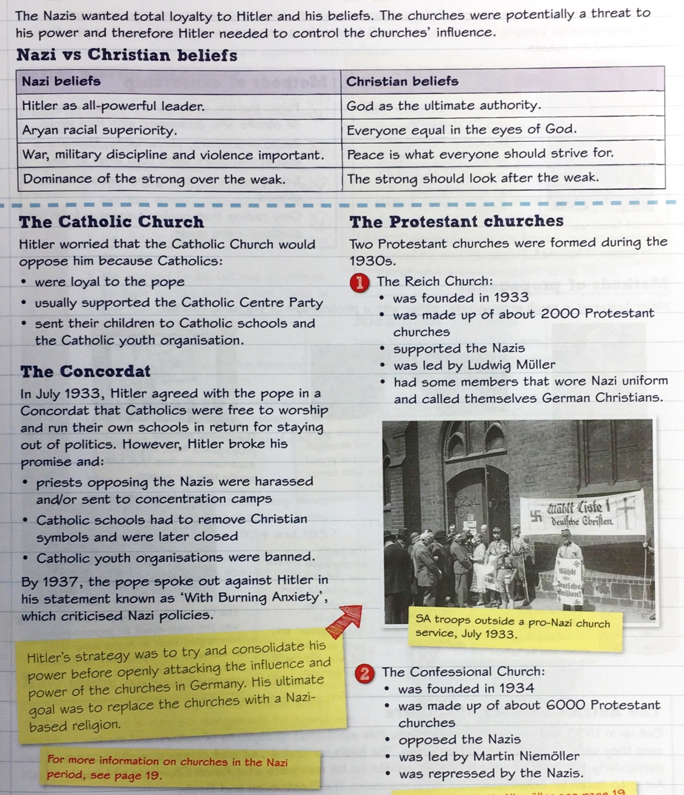

Hitler tried, at first, to work with the Christian Churches. However, he ended up in conflict with them and tried to make them conform to Nazi ideals. Just like the police and the law courts, they became ‘Nazified’. In all areas in which Hitler tried to control Germans, there were some people who opposed him.
As a result of all this, Germany was gradually becoming a totalitarian state – a country where the government controlled all sections of the state, including the Reichstag, the NSDAP, the army, the police and the legal system.

3.3 Controlling and influencing attitudes
In Hitler’s totalitarian state, the Nazi Party sought to control and influence the attitudes of the German public. They did this through censorship, propaganda and controlling culture and the Arts.
Joseph Goebbels was the key person in the Nazi efforts to control and influence attitudes. In 1933, Hitler made Goebbels the Minister of People’s Enlightenment and Propaganda. In this role, Goebbels co-ordinated Nazi policy towards the media, sport, culture and the Arts so that attitudes which Nazis opposed were censored, and attitudes which Nazis supported were promoted.
Radio
- Goebbels loved this new technology. He made radios cheap so the message could reach more people. By 1939, 70% of Germans had a radio
- Listening to the radio was punishable by death
- 6000 loudspeakers also placed in bars and streets for those without radio
- Hitler’s speeches (and other important Nazis) repeated over and over
- People started to believe what they heard- inferiority of Jews and German expansion to the east
- The Reich Radio Company was established
- People would be regularly exposed to Hitler’s speeches, and as it was Hitler, ‘the Messiah,’ they would listen intently.
Music
- Jazz was banned because it was seen as ‘black’ music
- Musicians had to be members of the Reich Chamber of Culture
- Goebbels could take membership away
- Folk songs and classical music was ok to listen to
Art/ Architecture/ Sculpture
- Only approved paintings were allowed – heroic Nazis, military figures or the ideal Aryan families
- Albert Speer was employed to create immense public buildings (large and built out of stone for public buildings, and they went for a country style family home)
Books
- Needed permission of Goebbels to publish
- Best seller was Mein Kampf
- In 1933, book burning of anything deemed to be unacceptable to Nazi ideology
- This began to eliminate unacceptable ideas to the Nazis.
Olympics
- 1936 – Berlin- Germans were full-time athletes who had trained, unlike other countries
- Goebbels convinced it would be good propaganda nationally and internationally
- Aryan superior race- pressure for countries to boycott so the Nazis put one Jew in the team
- Stadium for 100,000 with modern lighting and timing devices- showing to the world that Germany was advanced.
- A chance to show the Aryan race as superior.
Rallies
- Goebbels organised these huge rallies, marches, torch-lit processions and meetings.
- Nuremberg every summer for one week
- Bands, marches, speeches and flying displays, listening to speeches and watching the parade
- Gave a sense of belonging, show or power and they the sense that every German supported the Nazis.
- The Nazi’s main attraction was that they created order out of chaos and so the whole rally was constructed to demonstrate order.
Newspapers
- Controlled by Goebbels, no anti-Nazi ideas
- Jewish editors and journalists out of work, as anti-Nazi newspapers were shut down
- By 1944 there were only 1000 daily newspapers and most of these were controlled by the Nazi party
- Some Nazi newspapers threatened people who cancelled their subscriptions
Cinema
- Nazis made films promoting ideas e.g. The Eternal Jew.
- All European and exterior films were censored in order to get rid of bits containing anti-Nazi messages.
- They would also have a short film at the beginning about how brilliant Nazi Germany is.

3.4. Opposition, resistance and conformity
There were high levels of support amongst German people for Hitler and the Nazis. Hitler won 36% of the vote in April 1932 presidential election, and 38% of the vote in the July 1932 general election. Throughout the rest of the 1930s, amongst most German people, there was a high level of acceptance of Hitler, the Nazis and their policies. One reason for this was because of censorship and propaganda. Goebbels banned criticism of the Nazis and used the media to spread positive messages about them, ensuring that Hitler and the Nazis remained popular. Also, during the 1930s, Hitler reduced unemployment and achieved several successes in foreign policy.
BUT… there were some groups who opposed Hitler and his policies.
Resistance = refusing to support something or speaking out against it
Opposition = actively working against something in order to remove it
It is hard to know how much opposition there was to Hitler and the Nazis because organised opposition was banned, and unofficial opposition was risky. Criticism of Hitler was reported to the Gestapo and those reported would be punished.
Opponent | Reason for opposition | Action taken by opposition | Nazi action against opposition | How effective where Nazi actions
Church leaders | The Protestant Church, led by Pastor Martin Niemoller, opposed Hitler’s Reich Church.  The Catholic Church, e.g. von Galen were against the Euthanasia campaign | Formed an alternate ‘Confessional Church.’  Campaigned against the Euthanasia programme.  Pope wrote a letter with ‘burning concern.’ | Niemoller was put into a Concentration Camp. Hitler ordered his death shortly before the end of the war but he survived.  Campaign was successful as the Nazis did not want to make Galen a martyr, although they did execute 3 Catholic Priests who distributed Galen’s leaflets. | Goebbels stated that “if anything were done against the Bishop, the population of Munster could be regarded as lost to the war effort. Niemoller was arrested in 1937 and sent to Dachau concentration camp, due to be executed; however, he was freed by the Allies shortly before the end of WW2.  Bonhoffer was executed in April 1945 after being held at Buchenwald concentration camp.  Not very effective as churches remained.
Youth groups | Edelweiss Pirates- working class boys and girls who opposed the Nazi regime.  The Swing Youth (Hitler hated it- it was ‘negro’ music). These were middle class youths who rejected Nazi values, drank alcohol and danced to jazz.  The White Rose movement: against the slaughter of Jews and Poles. Munich university students led by Hans and Sophie Scholl, distributed anti-Nazi leaflets. Calling for an end to the war, and an end to the atrocities against the Jews and a United Europe. | EP- sang songs like the Hitler Youth but changed the words to mock Germany. They would taunt and attack HY members. They had boys and girls, with freer attitudes to sex. They also daubed anti-Nazi slogans, sheltered deserters and beat up Nazi officials. In 1944, the Cologne Pirates (Edelweiss Pirates based in Cologne) killed the Gestapo chief.  They wore English style clothes, girls wore make-up and they would use the common greeting of ‘Heil Benny.’  Published anti-Nazi leaflets urging the Germans not to help the war effort. | Nazis publicly hung 12 of them.  Nazis tried to stamp out such behaviour, and they were often harshly punished. Hasso Schutzendorff was put in a concentration camp, his hair cut off, and he was thrashed with an iron bar.  Many arrested and the six leading members were executed by decapitation in 1953. Three of those killed were: Christoph Probst; Hans Scholl; Sophie Scholl. | Quite effective in the 1930s, but more opposition grows in 1940s although these were dealt with harshly.

Check your understanding: answer these quick fire questions
- When was the Reichstag Fire?
- When was the Enabling Act?
- When was the Night of the Long Knives?
- Who was Hitler’s head of the SS?
- Name the Nazi leader who was put in charge of the SD and the Gestapo
- Who was Hitler’s Minister of Propaganda?
- Who was the U-Boat commander, and later a Protestant pastor, who became a key opponent of the Nazi religious policies?
- What was the name of the Youth group which set was set up in opposition to the Hitler Youth and which used a white flower as its emblem?
- What was the name given to the youth movement of young Germans who met to listen and dance to American big band music?

