Key topic 4: Life in Nazi Germany, 1933-1939
  - Nazi policies towards women
The Nazis had strong views about the role and position of women in society. Once they had control in Germany, they introduced policies that affected women’s lives in lots of ways.
- In 1934, the Nazis appointed a Reich Women’s Leader, Gertrud Scholtz-Klink to oversee all policies relating to women
- Make German women servants of the German state and Hitler
- All women’s organisations forced to merge with the German Women’s Enterprise (DFW)
- 6 million members
- Allowed them to spread their about women
- 1939, 1.7 million women had attended Nazi courses on subjects such as childcare, cooking and sewing.
Women, marriage and the family
The birth rate was falling in Germany. In 1900, there had been two million births per year in Germany. By 1933, this had fallen to one million. The Nazis were concerned – fewer children meant fewer German workers and soldiers later on. Therefore, Nazis wanted to reverse the fall in the birth rate. As a result, the Nazis made several changes to the law to encourage marriage, motherhood and childhood.
The Law for the Encouragement of Marriage, 1933: Loans, worth up to 1000 marks (8 months wages) were provided to encourage young couples to marry. This law encouraged wives to stay at home and bring up children, as the loans were only available if the wife stopped work. It encouraged childbirth. For each child born into a family, a quarter of the loan was written off. If a family had four children, the loan was written of.
Divorce laws: In 1938, the Nazis changed the divorce laws to encourage childbirth. If a wife would not (or could not) have children, or had an abortion, this could be used as grounds for divorce by the husband.
The Mother’s Cross: This encouraged childbirth as it was an award given to women for the number of children they had: bronze for four to five children, silver for six or seven and gold for eight. These were given as medals. The Hitler Youth were ordered to salute wearers of gold medals. Mothers as ten children were expected to name Hitler as the godfather of the tenth child, and, if it was a boy, name him Adolf.
Lebensborn: The Lebensborn (Fountain of Life) programme was another policy to encourage childbirth. This was started in 1935 by the SS leader Heinrich Himmler.
At first, the policy only provided nurseries and financial aid for women who had children with SS men. Later, it encouraged single women to breed with SS men. This was to create ‘genetically pure’ children for worthy German families. Between 1938 and 1941, one Lebensborn home alone helped over 540 mothers give birth.
Women and employment
One in power, the Nazis worked to reduce the number of women in work, as they believed a woman’s place was in the home, raising a family. One way the Nazis reduced the number of women in work was by propaganda- they tried to persuade women to act and behave differently. Nazi posters showed women as wives and mothers and Nazi speeches encouraged women to leave work and become housewives. They told women to concentrate on the ‘three Ks’ – Kinder, Kuche, Kirche (children, kitchen and the church).
- From 1933, women were banned from professional posts as teachers, doctors and civil servants. By the end of 1934, about 360,000 women had given up work
- From 1936, no women could become a judge or lawyer or even do jury service
- Schoolgirls were trained for motherhood, not work. They were taught housework, such as ironing and other domestic tasks.
- In 1937, grammas schools for girls, which prepared girls for university were banned. The number of female students starting higher education fell from just over 17,000 in 1932 to 6,000 in 1939.
The appearance of women in Nazi Germany
The Nazis never forced women to look a certain way through legislation. Nazi propaganda did. Women were encouraged to wear modest clothes, with their hair tied back, in plaits or in a bun, they were discouraged from dyeing their hair or wearing make-up.
Nazi policies had mixed successes.
Some women were persuaded by Nazi views  Content to accept the policies  Fewer women went to university  Birth rate increased  Unemployment amongst German men fell | Many women did not support Nazi ideas about womanhood  Some women believed the ideas degraded women and harmed the family  Some women did not like the Reich Women’s Leader Gertrud Scholtz-Klink  Domestic status of women was demeaning

The impact of some Nazi policies towards women was either minor or temporary. For example, by the end of 1930s, German industry was expanding so fast that the Nazis needed women to return to work. Some Nazi policies were reversed. In 1937, women with marriage loans were allowed the work. Compared with the 5 million women in work in 1933, there were actually 7 million in work by 1939.

  - Nazi policies towards the young

The aims of Nazi policies concerning the youth
- All parts of society should benefit the German state
- Hitler wanted the ‘Thousand Year Reich’ – a Nazi state that would last a very long time
- Policies aimed to strengthen Germany and the Nazi party
- Boys and girls were equal, but different
- Policies for boys and girls were different
- If young people supported the Nazi Party, it would help secure the future of his ‘Thousand Year Reich’
- Encouraged young to see Hitler as a father figure
The Nazis had four key aims for the young:
- The youth should be brought up to be proud Germans, supporting a strong, independent Germany
- All should be supporters of the Nazi Party, believing in Nazi policies
- Boys should be strong and healthy, to do productive work for the German economy and fight in the German armed forces
- Girls should be healthy, and strong in order to be strong wives, and healthy, fertile mothers.
Hitler takes over the youth groups
- Before Hitler became Chancellor in January 1933, there were many German groups for boys and girls
- Some were youth sections of political parties (e.g. Social Democrats) and some were church groups
- Nazis had set up youth sections for boys and girls in the 1920s but these were not very popular
- 1933, Hitler banned almost all youth groups apart from Nazi groups
- Mid 1930s, more and more pressure was put on young people to join Nazi youth groups
- 1936, all sport facilities for young people were taken over by the Hitler Youth
- March 1939, made compulsory for all young Germans to join Nazi youth groups from the age of 10
- Only unwanted minority groups, like Jews were omitted.

How were youth groups organised?
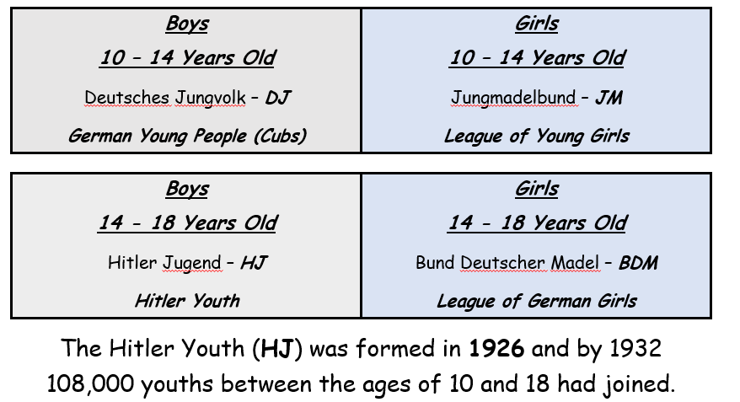
It was Hitler’s aim to control every aspect of life in Germany, including the daily life of ordinary people. If you had been a 16-year-old Aryan living in Nazi Germany you would probably have been a strong supporter of Hitler. The Nazis had reorganised every aspect of the school curriculum to make children loyal to them. Hitler’s dream was a Thousand Year Reich, which would only be possible through the loyalty and full support of young people in order to carry on the Thousand Year Reich.
Young people were important to the Nazi regime because:
- Children were easier to indoctrinate. They would not have formed their own political view or they would only have experienced the misery of the Weimar Republic. They would have indoctrinated to believe Hitler was the saviour and that Nazi ideas were the best. This would help to establish a 1000 year Reich.
- Hitler wanted to ensure the next generation were loyal to himself and the Nazis. He widely announced that the young boys were to learn nothing else but to think as Germans and to act as Germans. The generation they were raising would grow up to unquestionably obey the Nazis as they knew nothing else. The Hitler Youth was one way to confirm this as here boys were trained to be ready for war, girls were prepared for their lives as mothers but both were taught how everything Hitler was doing was for the best.
- The children became the eyes and ears for the Nazis. The adults were not as easily influenced but as their children could easily tell the Nazis what the parents were saying the parents would never say anything bad about Hitler for fear of being told upon.
Hitler Youth
After 1933, young people were encouraged to join the Hitler Youth and most other political youth organisations were closed down. By 1936 it was almost impossible not to join the Hitler Youth. There were separate organisations within the Hitler Youth for boys and girls, all under the command of Reich Youth Leader, Baldur von Schirach. Boys started at 6 years old in the Pimpf (Little Fellows), at 10 years old they moved onto the Jungvolk (Young Germans) and 10 - 14 years old moved onto the Hitler Jugend (Hitler Youth). Girls aged 10-14 joined the Yung Madel (Young Maidens) and aged 14-18 they moved onto the Bund Deutscher Madel (League of German Maidens).
Political training | Physical training | Military training | Character training
- Swore an oath of loyalty to Hitler  - Attended residential courses where they were told about Nazi ideas  - Leant about German heroes and the evil of the Jew  - Encourgaed to report anyone who was disloyal to the Nazis | - Regular camping and hiking expeditions  - Regional/national sport competitions | - Map-reading and signaling  - 1.2 million boys by 1938 had been trained in small-arm shooting | - Mould young people’s characters  - Activities stressed the need for loyalty, competition, comradeship and ruthlessness  - Might be drilled by SA instructors, plunged into ice-cold water to toughen them up

The League of German Maidens was the female equivalent. There were political activities like rallies and oaths of allegiances, as well as physical and character-building activities. BUT… the girls were trained to cook, iron, make beds, sew and were generally prepared to be a good housewife. Girls were taught the importance of racial hygiene – the idea that they should keep the German race ‘pure’ by only marrying Aryan men. Nazis believed that the Aryan race was superior to all other races.
Date | % of all 10-18 year olds
1933 | 30
1935 | 48
1936 | 63
1939 | 82

How did the Nazi regime cause a divide between parents and their children?
As a child in Nazi Germany, you might feel slightly alienated from your parents because they are not as keen on the Nazis as you are. They expect your first loyalty to be your family, whereas your Hitler Youth leader makes it clear that your first loyalty is to Hitler. You find it hard to understand why your father grumbles about Nazi regulation of his working practice- surely the Fuhrer is protecting him? Your parents find the idea of Nazi inspectors checking up on the teachers rather strange. For you it is normal.
Nazi education: What would you have learnt at school?
- PE: given 15% of school time and some sports such as boxing became compulsory for boys. Pupils had to pass an examination, and unsatisfactory performance could lead to being expelled.
- History: this concentrated on the rise of the Nazi Party, the injustices of the Treaty of Versailles and the evils of Communism and the Jews.
- Biology: explained Nazi ideas on race and population control. Pupils were taught how to measure their skulls and to classify racial types; also that Aryans were superior and should not marry inferior races. Taught you that you were special as a member of the Aryan race.
- German: this taught pupils to be conscious of their national identity by reading about German heroes of the Hitler Youth and the First World War.
- Geography: taught about the lands which were once part of Germany and the need for more living space (Lebensraum) for Germans.
- All subjects, including German language, Geography, Chemistry, Maths and History would focus on military subjects, the glorification of military service and of German heroes and leaders and the strength of a rebuilt Germany.
- At school you would have been told how the hardships of the 1920s were caused by Jews squeezing profits out of honest Germans.
- Religious Studies: became less important and by 1937 students could drop the subject.
In schools, you learnt the history of Germany. You would have been outraged at how the German army was ‘stabbed in the back’ by the weak politicians who had made the peace (TOV). You were taught how the hardships of the 1920s were caused by Jews squeezing profits out of honest Germans. By the time that you were a senior student, you were certain that loyalty to the Fuhrer was right and good = manipulation.
Girls usually had a different curriculum from boys. They also studied domestic science and eugenics (how to produce perfect offspring by selecting ideal qualities in the parents.
8:00 German (every day); 8:50 Geography, History or Singing (alternate days); 9:40 Race Studies and Ideology (every day); 10:25 Recess, Sports and Special Announcements (every day); 11:00 Domestic Science or Maths (alternate days); 12:10 Eugenics or Health Biology (alternate days); 13:00-18:00 Sport; Evening: Sex education, Ideology or Domestic Science (one evening each)
It was compulsory for teachers to be Nazi Party members, those who did not teach Nazi ideas were dismissed. Teachers’ camps taught them how to use Nazi ideas in their teaching.

  - Employment and living standards
- In January 1933, 5 million Germans were unemployed (around 25% of the labour force)
- Reducing unemployment was a priority for Hitler
- Politically dangerous to Hitler. Unemployed workers suffered poor living conditions and demanded help. If Hitler could not help, supporters may turn to the Communist Party
- Nazis believed that unemployed workers were a waste of resources and a burden on society. To remove the burden, they wanted as many people in useful work, in service of the country.
By 1939, unemployment had fallen to about half a million people. How did the Nazis achieve this?
Year | Total unemployed (million)
1933 | 4.8
1934 | 2.7
1935 | 2.1
1936 | 1.5
1937 | 0.9
1938 | 0.5
1939 | 0.3

Labour Service (RAD): In 1933, the Nazis set up the Reichs Arbeits Dienst (RAD) – the National Labour Service, which provided paid work for the unemployed.
The RAD provided workers for public works, such as repairing roads, planting trees and draining marshes. Apart from giving men work, these projects were also good for Germany as a whole.
The RAD, at first, was voluntary. However, from 1935, it was made compulsory for all young men to service for 6 months. The number of people in the RAD reached 422,000 in 1935.
However, the RAD was not popular. It was organised like an army – workers wore uniforms, lived in camps and did military drills and parades as well as work. Rates of pay were low and some complained of poor food and working conditions. Some men saw the RAD as service for the Nazi Party or military service rather than normal employment.
Autobahns: Another scheme which the Nazis used to reduce unemployment was the autobahn (motorway) project. The Nazis planned a 7,000 mile network of dual-carriageway roads to improve transport around Germany.
- In September 1933, Hitler personally started construction of the very first autobahn, and the first stretch of motorway was opened in 1935
- By 1935, 125,000 men were employed building motorways and by 1938, 3500km had been finished
The autobahn project was just one example of a huge number of public works schemes financed by the Nazis. They created public buildings, bridges, coastal walls and sport facilities. Spending on public works grew from 18 billion marks in 1933 to 38 billion marks in 1938.
Public works such as these created many jobs in the construction industry. Better roads and bridges also meant quicker and cheaper transport for German industry and agriculture. This helped to boost the sale of German goods at home and abroad, creating even more jobs in the rest of the German economy.
Rearmament: One of Hitler’s main aims in government was boosting Germany’s armed forces.
Rearmament helped to reduce unemployment in two ways:
- The TOV had limited the size of Germany’s armed forces. Hitler defied these limited. In 1935, he announced military conscription. All young German men would have to serve a period in the German armed forces. By 1939, there were 1,360,000 men in the armed forces. This helped reduced the number of unemployed
- Hitler’s bigger armed forces needed more arms and equipment. Government spending on arms in 1933 was 3.5 billion marks. By 1939, this had grown to 26 billion marks. This caused a big jump in employment in the arms industry. For example, there were only 4000 people employed in the aircraft construction industry, but by 1935, this had grown to 72,000.
Invisible unemployment: Some historians say that the Nazis did not really reduce unemployment. Some historians say that the real number of unemployed people was higher than the official figures by almost one and a half million people. The Nazis found ways to reduce the number of people recorded as unemployed. In other words, they made some unemployment ‘invisible’.
- Women and Jews who may have wanted jobs were forced to give up work; invisible unemployed
- Men who would have been unemployed were found jobs in the Labour Service of public works
- People who could only find part-time work were counted as fully employed
‘Reducing’ unemployment figures
- The Labour Service: by the middle of the 1930s, there were about half a million ‘unemployed’ people in the Labour Service. These did not show up in unemployment figures
- Rearmament: by 1939, many jobs depended upon massive armaments orders. In normal peace-time, these jobs did not exist.
- Women and Jews: forced to give up work, these unemployed did not show up on the unemployment figures
- Changing statistics: from 1935, people in part-time jobs counted amongst the full-time employed.
- Public works: the Nazis had a huge programme of public works in the 1930s, which was too expensive to afford for long, so the jobs created were not ‘real’ jobs
- Prisons: the Nazis put hundreds of thousands into prisons or concentration camps, which made unemployment look lower than it would in normal times
- Armed forces: by 1939, there were over 1.3 million men in the armed forces, in peace-time these men would need jobs
- The SA, SS and Gestapo: the Nazis used public money to employ hundreds of thousands of men in their own security force. These were not ‘real’ jobs.

Overall verdict on unemployment in Nazi Germany: The achievement of the Nazis in reducing the official unemployment figures in Germany by over four million was remarkable. In Britain, in comparison, unemployment fell by only about one million in the 1930s. Reducing unemployment helped to prevent any build-up of public resentment towards the Nazis. It must be remembered:
- Unemployment was falling everywhere as countries recovered from the Great Depressions
- Some unemployed people were not counted in official figures
- Some jobs created by the Nazis were not real jobs
Some jobs in Nazi Germany were supported by very high levels of government spending which could not be maintained in the long run
Changes in the standard of living: the standard of living which tells us whether people’s lives are getting better or worse. Hitler realised that he must make sure that the German workers were satisfied and avoid losing their support. He set up different workers’ organisations that were meant to improve the lives and conditions of German people.
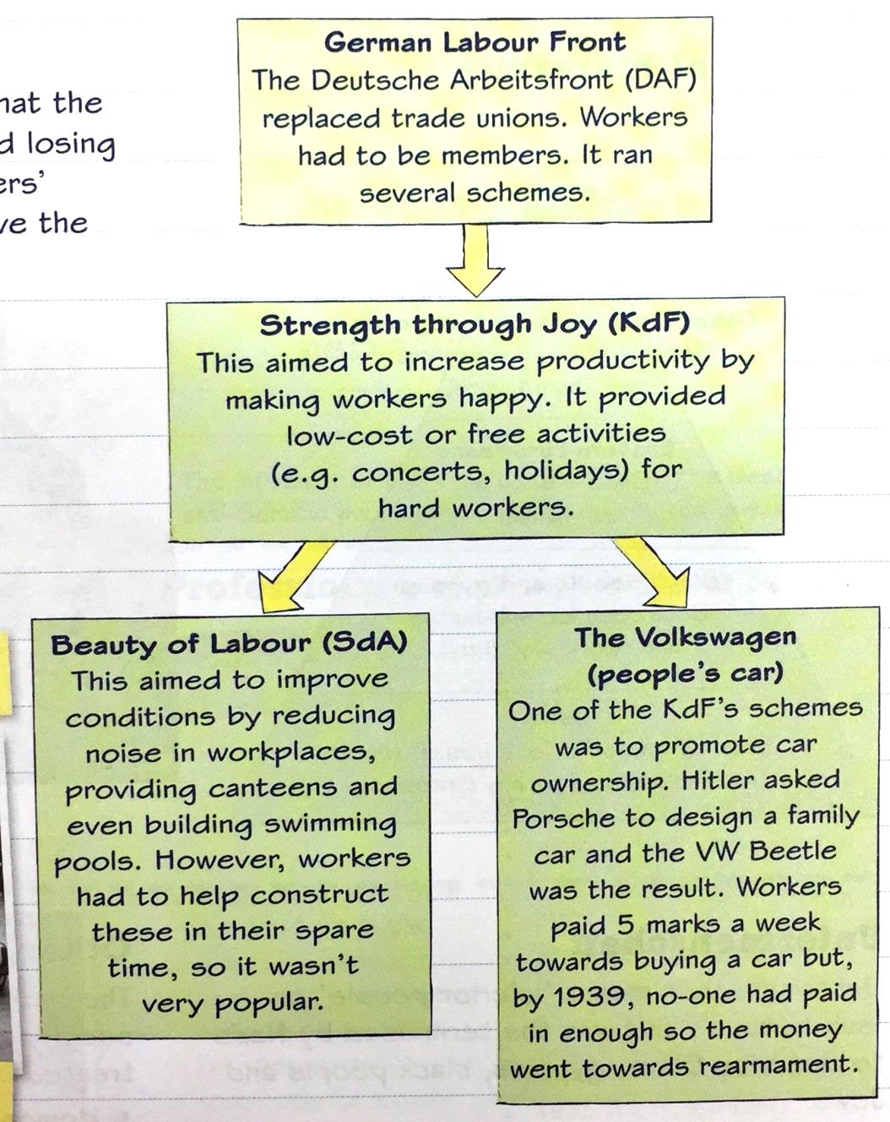

People were better off under the Nazis | People were worse off under the Nazis
- More or less full employment  - Strength through Joy (KdF) tried to improve the leisure time of German workers through cultural trips. These included concerts, theatre trips, sporting events and weekend trips  - Beauty of Labour tried to improve working conditions. It organized the building of canteens, swimming pools and sports facilities. It installed better workplace and improved noise levels  - Average wages rose by 20% compared to 1933  - Car ownership increased three-fold | - Lack of freedom. German workers lost their rights under the Nazis. In 1933, trade unions were banned and replaced by the German Labour Front. The Labour Front did not permit workers to negotiate for better pay or reduced hours of work. Strikes were banned  - Volkswagen swindle – this idea to encourage people to put aside money every week to buy a VW was a con trick. By 1939, not a single customer had taken delivery of a car. None of the money was refunded  - Invisible unemployment  - Cost of food rose by an equivalent amount so this cancelled out the wage rises

  - The persecution of minorities
Volksgmeinschaft = national community
Under Nazi rule, workers, farmers, and so on would no longer see themselves primarily as workers or farmers; they would see themselves as Germans. Their first loyalty would not be to their own social group but to Germany and the Fuhrer. They would be so proud to belong to a great nation that was racially and culturally superior to other nations that they would put the interests of Germany before their own. Hitler’s policies towards each group were designed to win this kind of loyalty to the Nazi state.
People who were welcomed as part of the Volksgmeinschaft had to be…
- Pure Aryans
- Physically and mentally healthy
- Socially useful- they had a job and they contributed to the Volk or national community
- Welcome Nazism
These people were encouraged to contribute towards the Volk by…
- Having racially pure children
- All Aryan men were to have lots of healthy children
- Contributed to the national community
People who were considered to be a threat to the Volk included…
- Alcoholics
- Prostitutes
- Homosexuals
- Juvenile delinquents
- Gypsies; non-Aryan, work-shy and homeless
- Jews
1938 Decree for the Struggles against the Gypsy Plague: aim was to register all Gypsies and so be able to ensure the racial separation of Gypsies from Aryans
Propaganda: a propaganda campaign started which tried to stir up resentment against people who were burdens on the community
The Sterilisation Law July 1933: this allowed Nazis to sterilise people with certain illnesses such as ‘simple-mindedness’s’ and ‘chronic alcoholism’. In September 1933 a massive round-up of tramps and beggars began and many were sterilised. Between 1934-1945 between 320,000 and 350,000 men and women were compulsorily sterilised.
The concentration camps: by 1936, the work-shy, tramps and beggars, alcoholics, prostitutes, homosexuals and juvenile delinquents were being sent to concentration camps. A special youth concentration camp was set up in 1937. In 1938 another round-up netted about 11,000 beggars, tramps and Gypsies, most of who were sent to Buchenwald concentration camp.
The euthanasia campaign 1939: in 1939 the Nazis secretly began to exterminate the mentally ill in a euthanasia programme. 6000 handicapped babies, children and teenagers were murdered by starvation or lethal injections. The Nazis also devised a new method of killing by using carbon gas. Gas chambers were built in asylums. German officials busied themselves calculating how much money and food had been saved by these killings and how to make better use of the hospital beds and buildings. Some 72,000 people had been murdered before public protests made Hitler stop the programme in 1941. Some Germans did approve- some sent Hitler letters asking for mercy killings, including a woman dying of cancer, and parents with handicapped children.

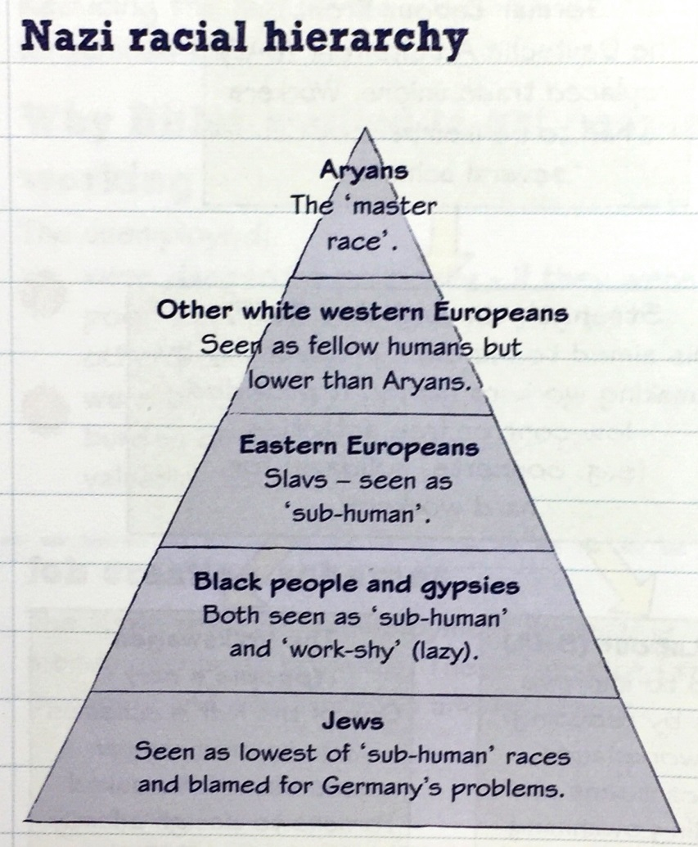

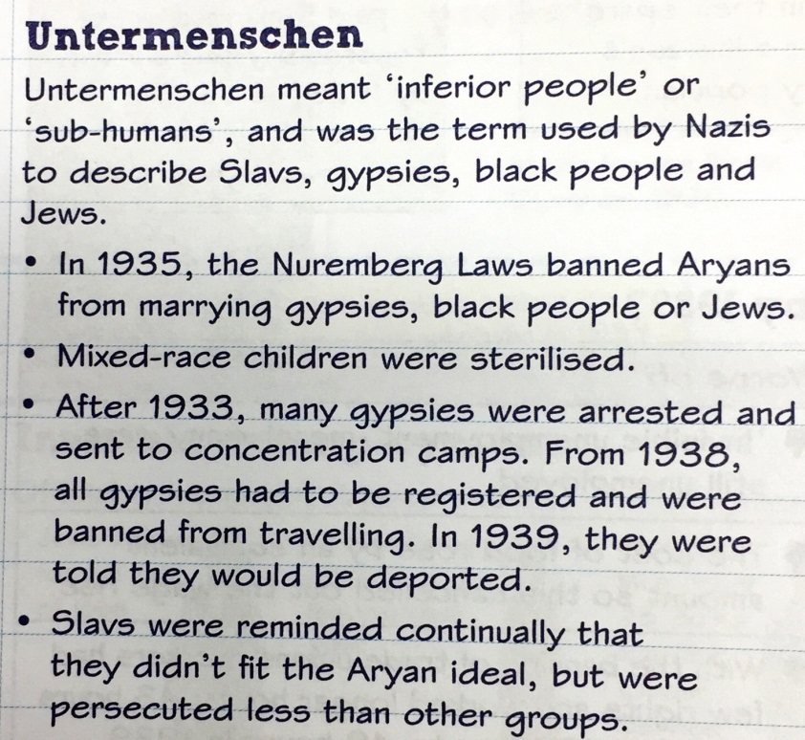
Hitler and the Jews: Anti-Semitism means hatred of Jews. Throughout Europe, Jews had experienced discrimination for hundreds of years. They were often treated unjustly in courts or forced to live in ghettos. One reason for this persecution was religious, in that Jews were blamed for the death of Jesus Christ. Another reason was that they tended to be well educated and therefore held well-paid professional jobs or ran successful stores or businesses.
Hitler hated Jews insanely. In his years of poverty in Vienna, he became obsessed by the fact that Jews ran many of the most successful businesses, particularly the large department stores. This offended his idea of the superiority of Aryans. Hitler also blamed Jewish businessmen and bankers for Germany’s defeat in the First World War. He thought that they had forced the surrender of the German army.
As soon as Hitler took power in 1933 he began to mobilise the full powers of the state against the Jews. They were immediately banned from the Civil Service and a variety of public services such as broadcasting and teaching. At the same time, SA and later SS troopers organised boycotts of Jewish shops and businesses, which were marked with a Star of David.
March 1933 | Jewish lawyers were forbidden to work as lawyers in Berlin  Jewish judges suspended from office
April 1933 | Jewish teachers were banned from teaching in state schools  Aryan and non-Aryan children were forbidden from playing with each other  Jewish civil servants were dismissed from public office  Jews were excluded from sports and gymnastic clubs
March 1935 | Jewish writers were not allowed to carry out any form of literacy work in Germany  Jewish musicians were not allowed to work in state orchestras
April 1935 | Jews were only allowed to sit on benches marked ‘for Jews’  Jewish art and antique dealers were not allowed to carry out their trade
September 1935 | The Nuremburg Laws:  - All Jews had their German citizenship removed  - Marriage ceremonies, and extramarital sex, between Germans and Jews was punishable by imprisonment  - Marriages that had already taken place were declared invalid
January 1936 | Jews had to hand over electrical and optical equipment, bicycles, typewriters and records
April 1936 | Jewish vets were banned from working
August 1936 | Anti-Jewish posters were temporarily removed during the Olympic games in Berlin
October 1936 | Even if Jews converted to Christianity and were baptised, they were still to be classed as members of the Jewish race
January 1938 | Jews were forbidden to become members of the German Red Cross
March 1938 | Only Aryan Germans could hold allotments
April 1938 | Jews had to declare their finances so that their assets could be taken by the government
July 1938 | Non-Jews were forbidden to leave anything in their wills to Jews  Jewish doctors were no longer allowed to work as doctors  Jewish street names were changed
August 1938 | Male Jews were forced to add the name ‘Israel’ and female Jews ‘Sara’ to their first name
October 1938 | Jewish passports had to be stamped with the letter ‘J’  Passports of those Jews whose emigration did not suit the Nazis were seized
November 1938 | Jews were no longer allowed to run independent business as craftspeople  Jews were banned from running a retail or wholesale business  Jews were banned from visiting cinemas, theatres, operas and concerts  Jews were no longer allowed to buy newspapers and magazines  Jewish children were no longer allowed to attend state schools
December 1938 | Jews were not allowed to use open-air and indoor swimming pools  Jews had to hand in their driving licenses and vehicle permits to the police  Jewish women were no longer able to work as midwives  Jewish publishing houses and bookshops were shut down
January 1939 | Emigrants were not allowed to take jewellery and valuables with them  Jewish dentists, chemists and nurses were forbidden to work
February 1939 | Jews had to hand in jewellery, gold, silver, platinum and pearls to the police
March 1939 | Jews had to collect up the ruins of their synagogues which had been attacked and were not allowed to rebuild them
April 1939 | Jews could be evicted from their homes without a reason given and without notice being served
September 1939 | Jews were not allowed to leave their homes after 8pm in the winter, or 9pm in the summer  Jews had to hand over their radio sets

In 1935 the Nuremberg Laws took away German citizenship from Jews. Jews were also forbidden to marry or have sex with pure-blooded Germans. Goebbels’ propaganda experts bombarded German children and families with anti-Jewish messages. Jews were often refused jobs, and people in shops refused to serve them. In schools, Jewish children were humiliated and then segregated.
Kristallnacht: In November 1938 a young German killed a German diplomat in Paris. The Nazis used this as an excuse to launch a violent revenge on Jews. Plain-clothed SS troopers were issued with pickaxes and hammers and the address of Jewish businesses. They ran riot, smashing up Jewish shops and workplaces. 91 Jews were murdered. Hundreds of synagogues were burned. 20,000 Jews were taken to concentration camps. Thousands more left the country. This event became known as ‘Kristallnacht’ or ‘Night of Broken Glass’. Many Germans watched the events with alarm and concern. The Nazi-controlled press presented Kristallnacht as a spontaneous reaction of ordinary Germans against the Jews. Most Germans did not believe this, however, hardly anyone protested. Those that did were brutally murdered.
Why did Kristallnacht take place? One reason was the power struggle between leading Nazis. Goebbels was out of favour with Hitler because of Goebbels’ affair with Czech actress and he decided to win his way back onto Hitler’s favour. He suggested to Hitler that Kristallnacht should take place to satisfy the hatred many Nazi hardliners had for the Jews. Hitler agreed and decided to use it to speed up the removal of the Jews from German economic life. Other Nazi leaders, especially Goering and Himmler disapproved and were irritated by the events of Kristallnacht. This is an example of the chaotic way in which the Nazis made up policies.
The climax of peacetime persecution: In January 1939, the Nazis decided to evict all Jews from Germany. The Reich Office for Jewish Emigration was set up under Heydrich, head of the Gestapo. His task was to deport all of Germany’s Jews. In April 1939, orders went out that all Jews should be evicted from their homes and collected together for deportation. This was when war broke out in September 1939
The role of the German people: the Nazi government kept some atrocities against Jews secret. BUT… most of what happened to Jews between 1933 and 1939 was known, both within Germany and in other countries. Indeed, many Germany took part in the persecution and many others – and most other countries – did little to stop it.

Check your understanding: answer these quick fire questions
- Give two changes the Nazis made to education.

- What group were young boys encouraged to join?

- What would race studies and ideology lessons teach?

- Which youth groups opposed the Nazis? Give two examples.

- What were the three K’s?

- The most effective way the Nazis controlled women was through physical constraints. Give another three ways they controlled the lives of women.

- What was the Lebensborn programme?

- What law gave newlyweds a loan so that wives could leave work to have children?

- What was the KDF?

- What was Hitler’s Volkgemeinshaft?

- The most effective way Hitler dealt with employment and the standard of living in Nazi Germany was by introducing conscription. Give another three ways that he dealt with these problems.

- Give two examples why people were NOT better off under Nazi rule.

- Give two examples of ‘a-socials’ or ‘undesirables’ who the Nazis persecuted?

- What were the Nuremberg Laws that were introduced in 1935?

- What month and year did Kristallnacht occur?

- What happened during Kristallnacht?

- What did the Nazis decide to set up to implement ‘The Final Solution’?

